ADOPTED - JUNE 14, 2016
AGENDA ITEM NO. 24

Introduced by the County Services and Finance Committees of the:

INGHAM COUNTY BOARD OF COMMISSIONERS

RESOLUTION AUTHORIZING THE PURCHASE OF
2016 SEASONAL REQUIREMENT OF SAND AND GRAVEL
FOR THE INGHAM COUNTY ROAD DEPARTMENT

RESOLUTION # 16 – 260

WHEREAS, the Road Department annually purchases approximately 10,000 to 15,000 tons of various types of processed road gravel and sand for use in various road maintenance operations; and

WHEREAS, the Road Department adopted 2016 budget includes controllable expenditures and funds for this and other maintenance material purchases; and

WHEREAS, bids for various types of processed road gravel and sand were solicited and evaluated by the Ingham County Purchasing Department per Request for Proposals (IFB) #62-16, and it is their recommendation, with the concurrence of Road Department staff, to award this bid and purchase the various types of sand and gravel, on an as-needed, unit price basis from all three responding bidders shown in the table below with various delivery options also shown, based on Road Department staff’s judgment as to which supplier is most advantageous to the County for any given operation based on lowest cost combination of bid unit price, supplier proximity to the work being performed at the given time, availability of required material, and delivery method.

THEREFORE BE IT RESOLVED, the Board of Commissioners accepts the bids, and authorizes the purchase of various types of sand and gravel on an as-needed, unit price basis from all three respondents to IFB #62-16 shown in the table below with the various delivery options also shown, based on Road Department staff’s judgment as to which supplier and delivery method is most advantageous to the County for any given operation based on lowest cost combination of bid unit price, supplier proximity to the work being performed at the given time, availability of required material, and delivery method.

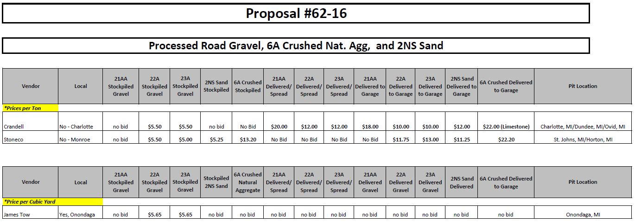

BE IT FURTHER RESOLVED, that the Road Department and Purchasing Department are hereby authorized to execute purchase orders with both above listed suppliers and purchase the various types of sand and gravel material as needed and budgeted.

COUNTY SERVICES: Yeas: Nolan, Bahar-Cook, Hope, Maiville
Nays: None Absent: Koenig, Celentino, Tsernoglou Approved 6/07/2016

FINANCE: Yeas: Bahar-Cook, McGrain, Crenshaw, Anthony, Schafer, Case Naeyaert
Nays: None Absent: Tennis Approved 6/08/2016

