ADOPTED - JUNE 28, 2016
AGENDA ITEM NO. 9

Introduced by the County Services Committee of the:

INGHAM COUNTY BOARD OF COMMISSIONERS

RESOLUTION TO ADOPT A POLICY FOR TUBERCULOSIS SCREENING
OF NEWLY HIRED EMPLOYEES

RESOLUTION # 16 – 282

WHEREAS, Ingham County is committed to providing a safe workplace for the public and its employees, customers, and contractors; and

WHEREAS, Ingham County identified the need to develop Tuberculosis (“TB”) screening policy and procedure for new hires; and

WHEREAS, the Ingham County Health Department, Ingham County Sheriff’s Office, Ingham County Youth Center and the Ingham County Human Resources Department collaborated to reevaluate, update and codify a policy and procedure for TB screening of newly hired employees; and

WHEREAS, the policy and procedure has been reviewed by the County Attorney.

THEREFORE BE IT RESOLVED, that the Ingham County Board of Commissioners hereby adopts the attached policy for Tuberculosis Screening of Newly Hired Employees.

COUNTY SERVICES: Yeas: Nolan, Koenig, Celentino, Bahar-Cook, Tsernoglou, Hope, Maiville
Nays: None Absent: None Approved 6/21/2016

Personnel Policy No. _____ |  | Tuberculosis Screening of Newly Hired Employees

Approved: | ____________
Resolution No. | ____________

1. Purpose and Applicability:

Tuberculosis (“TB”) is a disease caused by Mycobacterium tuberculosis that adversely affects public health around the world. In the United States, TB control remains a substantial public health challenge in multiple settings. Two settings where employees are particularly exposed are Health Care and Detention settings.

As part of its control efforts, Ingham County has historically required all newly hired employees to undergo TB screening. However, in recent years the need to screen all employees was identified as being unnecessary, and only newly hired employees in departments with a higher risk for potential exposure were screened.

This document is the product of a combined effort between the County Human Resources Department, Health Department, Youth Center and Sheriff’s Office to reevaluate, update, and codify the County’s newly hired employee TB screening policy and procedure. Its goal is to ensure the consistent and accurate processing of new employees assigned to locations at higher risk of exposure to TB and to lay a foundation on which departments can build their exposure control plans and follow-up testing programs for employees, contractors and volunteers.

The policy and procedures detailed in the pages that follow are informed by recommendations from the Centers for Disease Control (“CDC”), Curry International Tuberculosis Center and Michigan Department of Corrections and many other sources. Questions about the policy and procedures should be directed to the Human Resources Department at hr@ingham.org or 517-887-4328.

2. Abbreviations:

“CDC” - Centers for Disease Control and Prevention.
“OSHA” - Occupational Safety and Health Administration.
“TB” – Tuberculosis.
“TST” - Tuberculin skin test.

3. Definitions:

TB infection: A condition in which living tubercle bacilli are present in the body without clinical disease. TB infection without TB disease cannot be transmitted. Persons with TB infection have no symptoms of TB disease and generally have a positive tuberculin skin test or Quantiferon testing.

TB disease (i.e., active TB disease): A condition in which living tubercle bacilli are present in the body and the disease is clinically active. Bacilli from TB disease of the lungs or larynx can be transmitted when a person with the disease coughs, sings, laughs, speaks, or breathes. Persons with TB disease have symptoms and generally have a positive tuberculin skin test or Quantiferon testing.

Two-step tuberculin skin testing (TST): A procedure used to establish an accurate baseline for periodic TST programs. Two-step testing reduces the likelihood of mistaking a boosted TST reaction for new TB infection. In health-care and detention facilities, the two-step TST is conducted at the time of hire.

4. General Policy

A. Ingham County will provide a screening form for tuberculosis (TB) to all employees working in locations at higher risk for exposure to TB. See section C below.

B. The purpose of the TB screening program is to:

1. Identify newly hired employees assigned to locations at higher risk for exposure to TB to prevent transmission to other employees, patients, visitors;
2. Evaluate the effectiveness of TB exposure control measures in order to identify the need for corrective action; and
3. Comply with federal, state, and local regulations and guidelines.

C. Screening will be provided to all newly hired employees assigned to locations at higher risk of exposure to TB, including, but not limited to:

1. The Ingham County Health Department;
2. The Ingham County Sheriff’s Department;
3. The Ingham County Youth Center;
4. The Ingham County Potter Park Zoo.

5. Authority and Responsibility for Policy and Procedures:

A. The following individual(s)/ department(s) will have the authority and/or responsibility for all or parts of the policy and procedures:

1. The Health Officer and Human Resources Director have the authority to ensure full compliance with the policy and procedures;
2. The Human Resources Department and Health Department have the authority and responsibility to periodically review and revise the policy and procedures;
3. The Medical Director has the responsibility of medical direction of and active support for the TB screening program;
4. The Medical Director and their designee have the responsibility for performing TB risk assessments annually; and
5. Communicable Disease Control Supervisor and Immunization Supervisor have the authority and responsibility to screen for TB.

B. All newly hired employees assigned to susceptible locations will comply with the Policy and Procedures for Tuberculosis Screening as a condition of their employment, including obtaining required two-step tuberculin skin tests (TSTs) and follow-up, as appropriate; attending educational sessions; and using safe work practices to prevent exposure to TB.
6. Initial Tuberculosis Screening Procedure for Newly Hired Employees:

A. Newly hired employees assigned to locations at higher risk of exposure to TB will be provided the Mandatory Tuberculosis Screening Form by Human Resources. (Refer to appendix B and C for the screening forms.)

B. If a newly hired employee answers “yes” to the first question on the form, they will be directed to Immunizations for testing. If a newly hired employee answers “yes” to any other question on the screening form, they will be sent to Communicable Disease for evaluation and to immunizations if the evaluation dictates the need for testing. A newly hired employee being directed to either Immunizations or Communicable Disease will be directed to bring their completed Mandatory Tuberculosis Screening Form with them and will be added to a tracking spreadsheet by Human Resources. A newly hired employee answering “no” to all questions on the Mandatory Tuberculosis Screening Form will be informed that they are ready to begin working on their start date.

C. Once Communicable Disease and/or Immunizations staff have completed their evaluation of the newly hired employee and based on their findings have determined that the newly hired employee can begin working, they will complete the bottom portion of the Mandatory Tuberculosis Screening Form and direct the newly hired employee to return the form to the Human Resources Department. Should a newly hired employee be found to not be able to start working, Human Resources will be contacted by the appropriate staff and the process will continue at section F.

D. Human Resources through the utilization of a tracking spreadsheet will confirm that the completed Mandatory Tuberculosis Screening Form is received prior to the newly hired employee’s start date. Should the form not be received in time, Human Resources will contact the newly hired employee to determine their testing status, the newly hired employee’s supervisor to make them aware that the employee will not be able to start working on their start date and the Employee Services Coordinator to let them know to disregard the previously generated PAR for the newly hired employee. Once the Mandatory Tuberculosis Screening Form is received, Human Resources will contact the supervisor so that they may reach out to the employee to arrange a new start date and to have a corrected PAR generated.

E. Once Human Resources receives the corrected PAR, the newly hired employee will be removed from the tracking spreadsheet.

F. Should a newly hired employee be found to not be able to start working by the Communicable Disease/Immunizations Staff, the appropriate staff will contact Human Resources. Human Resources will then contact the newly hired employee’s supervisor to make them aware that the employee will not be able to start working on their start date and the Employee Services Coordinator to let them know to disregard the previously generated PAR for the newly hired employee.

G. Once the newly hired employee has been cleared by the Communicable Disease/Immunizations Staff to start working, the appropriate staff will contact Human Resources and the Mandatory Tuberculosis Screening Form will be submitted to Human Resources. With receipt of the Mandatory Tuberculosis Screening Form, Human Resources will contact the supervisor so that they may reach out to the employee to arrange a new start date and to have a corrected PAR generated. The process will continue at section E above.

7. Tuberculosis Testing Procedure for Newly Hired Employees:

A. A two-step skin test will be administered to all new employees working at locations which are at higher risk for exposure to TB and who have not had a skin test within the past twelve months. Two-step testing consists of an initial skin test and if negative; followed by a second test in 1-3 weeks. Employees may begin working after the 1st TST reading.

B. Newly hired employees with documented negative TB test results from testing done less than 12 months before becoming employed with the County will need to have a single TB test completed as a baseline. This test will be considered the second step.

C. Newly hired employees with documented negative Quantiferon testing completed less than 12 months before becoming employed with the County will be referred to the Communicable Disease Department.

D. The second test will be coordinated between the appropriate Communicable Disease/Immunizations staff and the newly hired employee. Once testing is complete, the newly hired employee will be provided documentation stating they completed their second step testing. The newly hired employee will provide this documentation to their supervisor as proof of completing the testing. The supervisor can discard this documentation after receipt.

8. Compliance with the TB Screening Program:

A. Compliance with TB screening is mandatory.

B. Employees failing to comply with the requirements of TB screening may be subject to disciplinary action, up to and including termination.

9. Confidentiality of Medical Records

A. Medical information obtained from employees during TB screening is confidential and will be placed in locked files separate from their personnel file. (If computerized, access to information in the database will be protected and limited to designated staff.)

B. Names of persons (including patients) diagnosed with TB disease (who may be the source of TB exposure to employees, contractors and volunteers) will be kept confidential.

C. Access to employee medical records will be limited to designated staff. However, medical records may be subject to disclosure, if subpoenaed.

10. Record Keeping and Reporting:

A. Employees will be provided with a copy of their TB skin testing results. If requested, employees will be provided with a copy of their Mandatory Tuberculosis Screening Form.

B. All medical information obtained through the TB screening program will be maintained for the duration of employment plus 30 years, including, but not limited to:
1. TST;
2. Medical examination and follow-up;
3. Medical testing and procedures; and
4. Treatment.

C. TST conversions and active TB cases among employees will be recorded on
the OSHA Log 300 as required by law.

Appendix A TB Process Flow Diagram P1

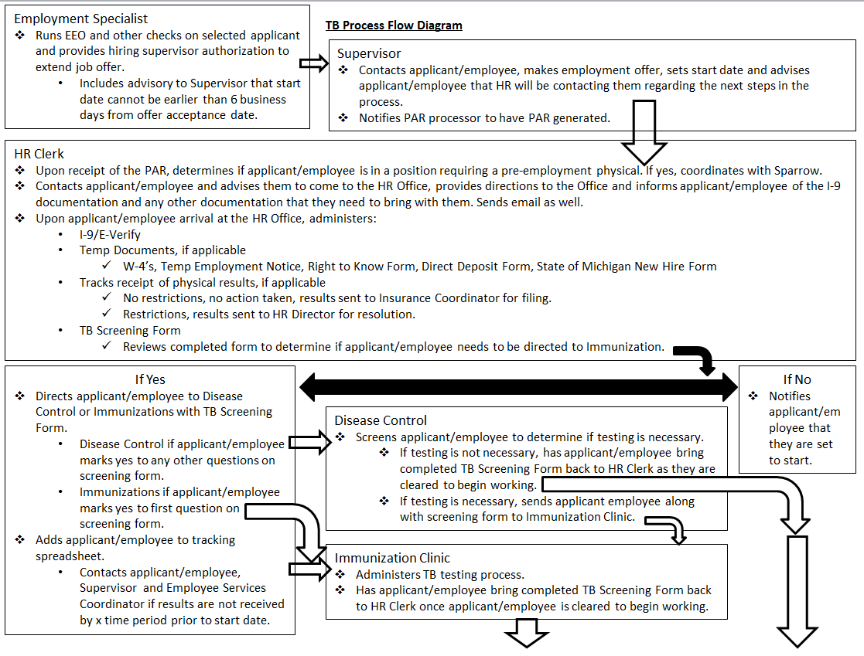

TB Process Flow Diagram P2

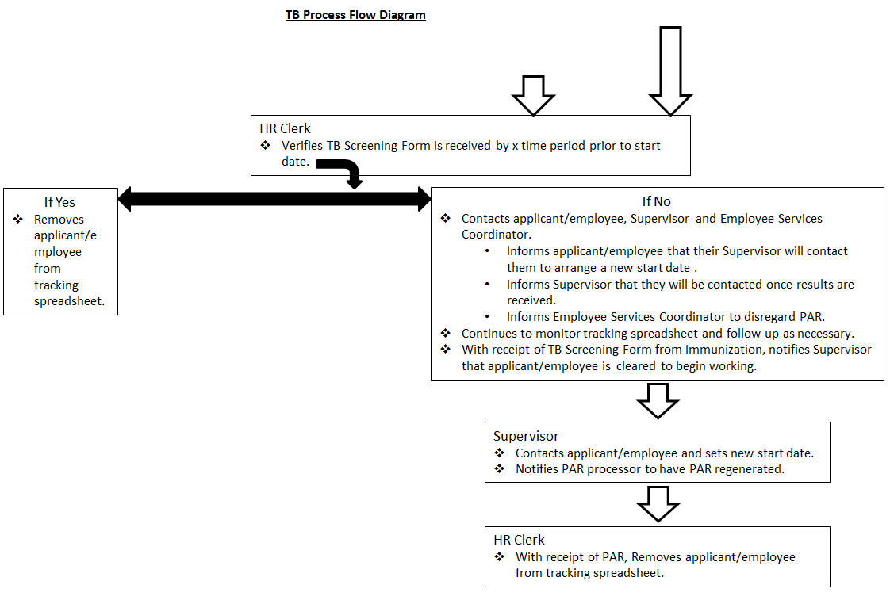

Appendix B
INGHAM COUNTY HEALTH DEPARTMENT
EMPLOYEE MANDATORY TUBERCULOSIS SCREENING FORM

Name (please print):
Last First MI

Country of Birth: Year arrived in US:

MANDATORY TUBERCULOSIS SCREENING FORM Sections A and B are REQUIRED for ALL employees
Are you a health care worker? YES 􀂆 NO 􀂆
Medical provider, nurse, medical assistant, dentist, dental hygienist, dental assistant, nutritionist, social workers, behavioral health therapist and contractual employees.

SECTION A: History of Tuberculosis (TB)?

1. Have you ever been sick with tuberculosis? YES 􀂆 NO 􀂆

2. Have you ever had a positive PPD, TB Quantiferon test, or T-SPOT? YES 􀂆 NO 􀂆

SECTION B: At Risk for Tuberculosis (TB)?

- Were you born in, or have you lived, worked or visited for more than one month in any of the following:
Asia, Africa, the Caribbean, South America, Central America, Russia or Eastern Europe? YES 􀂆 NO 􀂆

If yes, what country? How long?

Reason (please circle) Born there Tourist Work School Other ____________

2) Have you had HIV infection, AIDS, diabetes, leukemia, lymphoma or a chronic immune disorder?
YES 􀂆 NO 􀂆
3) Do you have a persistent cough? (3 weeks or more), fever, night sweats, fatigue, loss of appetite,
or weight loss? YES 􀂆 NO 􀂆

4) Have you ever lived with or been in close contact to a person known or suspected of being sick
with TB? Do you use illegal drugs or abuse alcohol? YES 􀂆 NO 􀂆

5) Have you ever lived, worked, or volunteered in any homeless shelter, prison/jail, hospital or
drug rehabilitation unit, nursing home or residential healthcare facility? YES 􀂆 NO 􀂆

Employee Signature/Date ____________________________________ HR Representative Signature/Date______________________

If you answered NO to all of the above questions, skip Section C.
If you answered YES to any of the above questions, you must go to the communicable disease office to be evaluated by a Communicable Disease Nurse (CDN). Section C to be completed by CDN.

SECTION C: If patient answered YES to any of the above questions, proof of a PPD, QuantiFERON –TB Gold or T-SPOT is REQUIRED. If PPD results are 10mm or more, or QuantiFERON-TB Gold or T-SPOT are positive a chest x-ray is REQUIRED. If an employee has history of positive PPD, chest x-ray is required
PPD: Date placed Date read # of mm induration

QuantiFERON-TB Gold or T-SPOT: Result Date Result (attach lab report)

Date of chest x-ray Result

If negative CXR and positive PPD, did employee complete a course of LTBI treatment? YES 􀂆 NO 􀂆
If yes, date of treatment medication months of treatment
DCN evaluation:

Name/Signature of CD Nurse Phone number 887-4308 Date

Appendix C
INGHAM COUNTY HEALTH DEPARTMENT
EMPLOYEE MANDATORY TUBERCULOSIS SCREENING FORM

SHERIFF DEPARTMENT YOUTH CENTER AND ZOO
MANDATORY TUBERCULOSIS SCREENING FORM

Name (please print): _________________________________________________________________________
Last First MI
Country of Birth: Year Arrived in US:
MANDATORY TUBERCULOSIS SCREENING FORM Sections A and B are REQUIRED for ALL Employees
Are you a health care worker, a Sheriff’s Deputy, custody staff, maintenance staff, or a cook at the Jail or Youth Center or any staff working at the zoo? YES NO
SECTION A: History of Tuberculosis (TB)?
1. | Have you ever been sick with tuberculosis? | YES NO
2. | Have you ever had a positive PPD, TB Quantiferon test, or T-SPOT? | YES NO
SECTION B: At Risk for Tuberculosis (TB)?
1. | Were you born in, or have you lived, worked or visited for more than one month in any of the following: Asia, Africa, the Caribbean, South America, Central America, Russia or Eastern Europe?  If yes, what country? How long?  Circle Reason: Born There School Tourist Work Other: | YES NO
2. | Have you had HIV infection, AIDS, recent immigration, history of TB, recent close contact with a person with TB disease, injection drug use, immunosuppressive therapy, diabetes, leukemia, hematologic malignancy or lymphoma, chronic renal failure, history of gastrectomy or jejunoileal bypass, or a chronic immune disorder, medical conditions associated with substantial weight loss or malnutrition? | YES NO
3. | Do you have a persistent cough? (3 weeks or more), fever, night sweats, fatigue, loss of appetite, weight loss or coughing blood? | YES NO
4. | Have you ever lived with or been in close contact to a person known or suspected of being sick with TB? Have you used or currently use illegal drugs or abuse alcohol? | YES NO
5. | Have you ever lived, worked, or volunteered in any homeless shelter, prison/jail, hospital or drug rehabilitation unit, nursing home or residential healthcare facility? | YES NO
Employee Signature/Date: HR Representative Signature/Date:
If you answered NO to all of the above questions, skip Section C. If you answered YES to any of the above questions, you will be directed to the Communicable Disease Department. Section C to be completed by Communicable Disease Nurse.

SECTION C: If patient answered YES to any of the above questions, proof of a PPD, QuantiFERON –TB Gold or T-SPOT is REQUIRED. If PPD results are 10mm or more, or QuantiFERON-TB Gold or T-SPOT are positive a chest x-ray is REQUIRED. If an employee has history of positive PPD, chest x-ray is required.
PPD:Date Placed__________ Date Read:__________ # of mm Induration: ___________
QuantiFERON-TB Gold or T-SPOT: Result Date:_____________ Result (Attach Lab Report):_____________
Date of Chest X-Ray: Result:

If negative CXR and positive PPD, did employee complete a course of LTBI treatment? YES NO

If yes, date of treatment ______________ Medication______________ Months of treatment ____________

Name/Signature of Nurse Phone Number Date

