ADOPTED – JULY 25, 2017
AGENDA ITEM NO. 8

Introduced by the County Services Committee of the:

INGHAM COUNTY BOARD OF COMMISSIONERS

RESOLUTION TO ADOPT THE RECOMMENDATIONS OF THE
SPECIAL TRAILS AND PARKS COMMITTEE
RESOLUTION # 17 – 275

WHEREAS, in November 2014, the electorate approved a countywide trails and parks millage levy of 50/100 (.50) of one mill to be used for the purpose of creating and maintaining a county system of recreational trails and adjacent parks trail system, which may incorporate trails or parks created by local units of government, including Lansing’s River Trail, and may acquire rights of way to connect and extend existing trails; and

WHEREAS, a Trails and Parks Task Force was created to recommend a process to be utilized for the expenditure of trails and parks millage funds; and

WHEREAS, the Trails and Parks Task Force expired December 31, 2016 and it was the desire of the Board of Commissioners to create a Special Trails and Parks Committee to examine the procedures currently in place; and

WHEREAS, by Resolution #17-087 the Special Trails and Parks Committee was established; and

WHEREAS, the Special Trails and Parks Committee has met four times, heard public comment from users, municipalities, the Park Commission and others, and has developed the following recommendations for approval by the Board of Commissioners.

THEREFORE BE IT RESOLVED, the Board of Commissioners may tentatively allocate funding for projects over a multi-year period (an annual amount not to exceed 70% of projected future millage revenue in any given year) to provide flexibility and to construct large projects in multi-year phases.

BE IT FURTHER RESOLVED, the Board of Commissioners will provide for consideration for Ingham County municipalities which contribute less than 5% of total county trails and parks millage revenue small grant requests of up to $50,000 each during each application round and staff is directed to provide additional needed technical assistance for completing applications.

BE IT FURTHER RESOLVED, the Ingham County Board of Commissioners adopts the recommended application for Trails and Parks Millage funding (attachment A).

BE IT FURTHER RESOLVED, the Ingham County Board of Commissioners adopts the criteria for use by Park Commission and staff for scoring applications for funding (attachment B).

BE IT FURTHER RESOLVED, the Ingham County Board of Commissioners adopts the tentative timeline for funding allocations in 2018 (attachment C).

COUNTY SERVICES: Yeas: Celentino, Crenshaw, Grebner, Nolan, Koenig, Sebolt, Maiville
Nays: None Absent: None Approved 7/18/2017

Attachment A
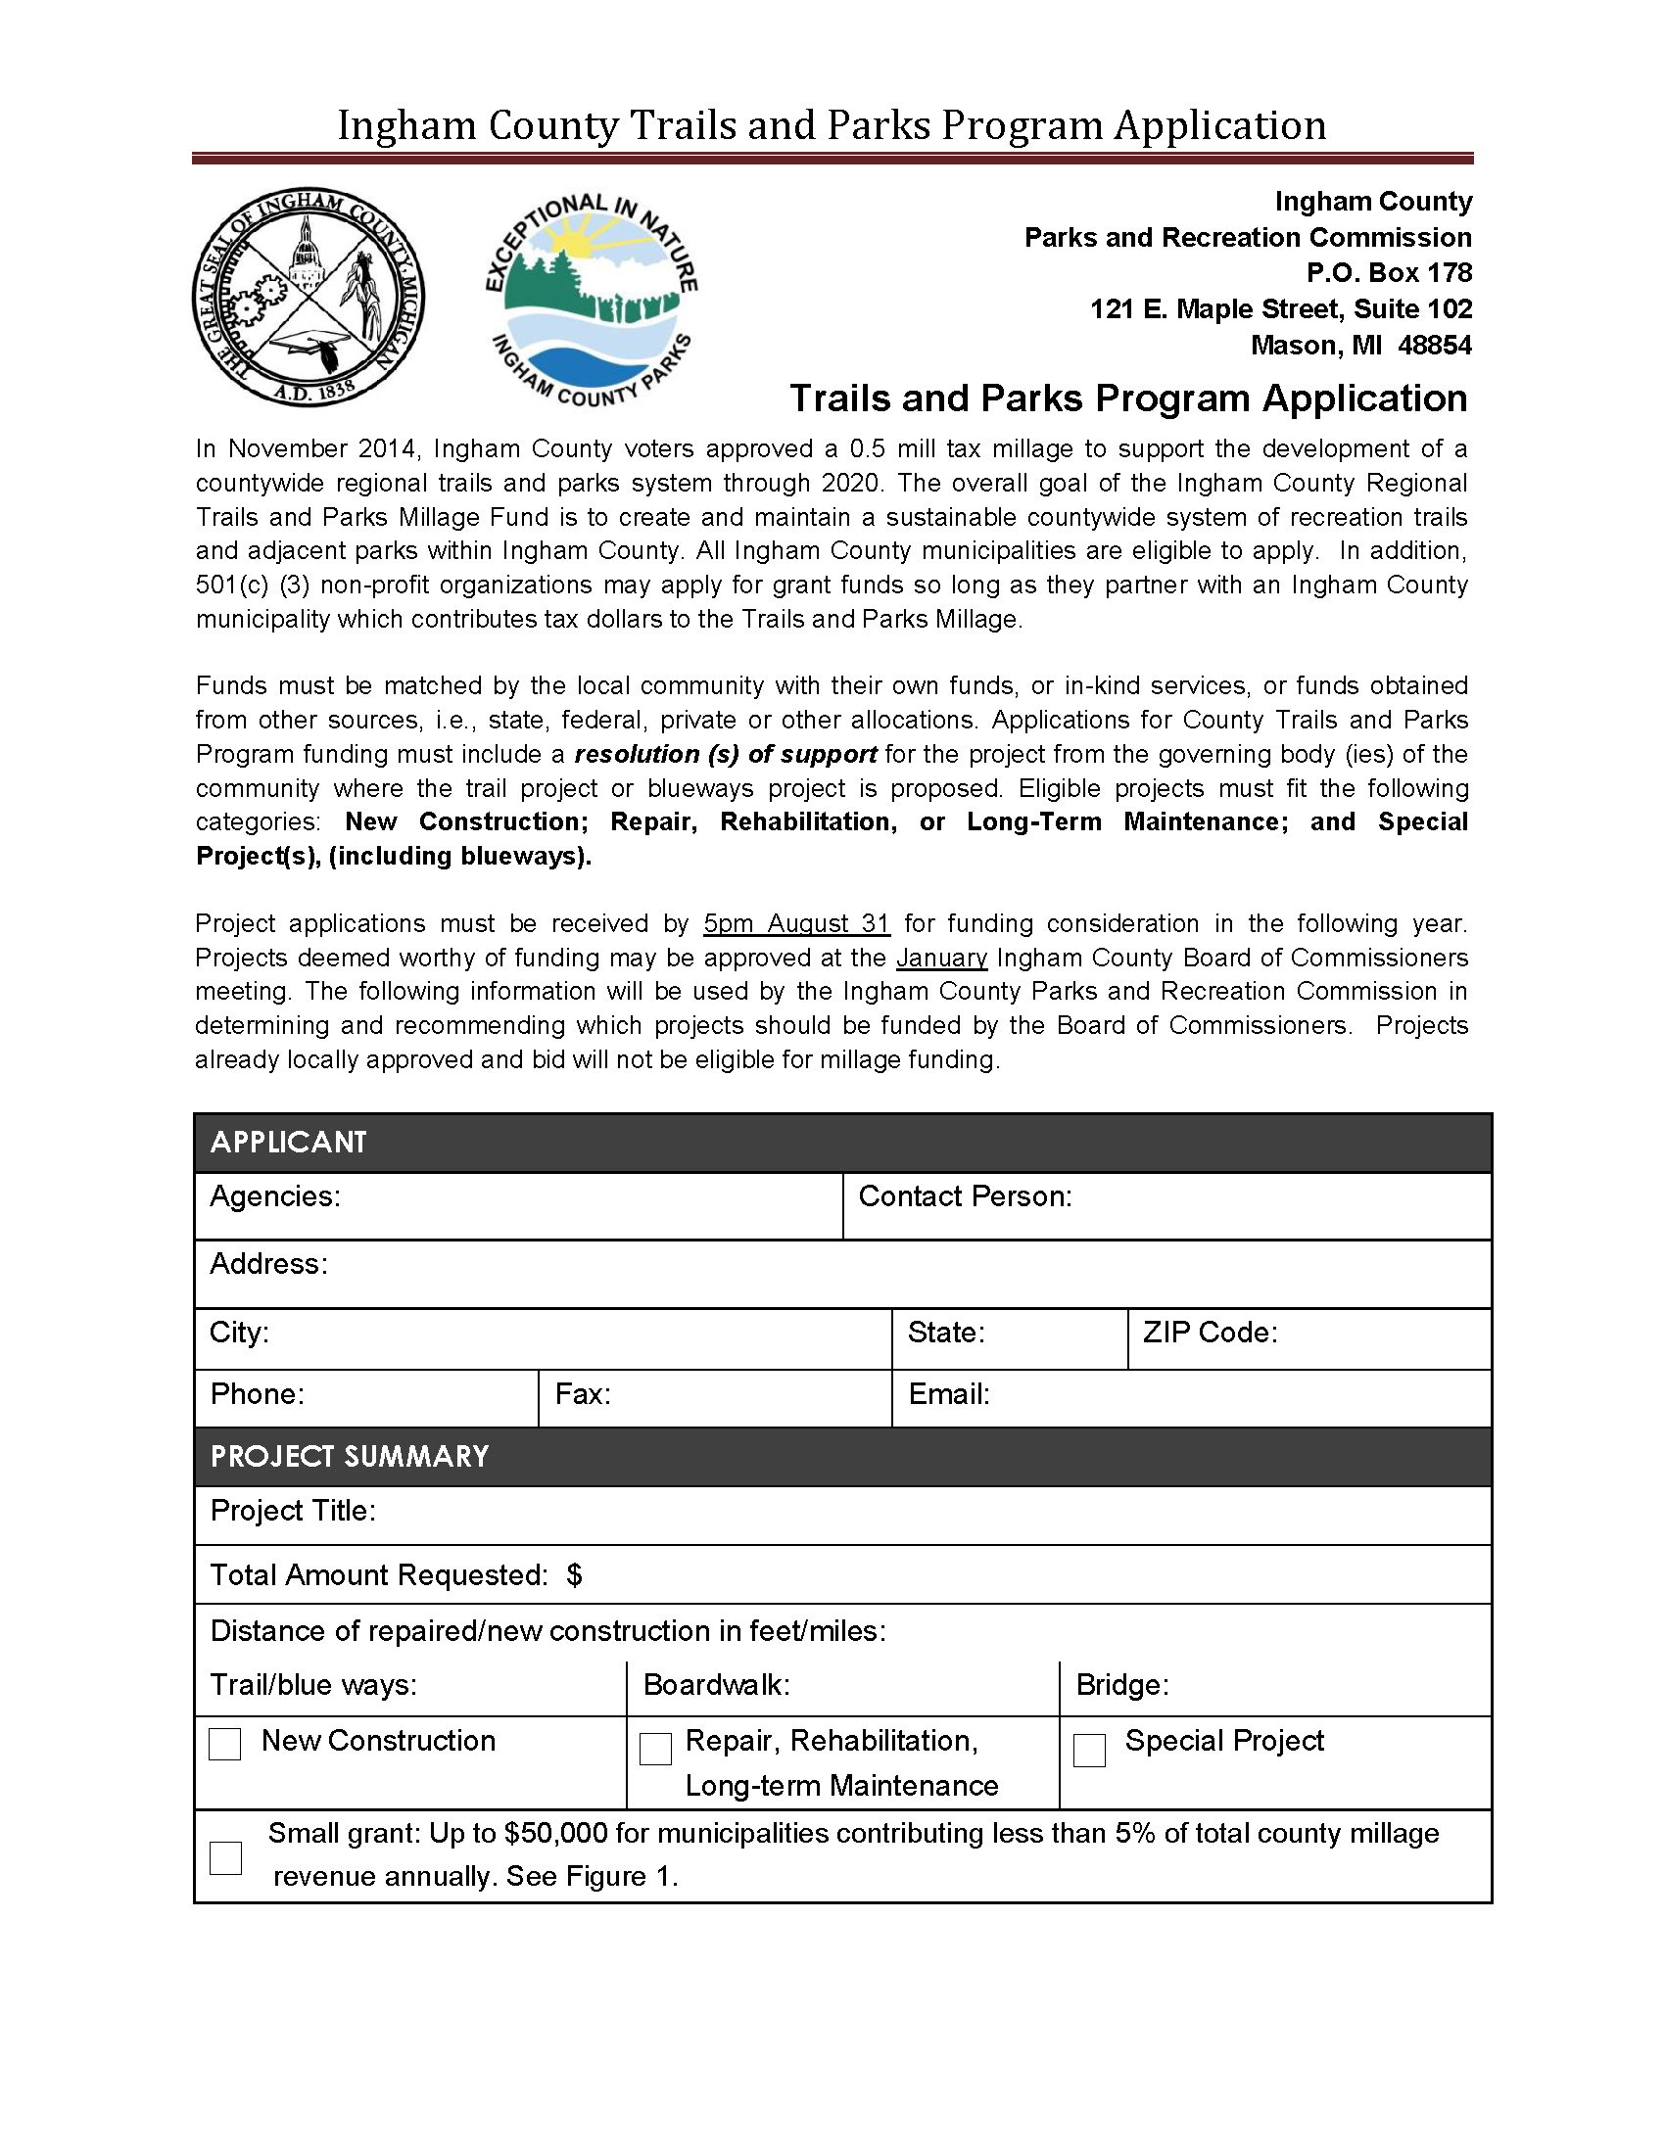

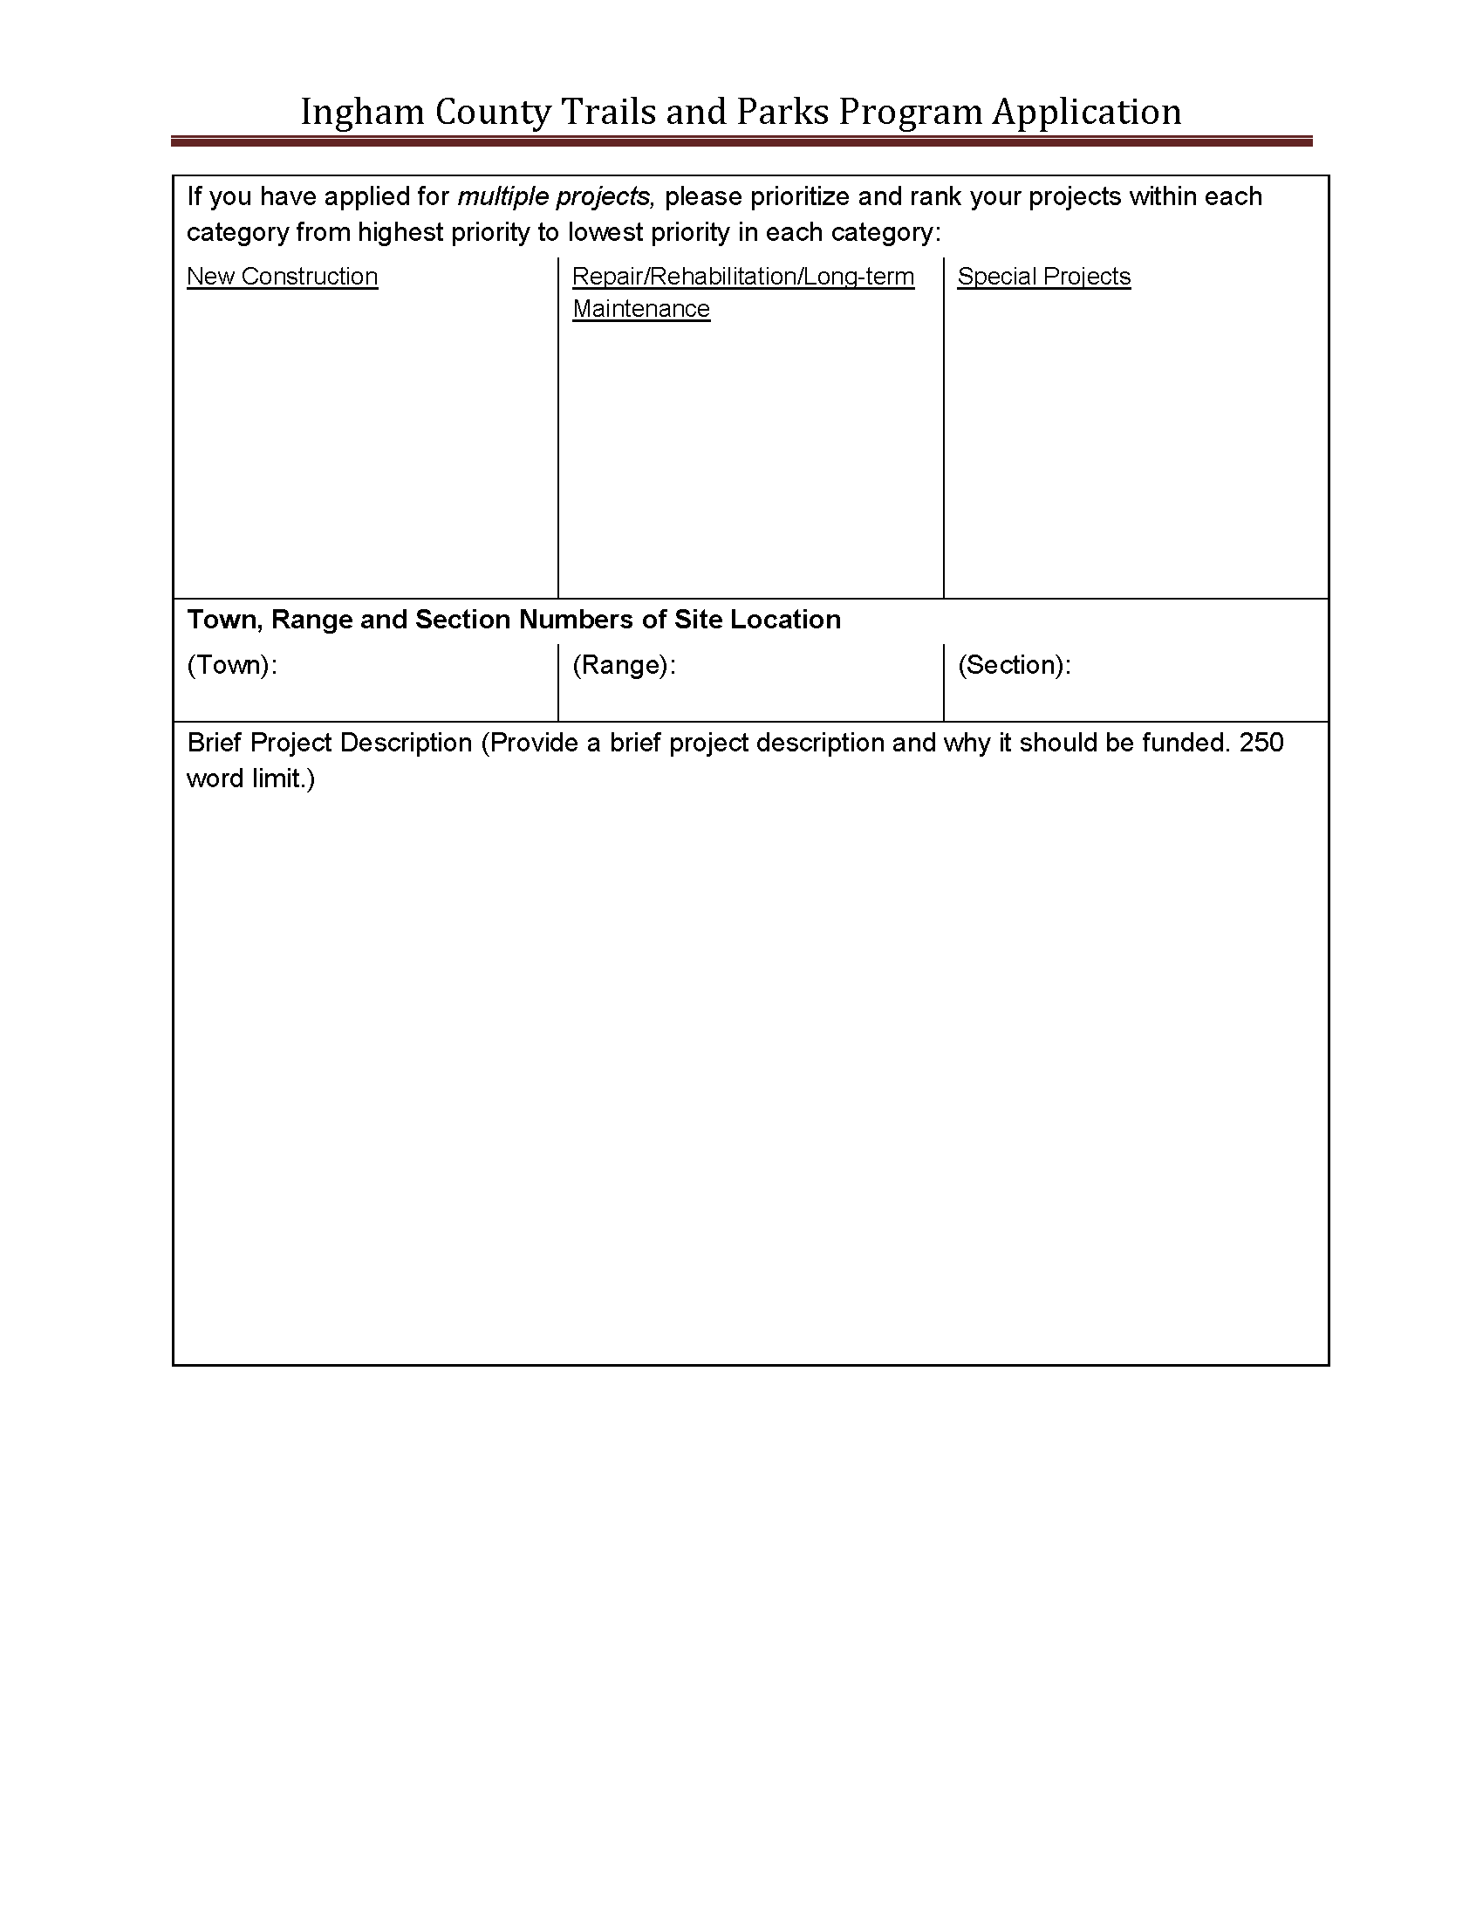
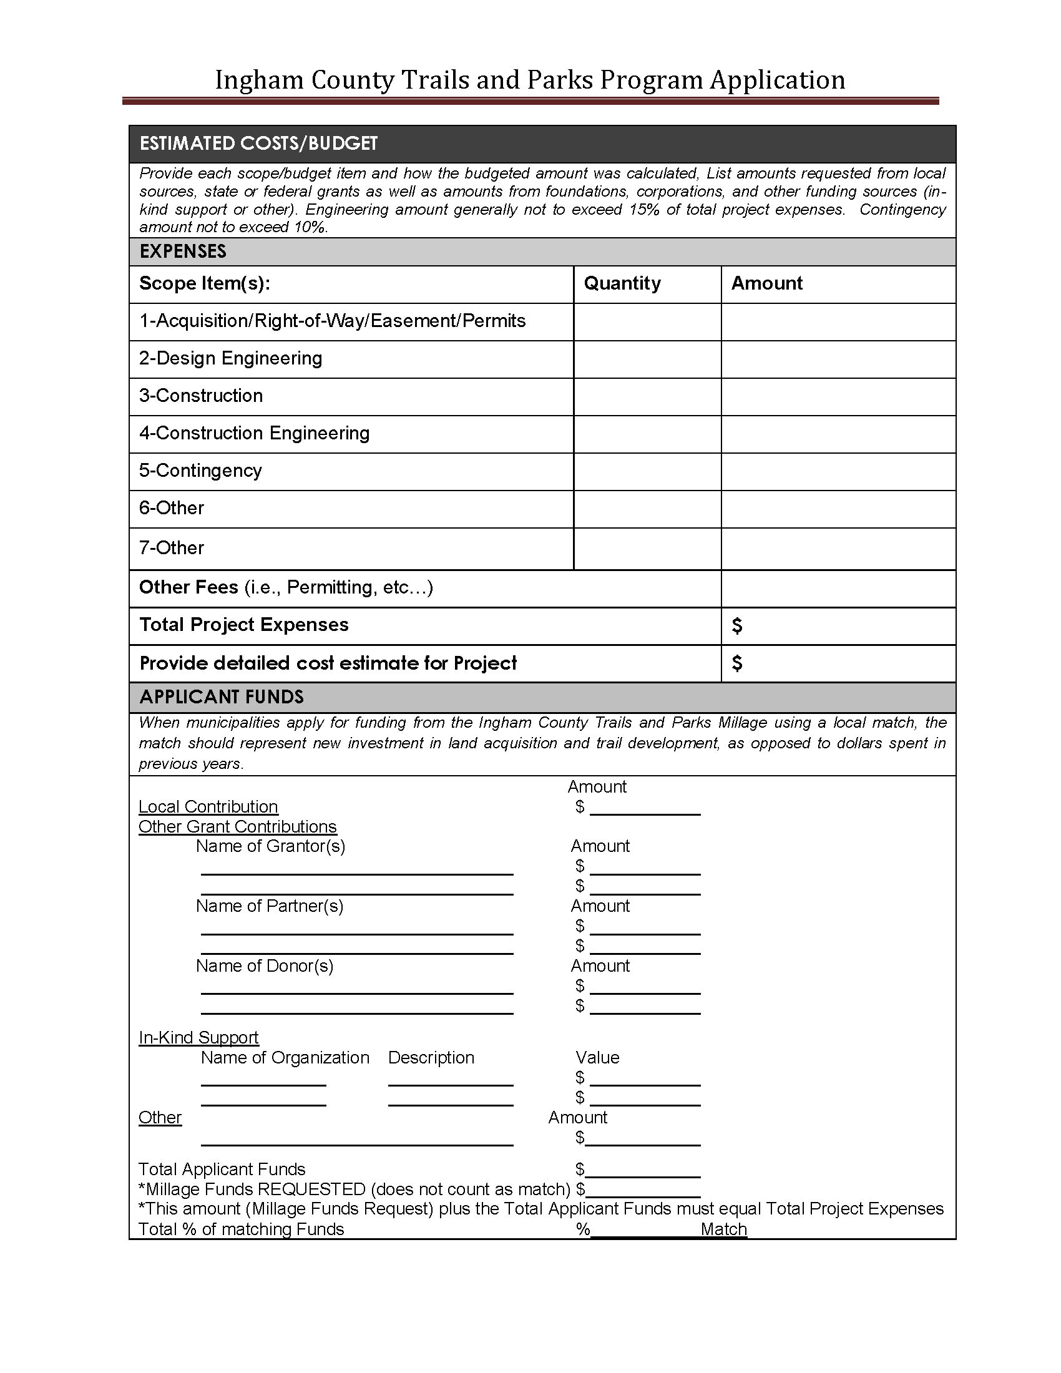
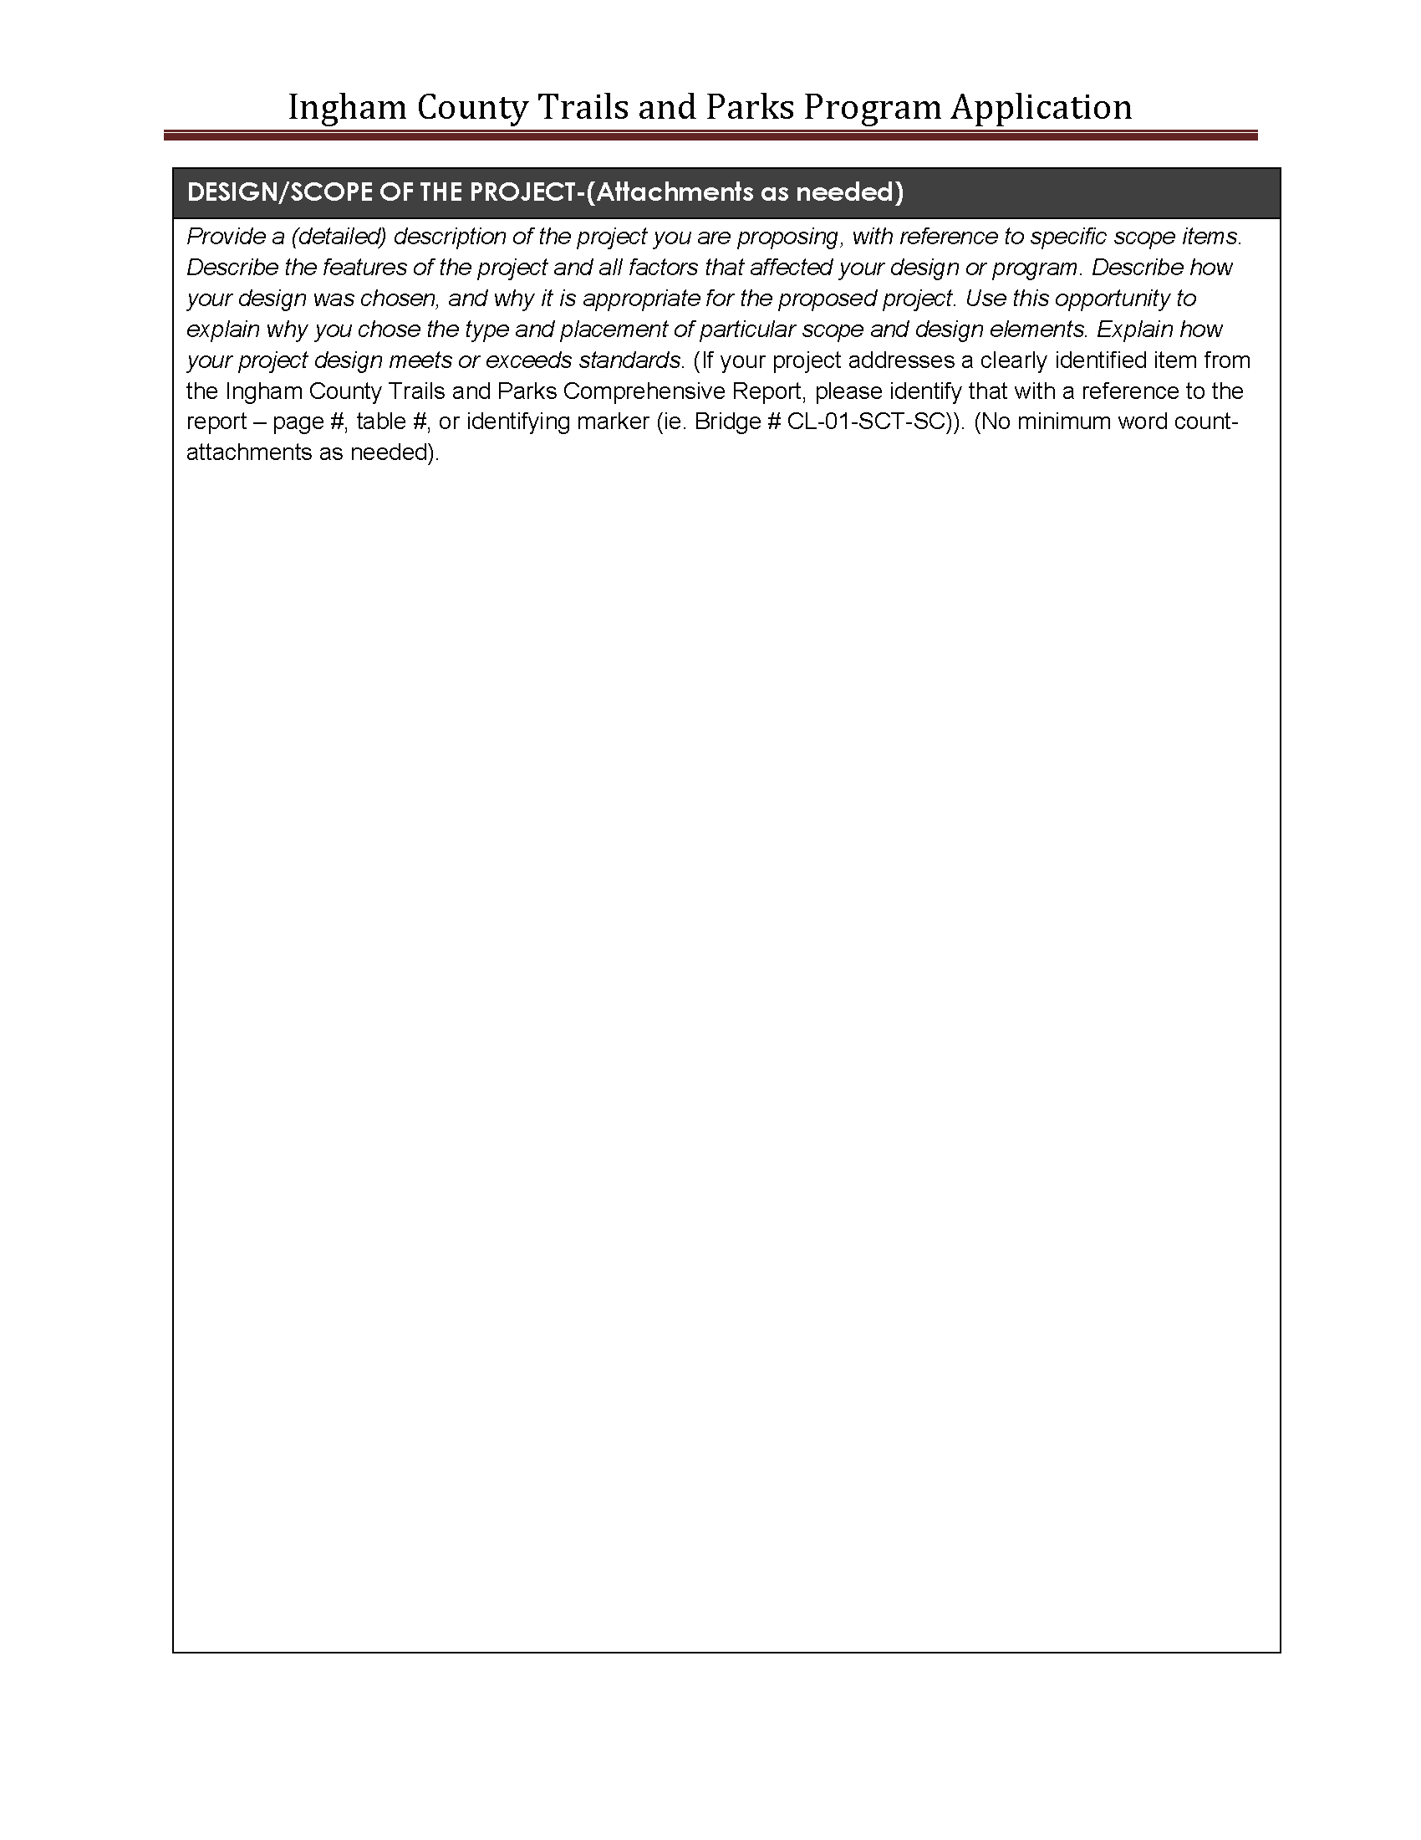
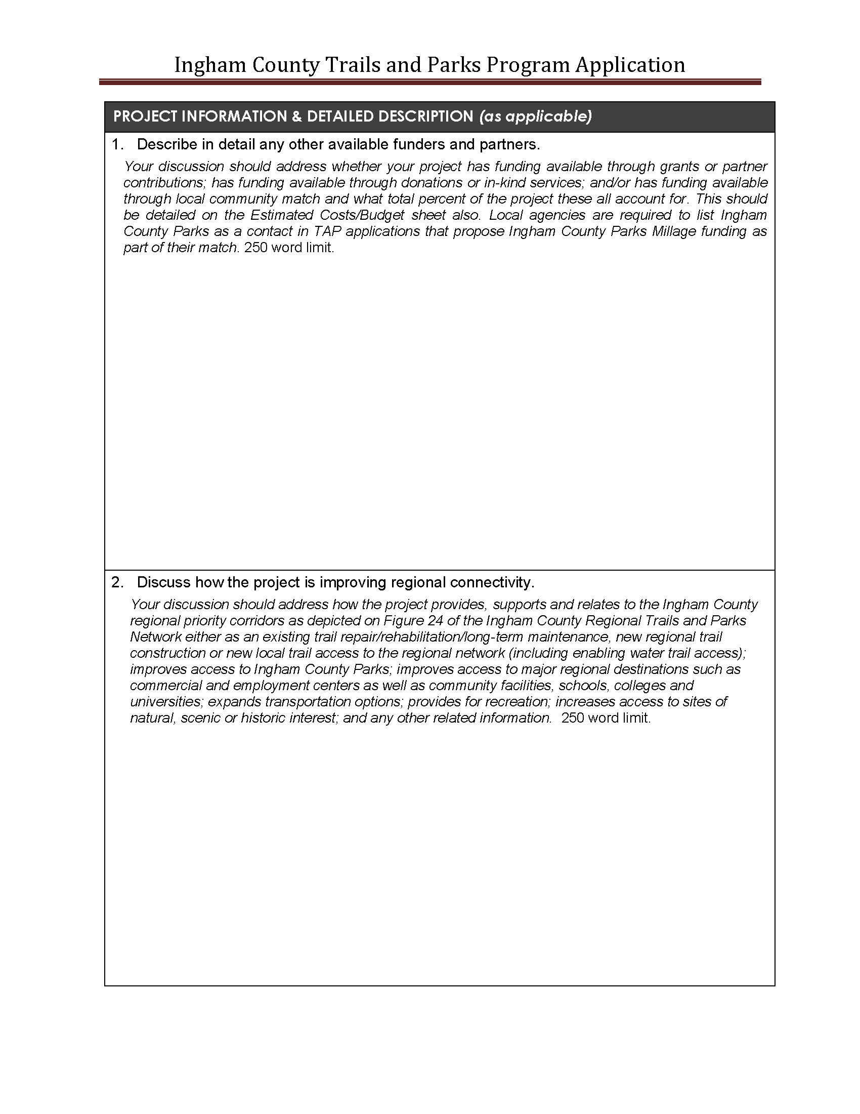
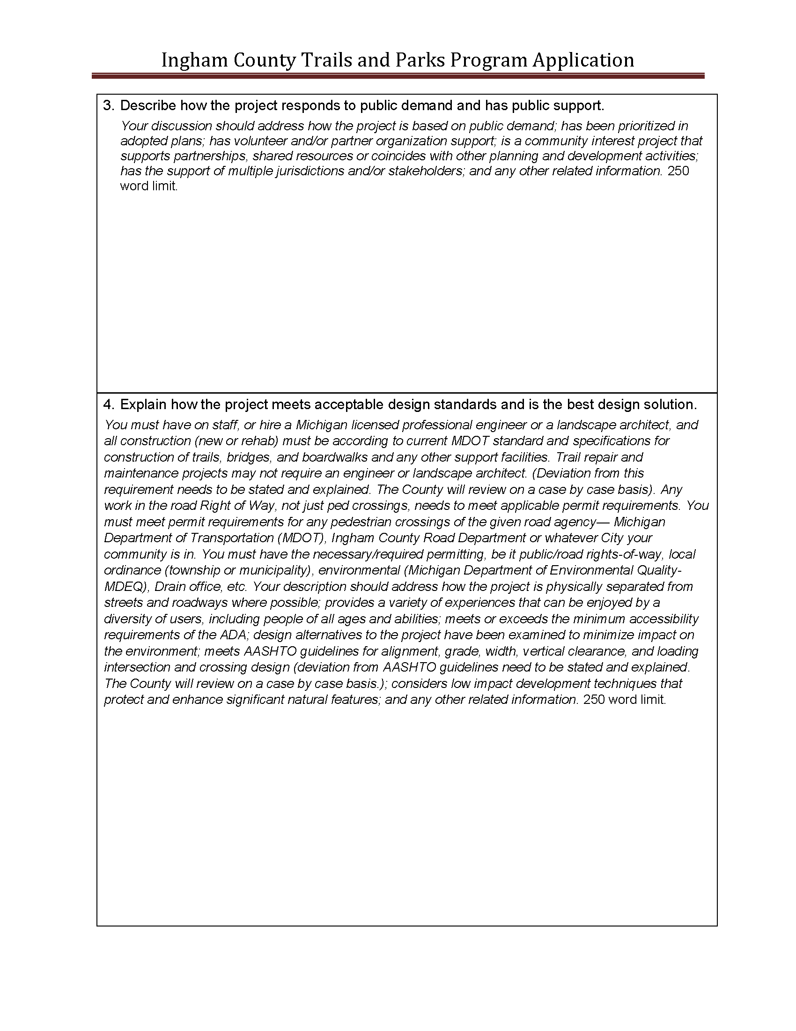
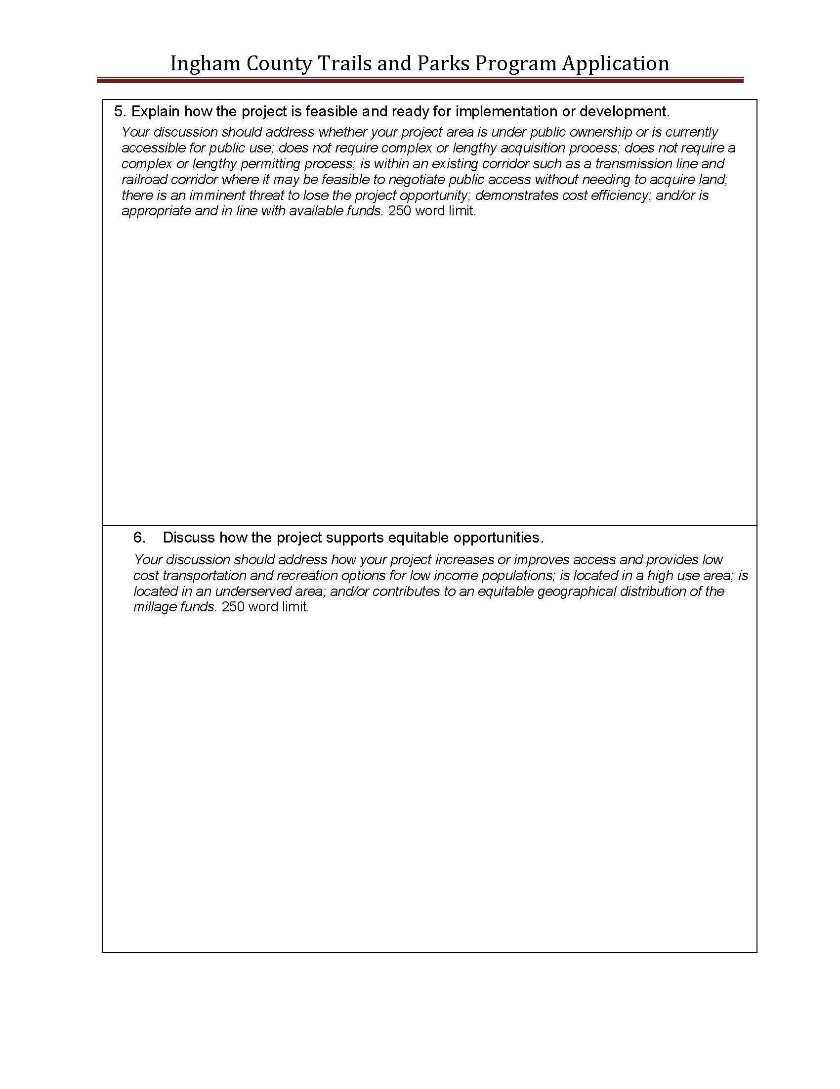
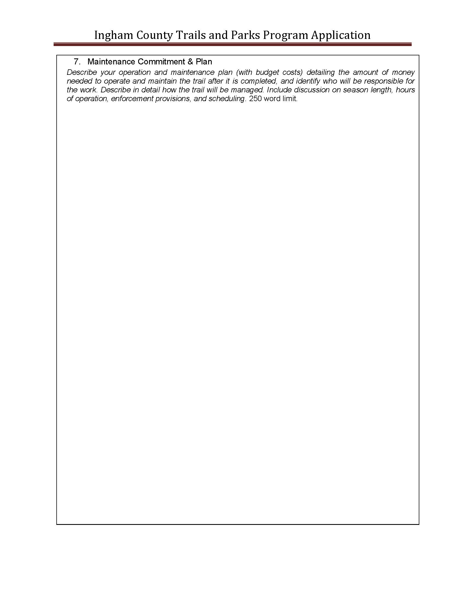
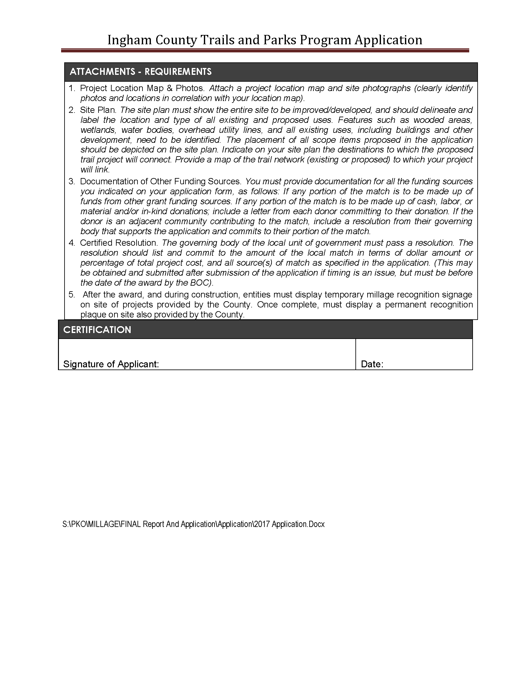
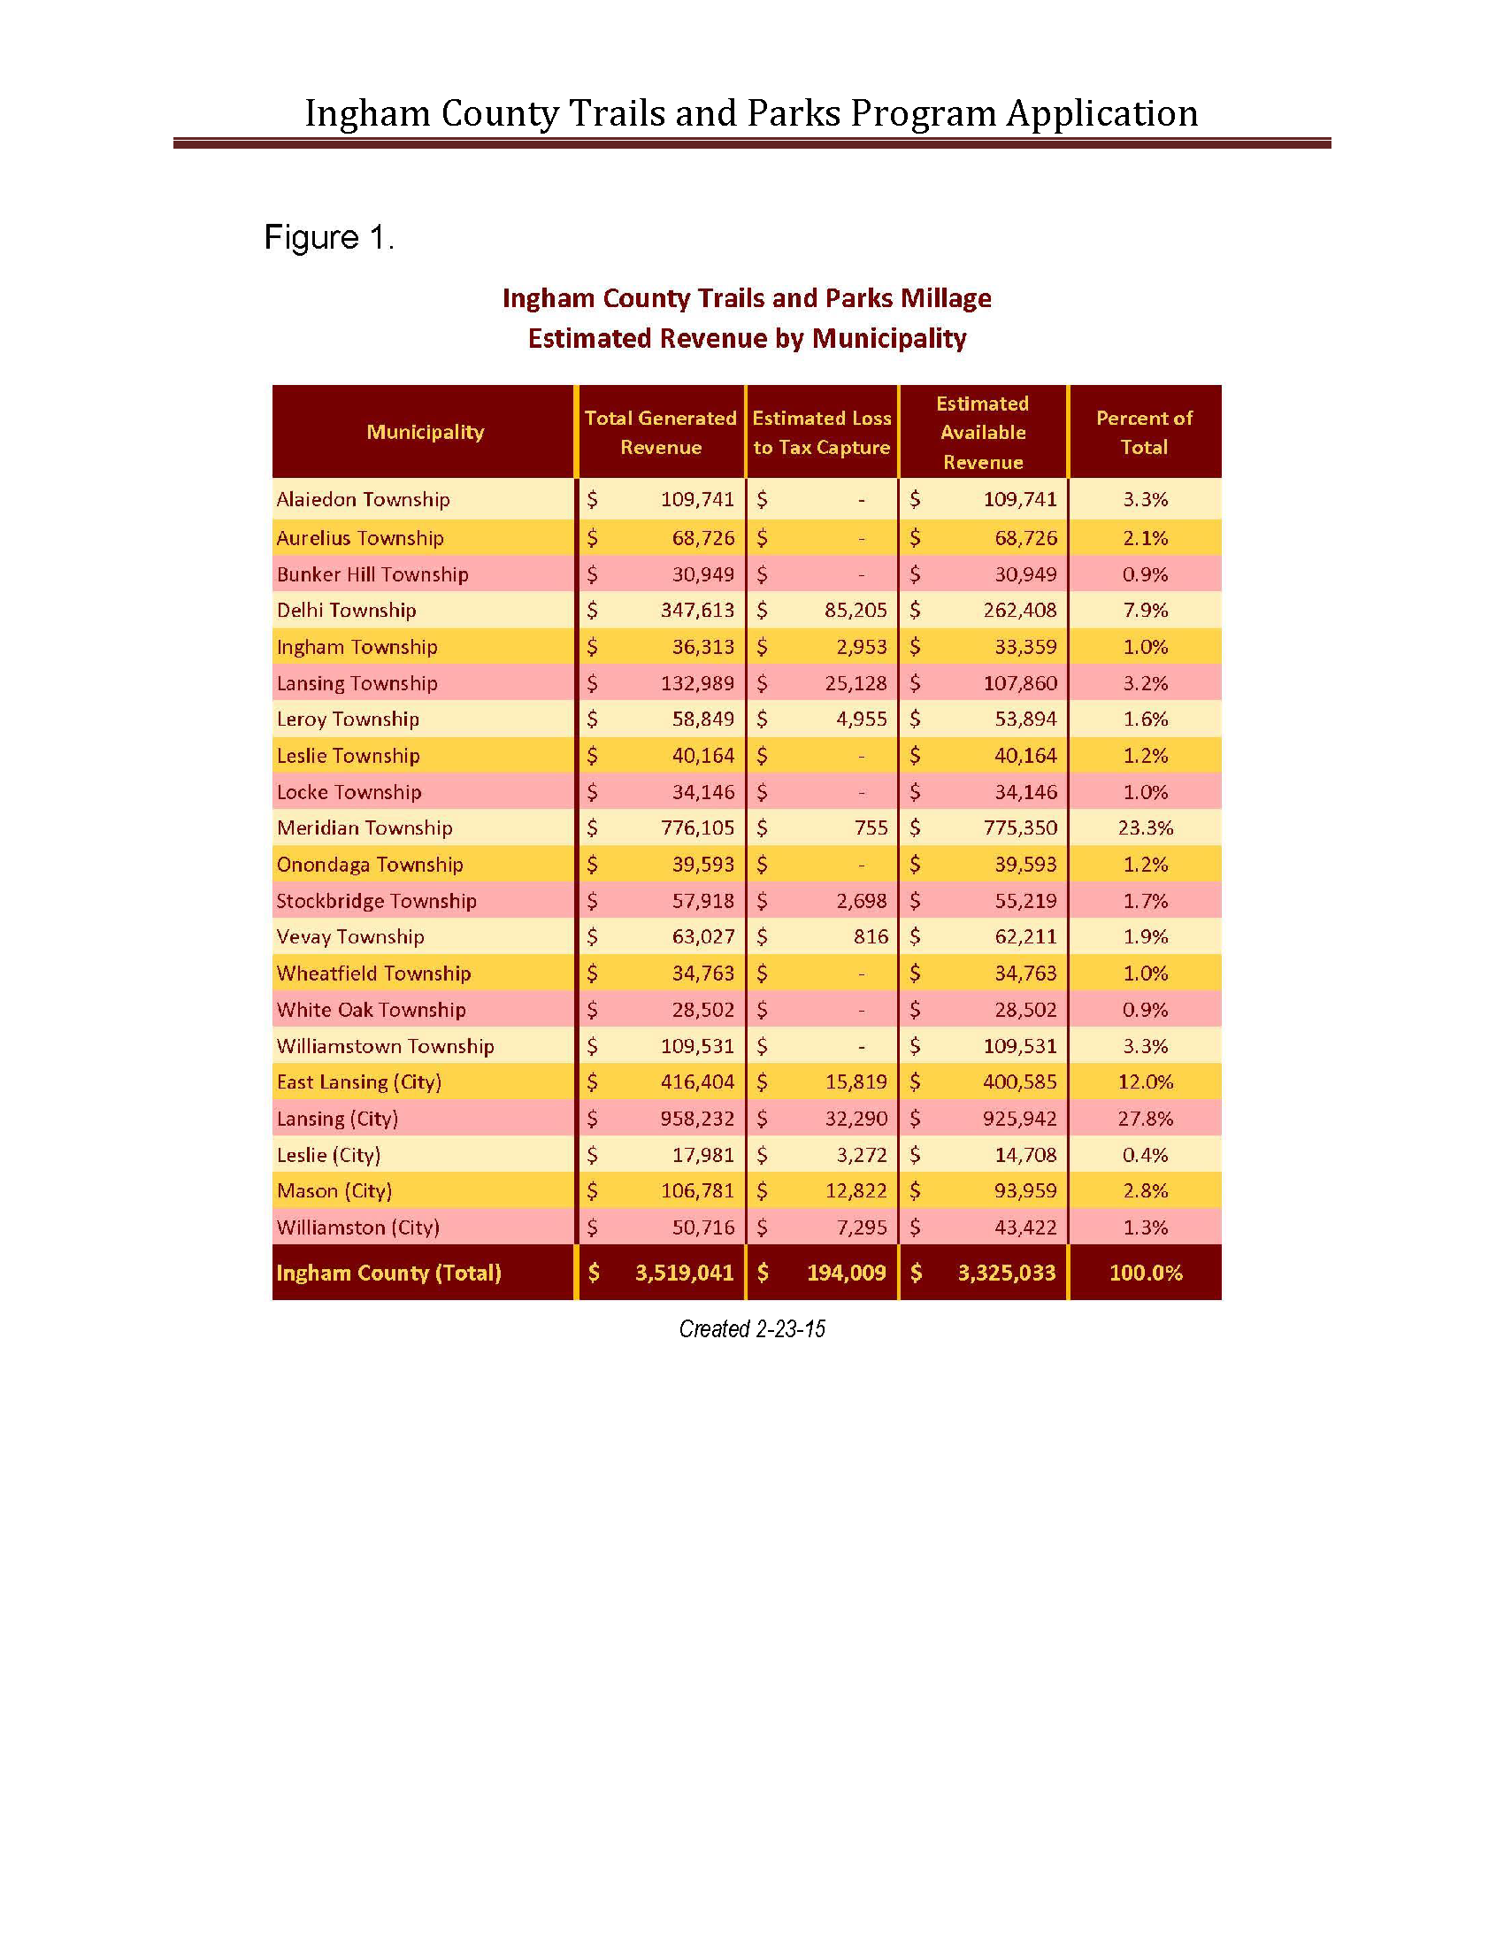

Attachment B
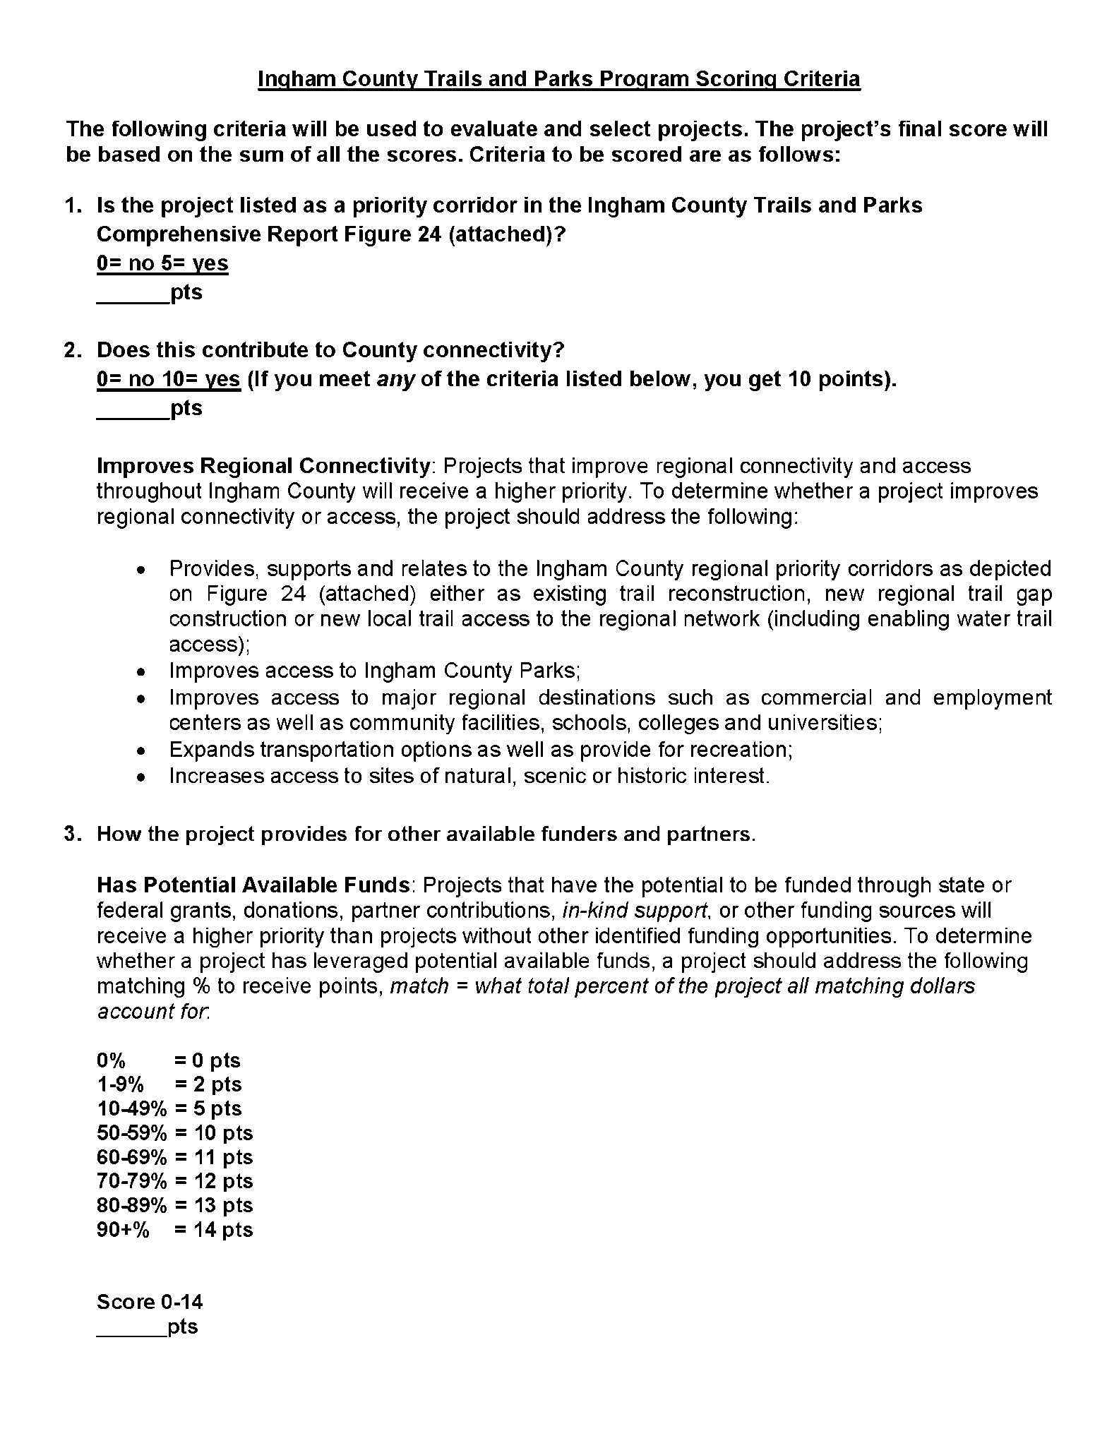

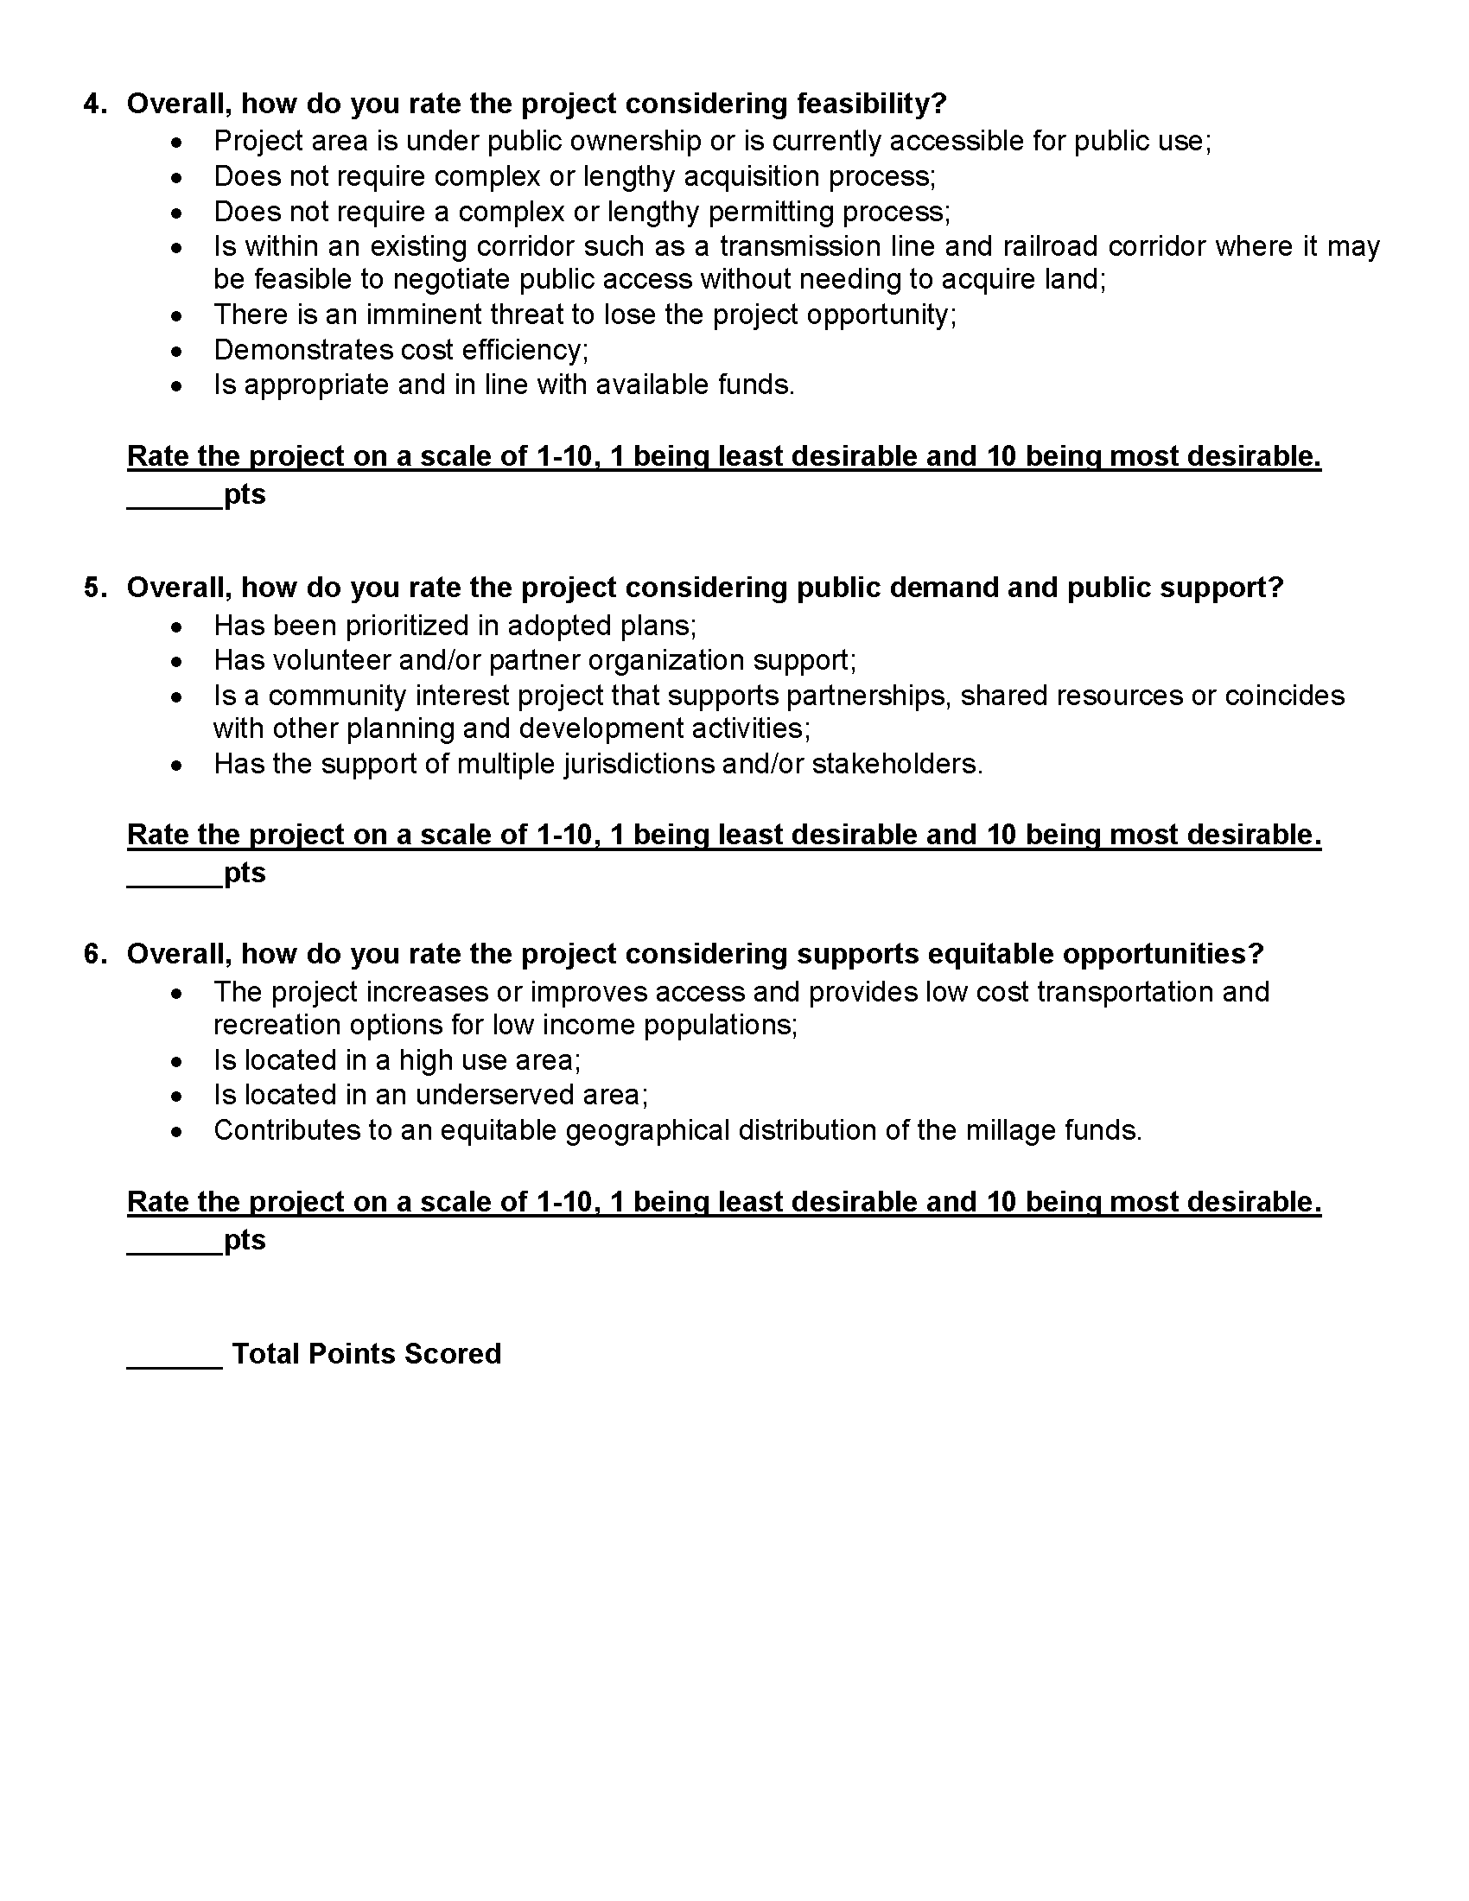
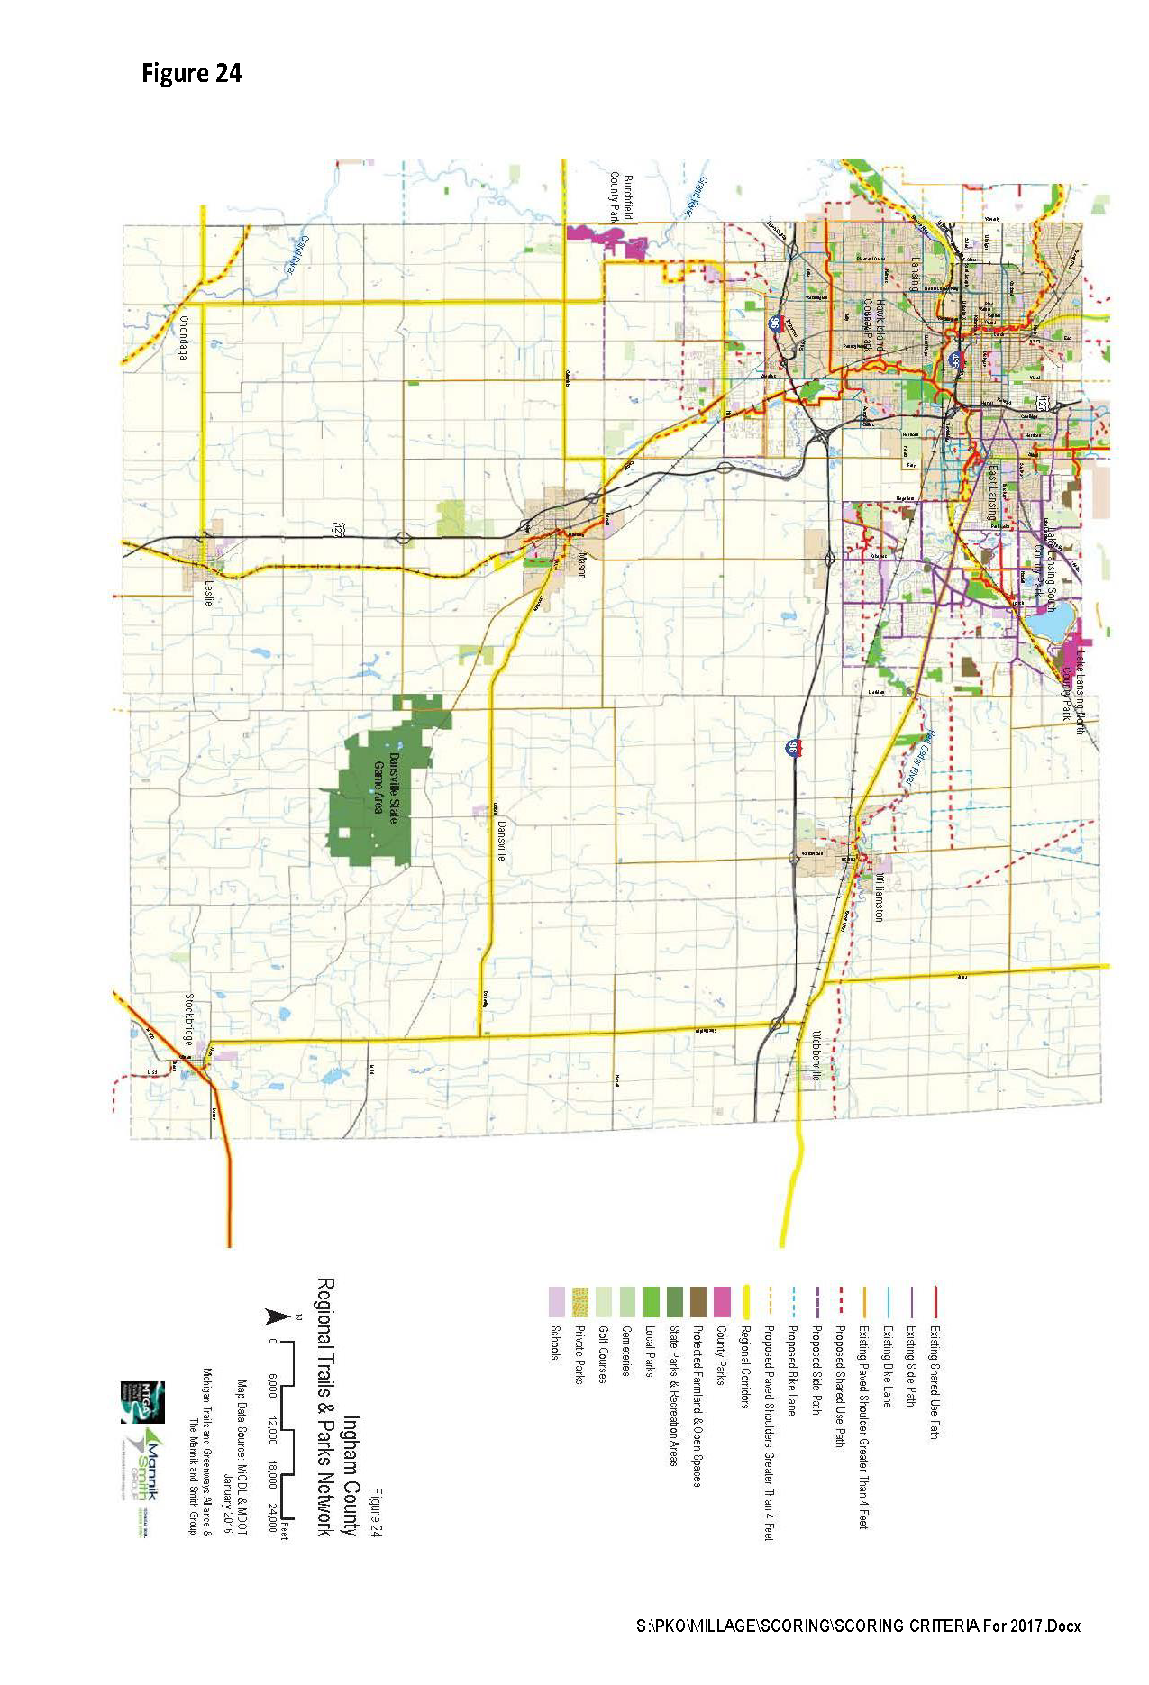

Attachment C
