ADOPTED - SEPTEMBER 25, 2018
AGENDA ITEM NO. 13
Introduced by the County Services Committee of the:

INGHAM COUNTY BOARD OF COMMISSIONERS

RESOLUTION TO AMEND THE REORGANIZATION PROCEDURE POLICY

RESOLUTION # 18 - 368

WHEREAS, the structure of County government has a profound effect on the delivery and funding of services; and

WHEREAS, the Reorganization Procedure Policy is intended to provide the Board of Commissioners with careful analysis of workforce demands, financial resources and the needs of County residents; and

WHEREAS, implementation nuances encountered since adoption of the Reorganization Procedure Policy in 2014 led to conversations about clarity and intent.

THEREFORE BE IT RESOLVED, the Ingham Board of Commissioners approves amendments to the Reorganization Procedure Policy as follows, effective upon ratification of this resolution.

- Add definitions for “job description amendment,” “reclassification” and “reorganization” to distinguish each term and to provide guidance on selection of the proper procedure to address changes in each category.

- Establish procedures for job description amendments, reclassification requests, new positions and reorganizations.

- Add a provision in the reorganization procedure to compel review of job descriptions for all positions impacted by the proposed reorganization.

- Allow an extension of up to six business days for a Union response to reclassification proposals at Step 4 of the Reorganization Procedure.

BE IT FURTHER RESOLVED that this policy shall be applicable to all departments of Ingham County.

COUNTY SERVICES: Yeas: Nolan, Sebolt, Grebner, Celentino, Hope, Maiville
Nays: None Absent: Naeyaert Approved 09/18/2018

General Administrative, Management and Operations  Policy No. 220 |  | Reorganization Procedure

Approved: | November 12, 2014
Resolution No. | 14-462

A. Purpose and Applicability

Because the structure of the County has a profound effect on the delivery and funding of services, the Board of Commissioners adopts the following policy with respect to reorganization. The provisions of this policy are intended to provide the Board of Commissioners with careful analysis based on workforce demands, financial resources and the needs of County residents.

Reorganization is the restructuring of departmental operations. The most common reasons to reorganize are job vacancies, the addition or loss of grant funds, the addition or termination of a program or service, the merger of two workgroups or a significant change in technology. This policy is not to be used to eliminate specific personnel or substitute for disciplinary policies.

While department reorganization may result in the classification/creation or changes to an existing position(s); this process is not used as a request for individual reclassification. Individual reclassification requests occur when an employee’s current position’s established classification is changed due to significant and permanent changes in the assigned responsibilities as the result of long-term adjustments to work assignments.

Since reorganizations impact classifications and employees, Department Heads are required to work in conjunction with Human Resources to ensure personnel issues are implemented according to the parameters of labor contracts. Department Heads will act as the principal advocate for the reorganization throughout subsequent discussions and review. Department Heads must consider the concerns of employees, unions, other departments, vendors, citizens and any related stakeholders while developing reorganization proposals.

History: 2014, Resolution 14-462, Effective November 13, 2014; -- Amended 2015, Resolution 15-52, Effective February 25, 2015

B. Definitions
Terms and phrases used throughout this policy are defined as follows.

- Job Description Amendment means a change in the essential functions, education or experience requirements of a position.

- Reclassification refers to a modification in duties of a single position that results in a classification or compensation change.

- Reorganization means a change in status of two or more positions, creating new positions, changing the duties and responsibilities of multiple positions or eliminating positions.

C. Procedure

- Job Description Amendment

Department Heads shall work in conjunction with the Human Resources Department to modify a job description. The Human Resources Department will determine if proposed changes warrant reclassification of the position (pay grade change). If proposed amendments do result in changes to the position pay grade, then the department head must follow procedures set forth for reclassification requests, below.

Once complete, the proposed job description shall be forwarded to the appropriate labor union representative for review. The union will have six business days to review and offer comments on the proposed job description. If the union is in agreement with the suggested changes, then the Human Resources Department will notify the Department Head. If not, then a meeting will be scheduled between the union, Department Head and Human Resources Department to discuss the proposed job description. After the meeting the Department Head may move forward with the proposal.

If proposed amendments do not result in changes to the position pay grade, then the Department Head may post the position.

- Reclassification

Reclassification proposals are considered as part of the collective bargaining process when Union officials call for reclassification requests from their respective members. Non-bargaining unit employees may request reclassification once each year upon expiration of the Managerial and Confidential Employee Personnel Manual.

Employees who seek position reclassification shall request the necessary application forms from either their Union or the Human Resources Department. Completed reclassification forms shall be submitted to the designated Union officials or the Human Resources Department by the closing deadline. The Human Resources Department shall schedule a meeting with the employee applicant, department supervisor, Department Head and appropriate union representative to review each reclassification request. Upon evaluation of each reclassification request, the Human Resources Department and union representatives shall meet to discuss their findings. If agreement is reached on the outcome of a requested reclassification, the Human Resources Director shall draft a resolution for consideration by the Board of Commissioners once the appropriate collective bargaining agreement has been settled. If no agreement is reached, then the reclassification request shall be referred to the negotiation table for discussion as part of the collective bargaining process.

The Human Resources Department shall notify employees about reclassification determinations upon approval or denial by the Board of Commissioners.

- New Positions

Department Heads may propose new positions through the annual budget process or by way of a budget amendment. Budget amendments are processed through standing liaison committees and the Finance Committee. Department Heads shall propose a funding source for each new position proposed. No department may create a position, grant funded or otherwise, unless the Board of Commissioners has approved the position and appropriated the necessary funds.

- Reorganization

Department Heads must follow the procedure as detailed in the Reorganization Procedure Form provided as an addendum to this policy. On this form, the order of tasks is definite but the corresponding timeline may fluctuate depending on various conditions: the number of positions involved in the reorganization, a change in the Board of Commissioner meeting schedule, a time-sensitive funding request, etc.

The Reorganization Procedure Form is necessary whenever a Department Head proposes a new position(s), a new classification(s) or a change to existing positions and classifications as a result of department reorganization. Examples of such changes include but are not limited to changes in job title, job duties, salary grade, union affiliation or status. The Human Resources Department will review the job description of all positions impacted by a proposed reorganization and recommend changes as necessary. Should any such change be necessary outside the definition of reorganization, the Department Head must still work cooperatively with Human Resources and the Union(s) to assure compliance with labor contracts.

History: 2014, Resolution 14-462, Effective November 13, 2014; -- Amended 2015, Resolution 15-52, Effective February 25, 2015

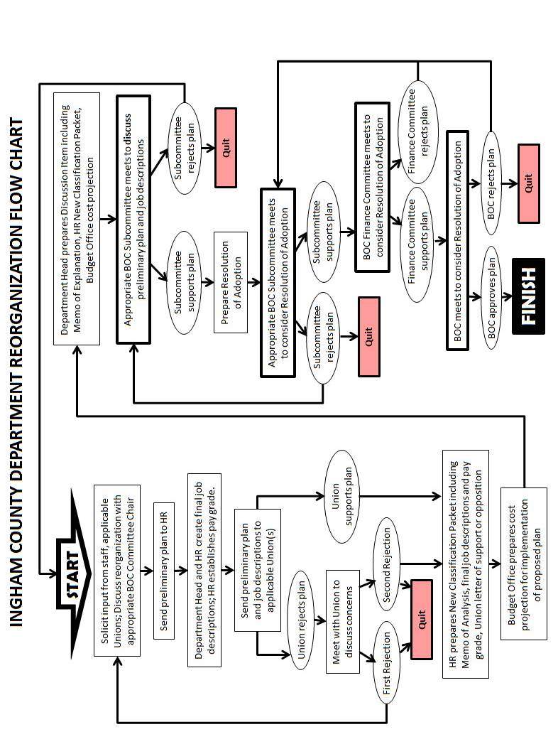

Reorganization Procedure
Step | Task Description | Completed no later than
1 | Department Head solicits input from staff, Union and discusses reorganization with the corresponding BOC Committee Chair. Department Head sends HR a preliminary plan including a list of tasks for each position and an updated organizational chart. | Start Date
2 | HR creates draft job descriptions for Department Head to review. | 7 business days to create JD
3 | Department Head and HR work together to create final job descriptions. HR evaluates the final job descriptions for union placement and salary grade. | 7 business days to evaluate
4 | HR sends notification to the appropriate Union representatives. | 6 business days for Union Response. An extension of up to an additional six (6) business days will be provided upon written request.
4 | A. If the Union supports the classification, the process moves to step 5.  B. If the Union opposes the classification; the Department Head and HR schedule a meeting with the Union to discuss the concerns. Based on the meeting, the Department Head can proceed without Union support OR return to Step 1 to alter the classification.
5 | HR sends a New Classification Packet to the Department Head.  The packet includes: | 7 business days to send packet
 | A. HR's Memo of Analysis | 7 business days to send packet
 | B. Final job descriptions with Union designation and salary | 7 business days to send packet
 | C. Union response of support or opposition | 7 business days to send packet
6 | Department Head secures a Personnel Cost Projection from the Budget Office. | 2 business days to obtain cost
7 | Department Head submits a Discussion Packet to the Resolutions group by the 5pm agenda deadline. The packet includes the following information for all changes which result in an increased expenditure or a new job classification. | 1 business day (agenda deadline)
 | A. Memo of Explanation prepared by Department Head including updated organization chart. | 1 business day (agenda deadline)
 | B. A copy of HR's New Classification packet | 1 business day (agenda deadline)
 | C. A copy of Budget's Personnel Cost Projection | 1 business day (agenda deadline)
8 | The Department Head attends sub-committee meetings and HR attends as needed. | 5 - 9 business days for meetings
9 | Based on the subcommittee discussions, Department Head either returns to step 1 to make changes or prepares a Resolution Packet for the next round of subcommittee meetings by 5p.m. deadline to include: | 2 - 10 business days for resolution packet
 | A. Resolution written by Department Head | 2 - 10 business days for resolution packet
 | B. Memo of Explanation written by Department Head including updated organization chart | 2 - 10 business days for resolution packet
 | C. A copy of HR's New Classification packet | 2 - 10 business days for resolution packet
 | D. A copy of Budget's Personnel Cost Projection | 2 - 10 business days for resolution packet
10 | The Department Head attends sub-committee meetings and HR attends as needed. | 5-9 business days
11 | After passing through the subcommittees, the resolution proceeds to the Full Board of Commissioner meeting for final approval. | 5 business days after final subcommittee
 | ***Timeline is approximate as holidays and other scheduling anomalies may impact final date.
 | Department Heads should anticipate 12 weeks for completion

