ADOPTED – NOVEMBER 13, 2018
AGENDA ITEM NO. 7

Introduced by Commissioners Crenshaw, Morgan, Banas, Celentino, Grebner, Hope, Nolan, Sebolt and Tennis of the:
INGHAM COUNTY BOARD OF COMMISSIONERS
RESOLUTION TO APPOINT DERRELL SLAUGHTER
AS COUNTY COMMISSIONER FOR DISTRICT 3

RESOLUTION # 18 – 454

WHEREAS, County Commissioner Sarah Anthony resigned as Ingham County Commissioner representing District 3 effective November 7, 2018; and

WHEREAS, pursuant to State statute, this Board of Commissioners is required to fill vacancies by appointment within thirty (30) days (MCL 46.412).

THEREFORE BE IT RESOLVED, that Derrell Slaughter is hereby appointed as County Commissioner representing District 3, to be effective immediately upon taking the required oath of office.

ADOPTED – NOVEMBER 13, 2018
AGENDA ITEM NO. 8

Introduced by Commissioners Crenshaw, Morgan, Banas, Celentino, Grebner, Hope, Nolan, Sebolt and Tennis of the:
INGHAM COUNTY BOARD OF COMMISSIONERS
RESOLUTION TO APPOINT NATHAN TRIPLETT
AS COUNTY COMMISSIONER FOR DISTRICT 9

RESOLUTION # 18 – 455

WHEREAS, County Commissioner Carol Koenig resigned as Ingham County Commissioner representing District 9 effective October 11, 2018; and

WHEREAS, pursuant to State statute, this Board of Commissioners is required to fill vacancies by appointment within thirty (30) days (MCL 46.412).

THEREFORE BE IT RESOLVED, that Nathan Triplett is hereby appointed as County Commissioner representing District 9, to be effective immediately upon taking the required oath of office.

ADOPTED – NOVEMBER 13, 2018
AGENDA ITEM NO. 9

Introduced by the County Services Committee of the:

INGHAM COUNTY BOARD OF COMMISSIONERS

RESOLUTION TO APPROVE THE SPECIAL AND ROUTINE PERMITS
FOR THE INGHAM COUNTY ROAD DEPARTMENT

RESOLUTION # 18 – 456

WHEREAS, as of July 23, 2013, the Ingham County Department of Transportation and Roads became the Ingham County Road Department per Resolution #13-289; and
WHEREAS, the Ingham County Road Commission periodically approved Special and Routine permits as part of the their roles and responsibilities; and
WHEREAS, this is now the responsibility of the Board of Commissioners to approve these permits as necessary.

THEREFORE BE IT RESOLVED, that the Ingham County Board of Commissioners approves the attached list of Special and Routine Permits dated October 23, 2018 as submitted.

COUNTY SERVICES: Yeas: Nolan, Grebner, Celentino, Sebolt, Naeyaert, Maiville
Nays: None Absent: Hope Approved 11/08/2018

INGHAM COUNTY ROAD DEPARTMENT

DATE: October 23, 2018
LIST OF CURRENT PERMITS ISSUED

R/W PERMIT# | R/W APPLICANT /CONTRACTOR | R/W WORK | R/W LOCATION | R/W CITY/TWP. | R/W SECTION
2018-660 | COMCAST | CABLE / UG | TIMES SQUARE & MARSH RD | MERIDIAN | 15
2018-661 | COMCAST | CABLE / OH | EYDE PKWY & HAGADORN RD | MERIDIAN | 20
2018-671 | PM ENVIRONMENTAL | MISCELLANEOUS | OKEMOS RD & JOLLY RD | MERIDIAN | 4
2018-672 | NICK VLAHAKIS | LAND DIVISION | DEXTER TR & WILLIAMSTON RD | INGHAM | 27
2018-674 | RUSSELL BLOOM | LAND DIVISION | MORRICE RD & BELL OAK RD | LOCKE | 24
2018-675 | FRONTIER | CABLE / UG | BROGAN RD & COOPER RD | WHITE OAK | 24
2018-676 | MERIDIAN TOWNSHIP | WATERMAIN | BIBER ST & PORTER AVE | MERIDIAN | 6
2018-680 | KEPS | CABLE/ OH | LAKE LANSING & WOOD ST | LANSING | 3
2018-683 | CONSUMERS ENERGY | GAS | ONONDAGA RD& STIMSON RD | ONONDAGA | 9
2018-686 | MICHAEL LAWTON | CURB CUT | KIMBERLY DR & COVINGTON CT | LANSING | 11
2018-688 | COMCAST | CABLE / UG | NIGHTINGALE DR & JAXX DR | DELHI | 20
2018-690 | JOHN DERENGOSKI | SANITARY | LAKE LANSING & OKEMOS RD | MERIDIAN | 9
2018-691 | LAUX CONSTRUCTION | SANITARY | LAKE LANSING & WOOD ST | LANSING | 3
2018-692 | MARTIN LUTHER HIGH SCHOOL | MISCELLANEOUS | GRAND RIVER & FAIRVIEW AVE | LANSING | 11
2018-693 | COMCAST | CABLE / UG | JAMES PHILLIPS DR & JOLLY RD | ALAIEDON | 5
2018-694 | COMCAST | CABLE / UG | OKEMOS RD & KENT ST | MERIDIAN | 21
2018-695 | CONSUMERS ENERGY | GAS | SANDHILL RD & HULETT RD | ALAIEDON | 8
2018-696 | CONSUMERS ENERGY | GAS | HOLT RD & OKEMOS RD | ALAIEDON | 16
2018-697 | CONSUMERS ENERGY | ELECTRIC / OH | NEWTON RD & SAGINAW ST | MERIDIAN | 24
2018-698 | CONSUMERS ENERGY | ELECTRIC / OH | IVES RD & COLUMBIA RD | VEVAY | 10
2018-699 | FRONTIER | CABLE / UG | SEARLS RD & FROST RD | LEROY | 26
2018-700 | CONSUMERS ENERGY | ELECTRIC / OH | VAN ATTA RD & PIPER RD | MERIDIAN | 13
2018-701 | CONSUMERS ENERGY | GAS | PENOBSCOT DR & TAHOE CIR | MERIDIAN | 27
2018-702 | CONSUMERS ENERGY | ELECTRIC / OH | ONONDAGA RD & STIMSON RD | ONONDAGA | 16
2018-704 | LESLIE TOWNSHIP | SPECIAL EVENT | VARIOUS | LESLIE
2018-705 | WESTSIDE WATER | WATERMAIN | MAIN ST & WARREN AVE | LANSING | 18

MANAGING DIRECTOR: ______________________________

ADOPTED – NOVEMBER 13, 2018
AGENDA ITEM NO. 10

Introduced by the County Services Committee of the:

INGHAM COUNTY BOARD OF COMMISSIONERS

RESOLUTION HONORING JILL RHODE ON THE
EVENT OF HER RETIREMENT

RESOLUTION # 18 – 457

WHEREAS, Jill Rhode began her career with the Ingham County Financial Services Department on August 13, 2008; and

WHEREAS, Jill joined Ingham County after distinguished service to the Cities of Lansing and Midland; and

WHEREAS, during her years of service to Ingham County, she has provided outstanding leadership and her ability to work well with elected officials, department heads and employees has played a vital role in the effective, efficient operation of Ingham County government, earning her the respect of county officials, colleagues state-wide and all those around her; and

WHEREAS, Jill has helped to guide the County through several very challenging budget cycles by sharing her understanding of public finance and her ability to maintain compliance with generally accepted accounting principles, Government Accounting Standards Board rules and many statutory requirements; and

WHEREAS, through Jill’s leadership, Ingham County has been awarded the Government Finance Officers Association Certificate of Achievement for Excellence in Financial Reporting in each year of Jill’s employment with Ingham County; and

WHEREAS, Jill has willingly lent her talents to other government endeavors such as the State Child Care Fund and the East Lansing Financial Health Team for the sole purpose of advancing sound fiscal management; and

WHEREAS, Jill consistently applied ethical standards in fulfillment of her assigned responsibilities which serves as an example for all Ingham County employees; and

WHEREAS, after a stellar 35-year career and 10 years of dedicated service to Ingham County, Jill has elected to retire from her position as Financial Services Director.

THEREFORE BE IT RESOLVED, that the Ingham County Board of Commissioners hereby honors Jill Rhode for her dedication and commitment to the County of Ingham and extends its sincere appreciation for the many contributions she has made to the citizens of Ingham.

BE IT FURTHER RESOLVED that the Board of Commissioners extends its best wishes to Jill and hopes for continued success in all of her future endeavors.

COUNTY SERVICES: Yeas: Nolan, Grebner, Celentino, Sebolt, Naeyaert, Maiville
Nays: None Absent: Hope Approved 11/08/2018

ADOPTED – NOVEMBER 13, 2018
AGENDA ITEM NO. 11

Introduced by the County Services and Finance Committees of the:

INGHAM COUNTY BOARD OF COMMISSIONERS

RESOLUTION APPOINTING ROBERT L. FRANCIS AS COUNTY GRANT ADMINISTRATOR
FOR THE INGHAM COUNTY REMONUMENTATION PROJECT

RESOLUTION # 18 – 458

WHEREAS, as required by Act 345, P.A. 1990, a condition of receiving annual grant funds to implement the County Monumentation and Remonumentation Plan is that the County appoint a County Grant Administrator; and

WHEREAS, at their April 12, 2016 meeting, by Resolution #16-131, the Ingham County Board of Commissioners appointed Douglas A. Stover for the related services of County Grant Administrator as required by Act 345, P.A. 1990; and

WHEREAS, on July 31, 2018 Douglas A. Stover retired from his position as Equalization Director of Ingham County.

THEREFORE BE IT RESOLVED, upon the respectful recommendation of the Ingham County Remonumentation Committee, the Ingham County Board of Commissioners appoint Robert L. Francis, Equalization Deputy Director, for the related services of County Grant Administrator as required by Act 345, P.A. 1990.

COUNTY SERVICES: Yeas: Nolan, Grebner, Celentino, Sebolt, Naeyaert, Maiville
Nays: None Absent: Hope Approved 11/08/2018

FINANCE: Yeas: Grebner, Crenshaw, Tennis, Morgan, Schafer
Nays: None Absent: Anthony Approved 11/07/2018

ADOPTED – NOVEMBER 13, 2018
AGENDA ITEM NO. 12

Introduced by County Services and Finance Committees of the:

INGHAM COUNTY BOARD OF COMMISSIONERS

RESOLUTION TO APPROVE RENEWAL OF SUPPORT FROM CORE TECHNOLOGY

RESOLUTION # 18 – 459

WHEREAS, Core Technology is the company that provides support for the MultiBridge and Talon software used by our Sheriff’s Office and patrol cars; and

WHEREAS, ongoing support is critical to ensuring that we have no disruption of service to our law enforcement personnel; and

WHEREAS, the current contract expires on 11/30/2018; and

WHEREAS, the funds are available in the current budgeted year.

THEREFORE BE IT RESOLVED, that the Board of Commissioners do hereby authorize the renewal of support from Core Technology in the amount not to exceed $5,307.00.

BE IT FURTHER RESOLVED, that the total cost will be paid out of the County’s Innovation and Technology Department’s LOFT Fund #636-25820-932050.

BE IT FURTHER RESOLVED, that the Controller/Adminsitrator is authorized to make any necessary budget adjustments.

BE IT FURTHER RESOLVED, that the Chairperson of the Ingham County Board of Commissioners is authorized to sign any contract documents consistent with this resolution and approved as to form by the County Attorney.

COUNTY SERVICES: Yeas: Nolan, Grebner, Celentino, Sebolt, Naeyaert, Maiville
Nays: None Absent: Hope Approved 11/08/2018

FINANCE: Yeas: Grebner, Crenshaw, Tennis, Morgan, Schafer
Nays: None Absent: Anthony Approved 11/07/2018

ADOPTED – NOVEMBER 13, 2018
AGENDA ITEM NO. 13

Introduced by the County Services and Finance Committees of the:

INGHAM COUNTY BOARD OF COMMISSIONERS

RESOLUTION TO APPROVE THE PURCHASE OF CYBERARK ENDPOINT
PRIVILEGE MANAGER FROM CDW-G

RESOLUTION # 18 – 460

WHEREAS, Ingham County has increased security on end-point computers; and

WHEREAS, the increased security has caused problems with the function of several software packages utilized by the County; and

WHEREAS, a search was initiated to identify solutions to the problems caused by tightened security; and

WHEREAS, several prospective solutions were considered with Endpoint Privilege Manager by CyberArk being determined to be the most appropriate solution; and

WHEREAS, this expenditure has been planned for and budgeted and will alleviate the inefficiencies caused by elevated security practices.

THEREFORE BE IT RESOLVED, that the Board of Commissioners do hereby authorize the purchase of CyberArk Endpoint Privilege Manager from CDW-G in the amount not to exceed $40,417.02.

BE IT FURTHER RESOLVED, the total cost will be paid from the Innovation and Technology’s Network Fund (#636-25810-932032).

BE IT FURTHER RESOLVED, that the Controller/Administrator is authorized to make any necessary budget adjustments.

BE IT FURTHER RESOLVED, that the Chairperson of the Ingham County Board of Commissioners is authorized to sign any contract documents consistent with this resolution and approved as to form by the County Attorney.

COUNTY SERVICES: Yeas: Nolan, Grebner, Celentino, Sebolt, Naeyaert, Maiville
Nays: None Absent: Hope Approved 11/08/2018

FINANCE: Yeas: Grebner, Crenshaw, Tennis, Morgan, Schafer
Nays: None Absent: Anthony Approved 11/07/2018

ADOPTED – NOVEMBER 13, 2018
AGENDA ITEM NO. 14

Introduced by County Services and Finance Committees of the:

INGHAM COUNTY BOARD OF COMMISSIONERS

RESOLUTION TO RENEW THE CONTRACT FOR CELL PHONE SERVICES FROM VERIZON

RESOLUTION # 18 – 461

WHEREAS, the State of Michigan has recently renegotiated its contract with Verizon under MiDeal; and

WHEREAS, the new plan continues the best features of the old plan while adding in new benefits like unlimited minutes and first responder priority access; and

WHEREAS, this new plan recognizes a savings of an estimated $29,000.00 over current contract rates; and

WHEREAS, Innovation & Technology is recommending we switch to the new MiDeal contract to realize these benefits and savings.

THEREFORE BE IT RESOLVED, that the Board of Commissioners do hereby authorize the continuation of the cell phone service from Verizon at the new rates for a period of 5 years.

BE IT FURTHER RESOLVED, that the total cost will be spread to various departments based on usage as per current practice.

BE IT FURTHER RESOLVED, that the Controller/Administrator is authorized to make any necessary budget adjustments.

BE IT FURTHER RESOLVED, that the Chairperson of the Ingham County Board of Commissioners is authorized to sign any contract documents consistent with this resolution and approved as to form by the County Attorney.

COUNTY SERVICES: Yeas: Nolan, Grebner, Celentino, Sebolt, Naeyaert, Maiville
Nays: None Absent: Hope Approved 11/08/2018

FINANCE: Yeas: Grebner, Crenshaw, Tennis, Morgan, Schafer
Nays: None Absent: Anthony Approved 11/07/2018

ADOPTED – NOVEMBER 13, 2018
AGENDA ITEM NO. 15

Introduced by the County Services and Finance Committees of the:

INGHAM COUNTY BOARD OF COMMISSIONERS

RESOLUTION TO AUTHORIZE AN AGREEMENT WITH LANSING TILE & MOSAIC, INC. TO REPLACE THE FLOORING IN THE WOMEN’S HEALTH TWO LOBBY AREAS AND HALLWAY

RESOLUTION# 18 – 462

WHEREAS, the flooring in the lobby areas and hallway of the Women’s Health is old and past its useful life; and

WHEREAS, over the years carpet is worn and in need of replacement; and

WHEREAS, Lansing Tile & Mosaic, Inc., an authorized installer, will remove and dispose of existing flooring, prep, furnish and install vinyl flooring and cove base; and

WHEREAS, Lansing Tile and Mosaic, Inc. is on the state contract therefore, three quotes are not required; and

WHEREAS, Lansing Tile and Mosaic, Inc. submitted a bid amount of $9,870.00; and

WHEREAS, funds for said services are located within the approved CIP Line Item #245-60199-931000-5FC09 for the Women’s Health flooring replacement.

THEREFORE BE IT RESOLVED, the Ingham County Board of Commissioners hereby authorizes an agreement with Lansing Tile & Mosaic, Inc., an authorized installer, 2210 Apollo Drive, Lansing, Michigan, 48906, to install new tile flooring in the Women’s Health lobby areas and hallway, under the State of Michigan contract, for the cost of $9,870.00.

BE IT FURTHER RESOLVED, the Ingham County Board of Commissioners authorizes the Board Chairperson to sign any necessary documents that are consistent with this resolution and approved as to form by the County Attorney.

COUNTY SERVICES: Yeas: Nolan, Grebner, Celentino, Sebolt, Naeyaert, Maiville
Nays: None Absent: Hope Approved 11/08/2018

FINANCE: Yeas: Grebner, Crenshaw, Tennis, Morgan, Schafer
Nays: None Absent: Anthony Approved 11/07/2018

ADOPTED – NOVEMBER 13, 2018
AGENDA ITEM NO. 16

Introduced by the County Services and Finance Committees of the:

INGHAM COUNTY BOARD OF COMMISSIONERS

RESOLUTION AUTHORIZING A PURCHASE ORDER TO VIDCOM SOLUTIONS FOR THE INSTALLATION OF CARD SWIPES ON THE SECOND FLOOR JUDICIAL HALLWAY STAIRWELL AT THE VETERANS MEMORIAL COURTHOUSE (VMC)

RESOLUTION # 18 – 463

WHEREAS, two additional card swipes are needed one in the north stairwell and one in the south stairwell on the second floor judicial hallway to enhance security; and

WHEREAS, it’s the recommendation of the Facilities Department to issue a purchase order to Vidcom Solutions, a registered local vendor who submitted the only bid of $4,979.52; and

WHEREAS, funds for this project are available through the Liability Insurance Fund with 50% of this project to be reimbursed from the Risk Avoidance Program Grant authorized through Michigan Municipal Risk Management Authority.

THEREFORE BE IT RESOLVED, that the Ingham County Board of Commissioners authorizes issuing a purchase order to Vidcom Solutions, 15559 South US-27, Lansing, Michigan 48906, for the installation of two new card swipes to provide access control on the VMC second floor judicial hallway stairwell doors for a total cost of $4,979.52.

BE IT FURTHER RESOLVED, the Ingham County Board of Commissioners authorizes the Board Chairperson to sign any necessary documents that are consistent with this resolution and approved as to form by the County Attorney.

COUNTY SERVICES: Yeas: Nolan, Grebner, Celentino, Sebolt, Naeyaert, Maiville
Nays: None Absent: Hope Approved 11/08/2018

FINANCE: Yeas: Grebner, Crenshaw, Tennis, Morgan, Schafer
Nays: None Absent: Anthony Approved 11/07/2018

ADOPTED – NOVEMBER 13, 2018
AGENDA ITEM NO. 17

Introduced by the County Services and Finance Committees of the:

INGHAM COUNTY BOARD OF COMMISSIONERS

RESOLUTION TO AUTHORIZE AGREEMENTS TO PARTICIPATE IN A SELF-FUNDED PRESCRIPTION DRUG PLAN

RESOLUTION # 18 – 464

WHEREAS, it is a goal of the Ingham County Board of Commissioners Strategic Plan to maintain and enhance County fiscal health to ensure delivery of services to residents; and

WHEREAS, one strategy to attain the Board goal is to identify efficiencies through regional collaboration, consolidation and service sharing that promotes accountability, transparency and controlling costs; and

WHEREAS, participation in a regional self-funded prescription drug plan will likely have a significant positive impact on the cost of the prescription drug benefit offered to county employees; and

WHEREAS, the cost of specialty medications can be substantially lowered through carrier incentive programs offered under the self-funded model, and will result in reduced out-of-pocket costs to employees.

THEREFORE BE IT RESOLVED, that the Board of Commissioners hereby authorizes agreements with MaxorPlus, Ltd. to provide pharmacy benefit management services; Advanced Benefit Solutions for pricing support services; and Rx Reins to provide aggregate stop-loss coverage.

BE IT FURTHER RESOLVED, that the Controller/Administrator is authorized to make any necessary budget adjustments consistent with this resolution.

BE IT FURTHER RESOLVED, that the Board Chairperson is authorized to sign any contract documents consistent with this resolution and approved as to form by the County Attorney.

COUNTY SERVICES: Yeas: Nolan, Grebner, Celentino, Sebolt, Naeyaert, Maiville
Nays: None Absent: Hope Approved 11/08/2018

FINANCE: Yeas: Grebner, Crenshaw, Tennis, Morgan, Schafer
Nays: None Absent: Anthony Approved 11/07/2018

ADOPTED – NOVEMBER 13, 2018
AGENDA ITEM NO. 18

Introduced by the Finance Committee of the:

INGHAM COUNTY BOARD OF COMMISSIONERS

RESOLUTION TO AUTHORIZE ADDITIONAL PAYMENT TO PLANTE MORAN FOR PREPARATION OF THE 2018 COMPREHENSIVE ANNUAL FINANCIAL REPORT

RESOLUTION # 18 – 465

WHEREAS, Ingham County has contracted with Plante Moran to conduct the audit for 2018; and

WHEREAS, staffing changes are occurring in the Financial Services Department including the retirement of the director; and

WHEREAS, the County believes it will not have the resources or expertise to prepare the 12/31/18 comprehensive annual financial report in-house and will need to contract with Plante Moran for preparation of the report; and

WHEREAS, Plante Moran has agreed to perform this service for the 2018 report at a cost of $12,500.

THEREFORE BE IT RESOLVED, that the Ingham County Board of Commissioners authorizes an additional payment of $12,500 to Plante Moran for preparation of the 12/31/18 Comprehensive Annual Financial Report.

BE IT FURTHER RESOLVED, that the Controller/Administrator is authorized to make any necessary budget adjustments to the 2019 budget.

BE IT FURTHER RESOLVED, that the Chairperson of the Ingham County Board of Commissioners is authorized to sign any contract documents consistent with this resolution and approved as to form by the County Attorney.

FINANCE: Yeas: Grebner, Crenshaw, Tennis, Morgan, Schafer
Nays: None Absent: Anthony Approved 11/07/2018

ADOPTED – NOVEMBER 13, 2018
AGENDA ITEM NO. 19

Introduced by the Human Services Committee of the:

INGHAM COUNTY BOARD OF COMMISSIONERS

RESOLUTION MAKING APPOINTMENTS TO THE
COMMUNITY HEALTH CENTER BOARD

RESOLUTION # 18 – 466

WHEREAS, several vacancies exist on the Community Health Center Board; and

WHEREAS, the Human Services Committee interviewed applicants interested in serving on this Board.

THEREFORE BE IT RESOLVED, that the Ingham County Board of Commissioners hereby appoints

Hope Lovell, 8201 Corrison Rd, Grand Ledge, 48837
Amy Fountain, 3200 S. Washington Ave, #514, Lansing, 48910
Daphine Whitfield, 3715 Delta River Dr, Lansing, 48906

to the Community Health Center Board to terms expiring December 31, 2019, and appoints

Katreva Bisbee, 437 Spector Rd, #1022, Lansing, 48917
Robert Stark, 1800 Nemoke Trl, Haslett, 48840
Ramona Borowicz, 901 Riverview Dr, Alma 48801

to the Community Health Center Board to terms expiring December 31, 2020.

BE IT FURTHER RESOLVED, that the residency requirement is hereby waived for Hope Lovell, Katreva Bisbee and Ramona Borowicz.

HUMAN SERVICES: Yeas: Banas, Tennis, Sebolt, Morgan
Nays: None Absent: Nolan, Naeyaert Approved 11/05/2018

ADOPTED – NOVEMBER 13, 2018
AGENDA ITEM NO. 20

Introduced by the Human Services and Finance Committees of the:

INGHAM COUNTY BOARD OF COMMISSIONERS

RESOLUTION AUTHORIZING 2019 AGREEMENTS FOR COMMUNITY AGENCIES

RESOLUTION # 18 – 467

WHEREAS, the 2019 Ingham County Budget has been approved by the Board of Commissioners; and

WHEREAS, under the Community Agency Program a number of agencies have been allocated funds to provide important services that are consistent with the County’s Strategic Planning objective to Ingham County residents; and

WHEREAS, the 2019 budget includes $200,000 allocated for community agencies; and

WHEREAS, the Controller/Administrator has provided recommended funding levels for each agency that were determined using the criteria set forth in Resolution #18-258.

THEREFORE BE IT RESOLVED, the Ingham County Board of Commissioners hereby directs the County Attorney to draft contracts for the period of January 1, 2019 through December 31, 2019, in the amount specified for each community agency listed on the attached, for the services to Ingham County residents previously approved by the Human Services and Finance Committees.

BE IT FURTHER RESOLVED, that the Controller/Administrator is authorized to transfer up to $8,550 from the 2019 contingency fund to the community agency fund.

BE IT FURTHER RESOLVED, that the Board Chairperson is hereby authorized to sign any necessary contract documents on behalf of the County after approval as to form by the County Attorney.

HUMAN SERVICES: Yeas: Banas, Tennis, Sebolt, Morgan
Nays: None Absent: Nolan, Naeyaert Approved 11/05/2018

FINANCE: Yeas: Grebner, Crenshaw, Tennis, Morgan, Schafer
Nays: None Absent: Anthony Approved 11/07/2018

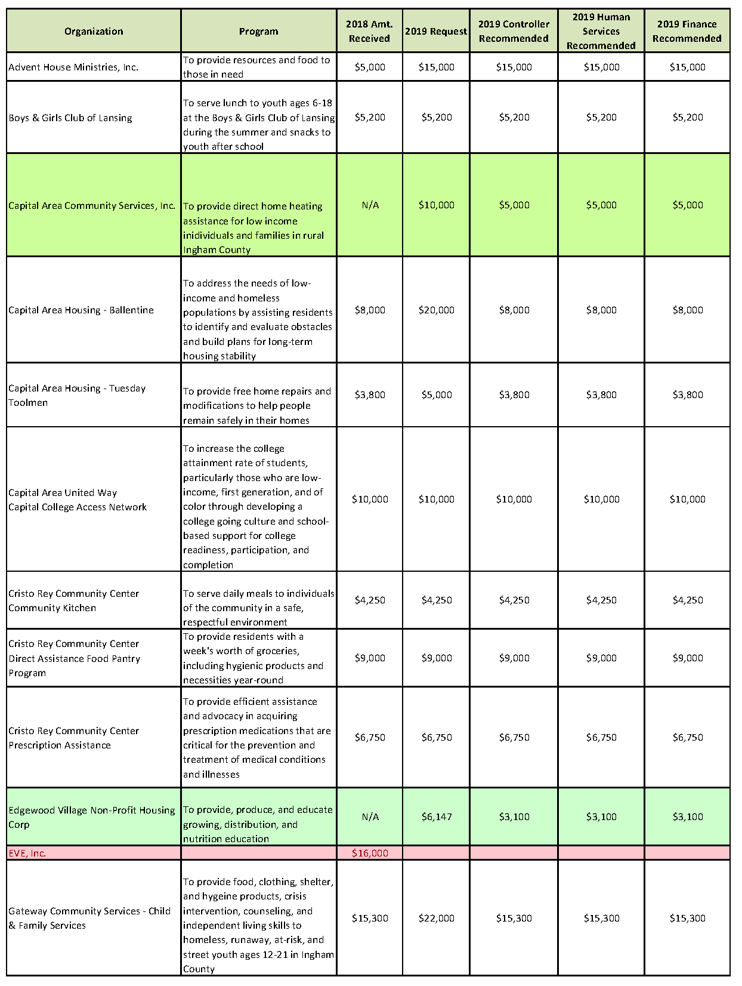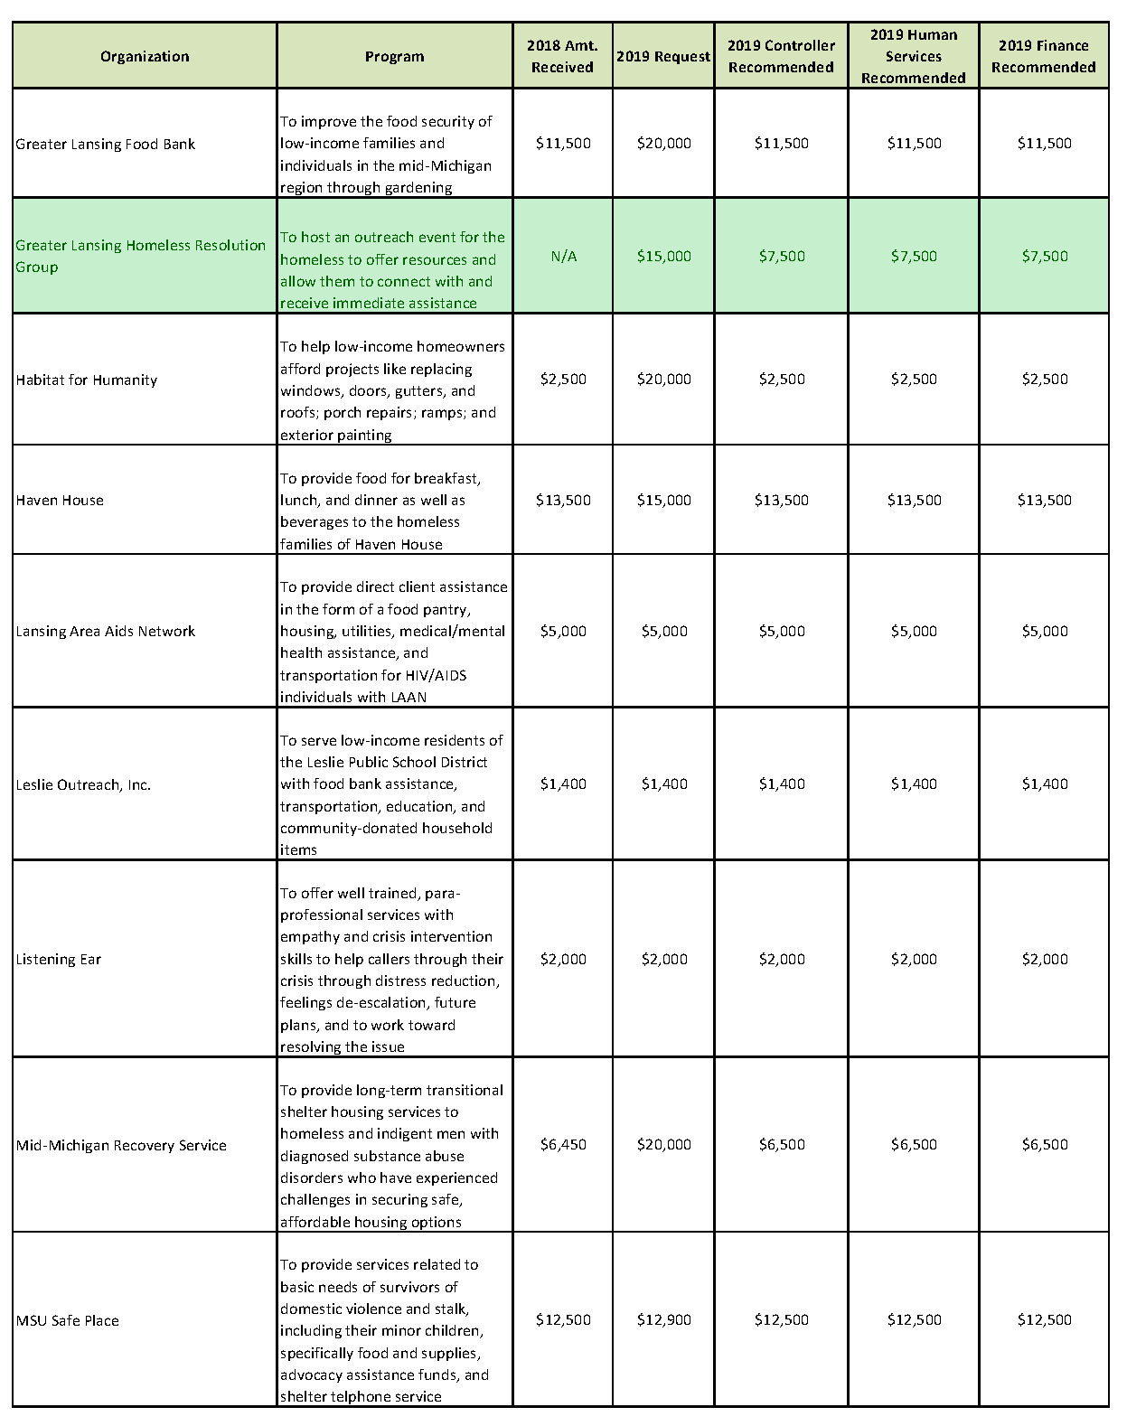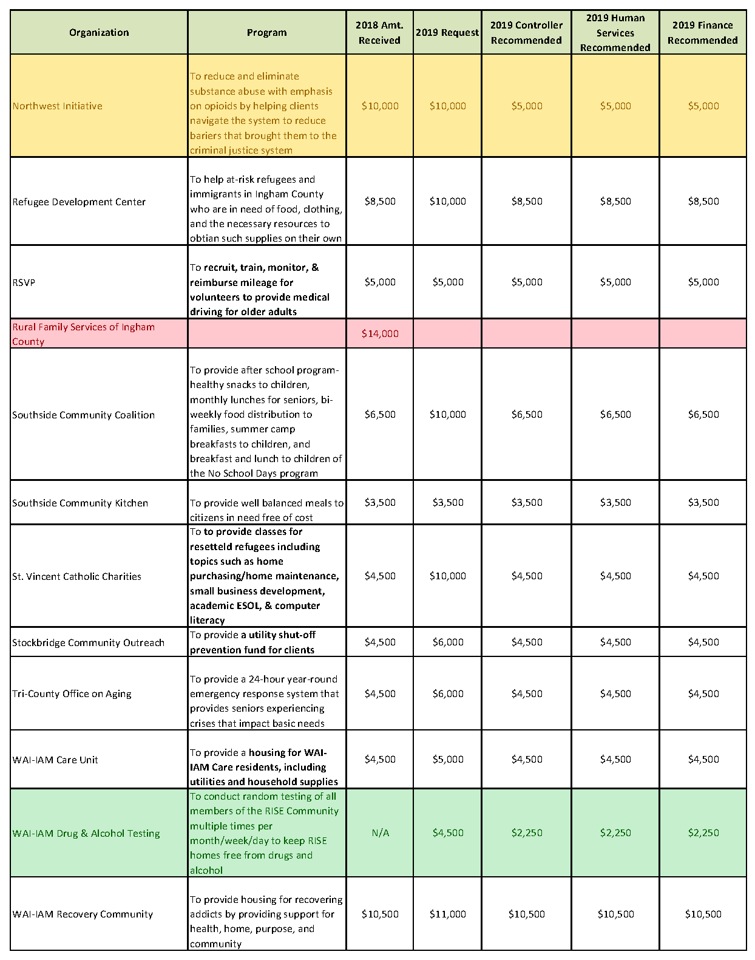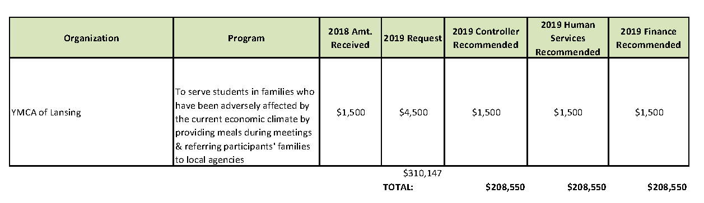

ADOPTED – NOVEMBER 13, 2018
AGENDA ITEM NO. 21

Introduced by the Human Services and Finance Committees of the:

INGHAM COUNTY BOARD OF COMMISSIONERS

RESOLUTION TO AUTHORIZE AN AGREEMENT FOR MICHIGAN STATE UNIVERSITY EXTENSION SERVICES BETWEEN MICHIGAN STATE UNIVERSITY AND INGHAM COUNTY APPROVING THE ANNUAL WORK PLAN FOR 2019
RESOLUTION # 18 – 468

WHEREAS, Michigan State University Extension (MSUE), in collaboration with Ingham County are committed to helping people improve their lives through initiatives in four Extension Educational Program Institutes; and

WHEREAS, MSUE will provide access to educators appointed to the four Institutes and MSU faculty affiliated with each Institute to deliver core programs; and

WHEREAS, MSUE will provide administrative oversight of operating expenses for educators, 4-H coordinators, and other MSUE program staff and faculty who provide programming to counties; and

WHEREAS, the Ingham County Board of Commissioners will provide office space for a County Extension office, including utilities, telephone and access to high speed internet; and

WHEREAS, the Ingham County Board of Commissioners will provide clerical staff for the Extension office that will perform clerical functions, including assisting County residents in accessing MSUE resources by office visit, telephone, email, internet and media; and

WHEREAS, the parties will adhere to all applicable federal, state and local laws, ordinances, rules and regulations prohibiting discrimination.

THEREFORE BE IT RESOLVED, the Board of Commissioners authorizes entering into the attached annual Work Plan that includes a county assessment of $213,463 with MSU Extension for the period of January 1, 2019 through December 31, 2019 for delivery of Extension services and education.

BE IT FURTHER RESOLVED, the Ingham County Board of Commissioners authorizes the Board Chairperson to sign any necessary contract/placement documents that are consistent with this resolution and approved as to form by the County Attorney.

HUMAN SERVICES: Yeas: Banas, Tennis, Sebolt, Morgan
Nays: None Absent: Nolan, Naeyaert Approved 11/05/2018

FINANCE: Yeas: Grebner, Crenshaw, Tennis, Morgan, Schafer
Nays: None Absent: Anthony Approved 11/07/2018

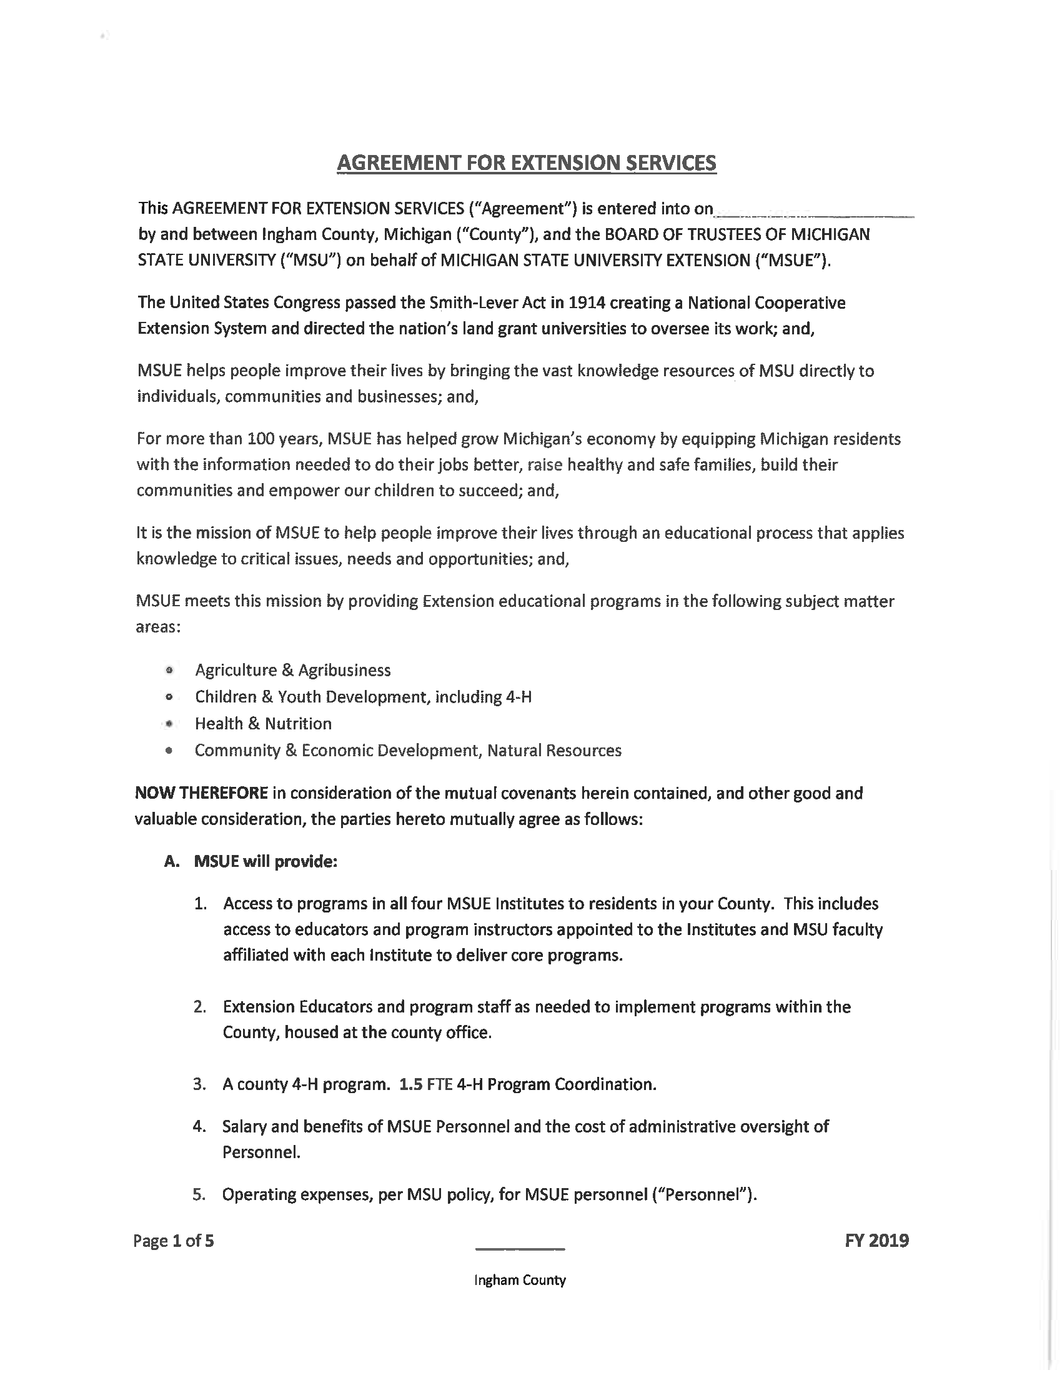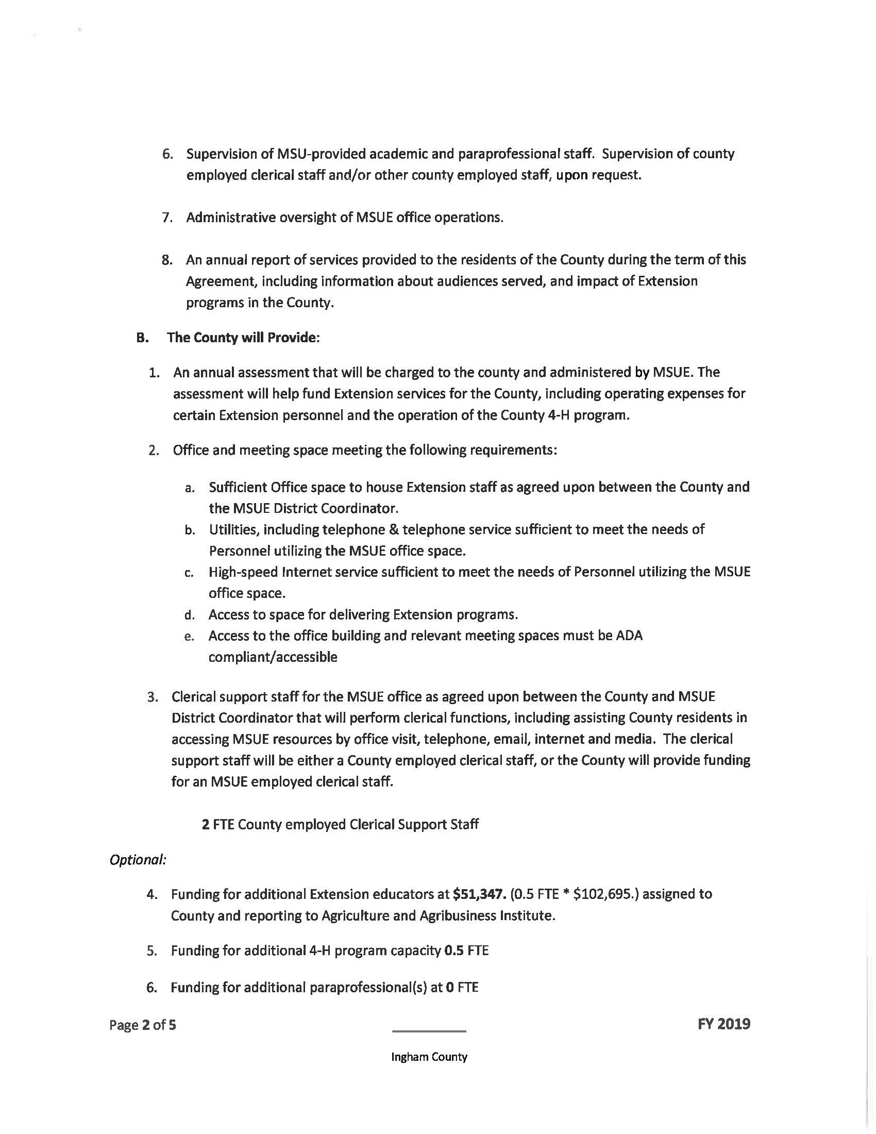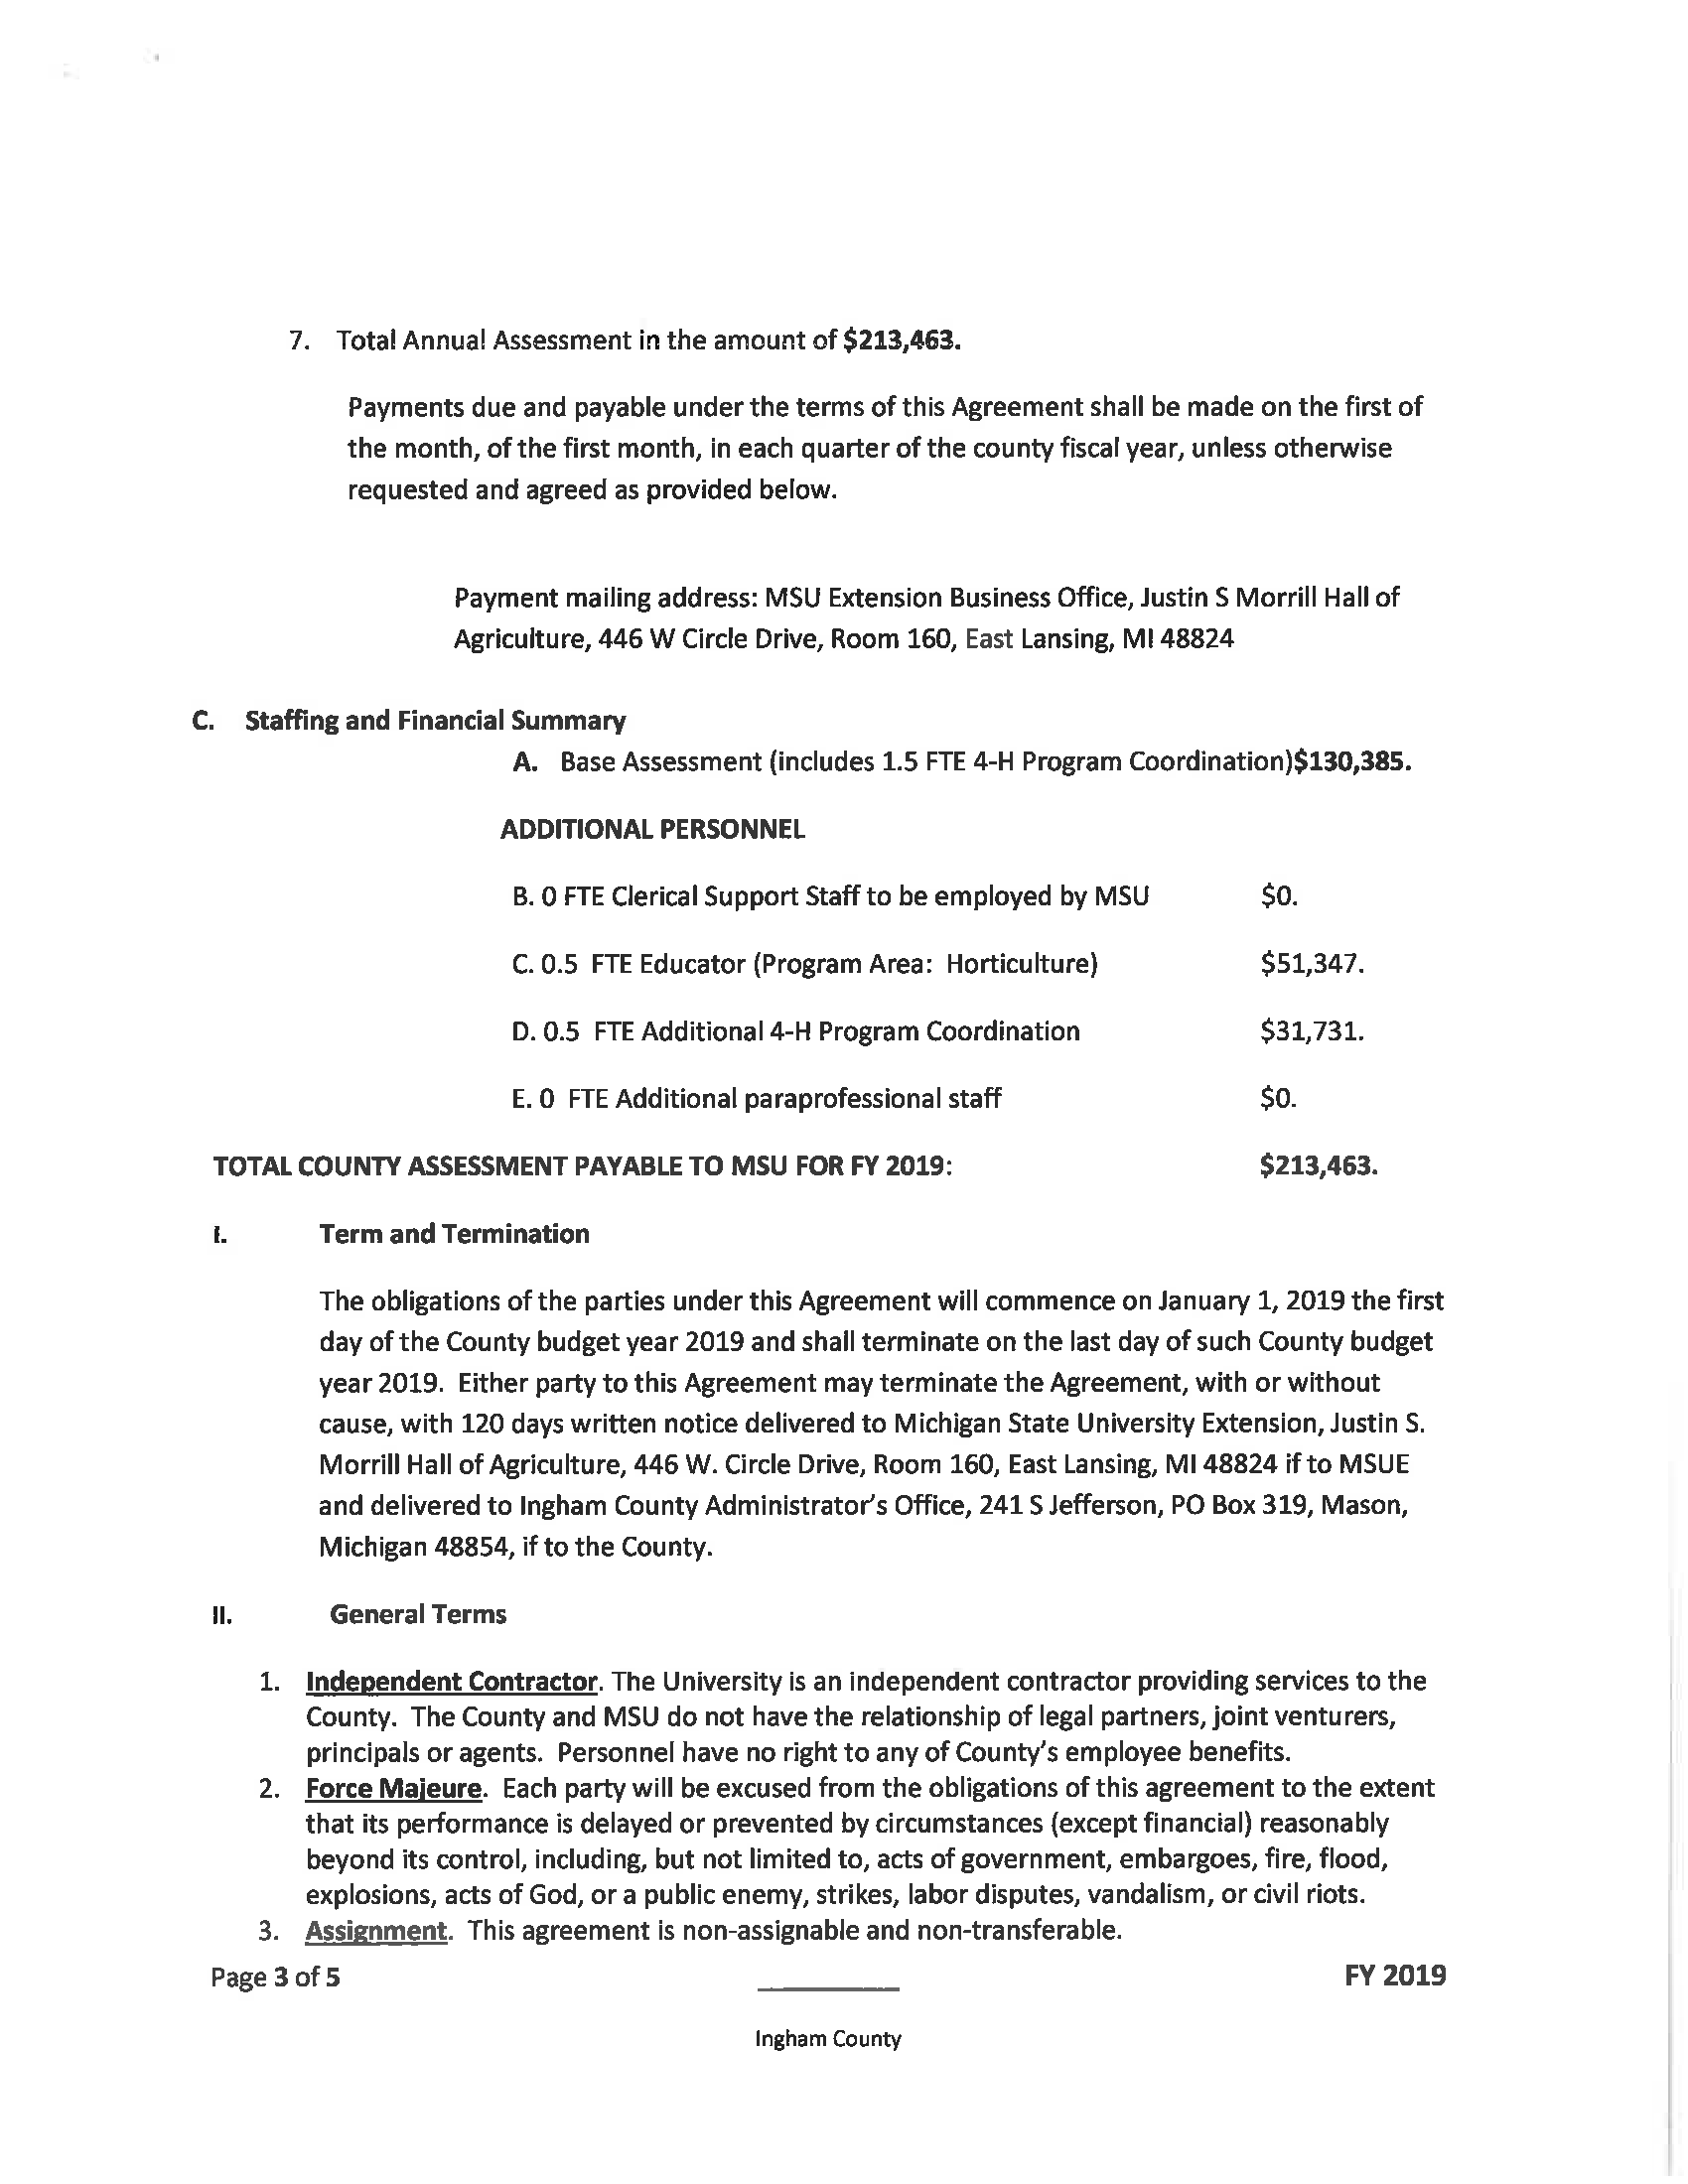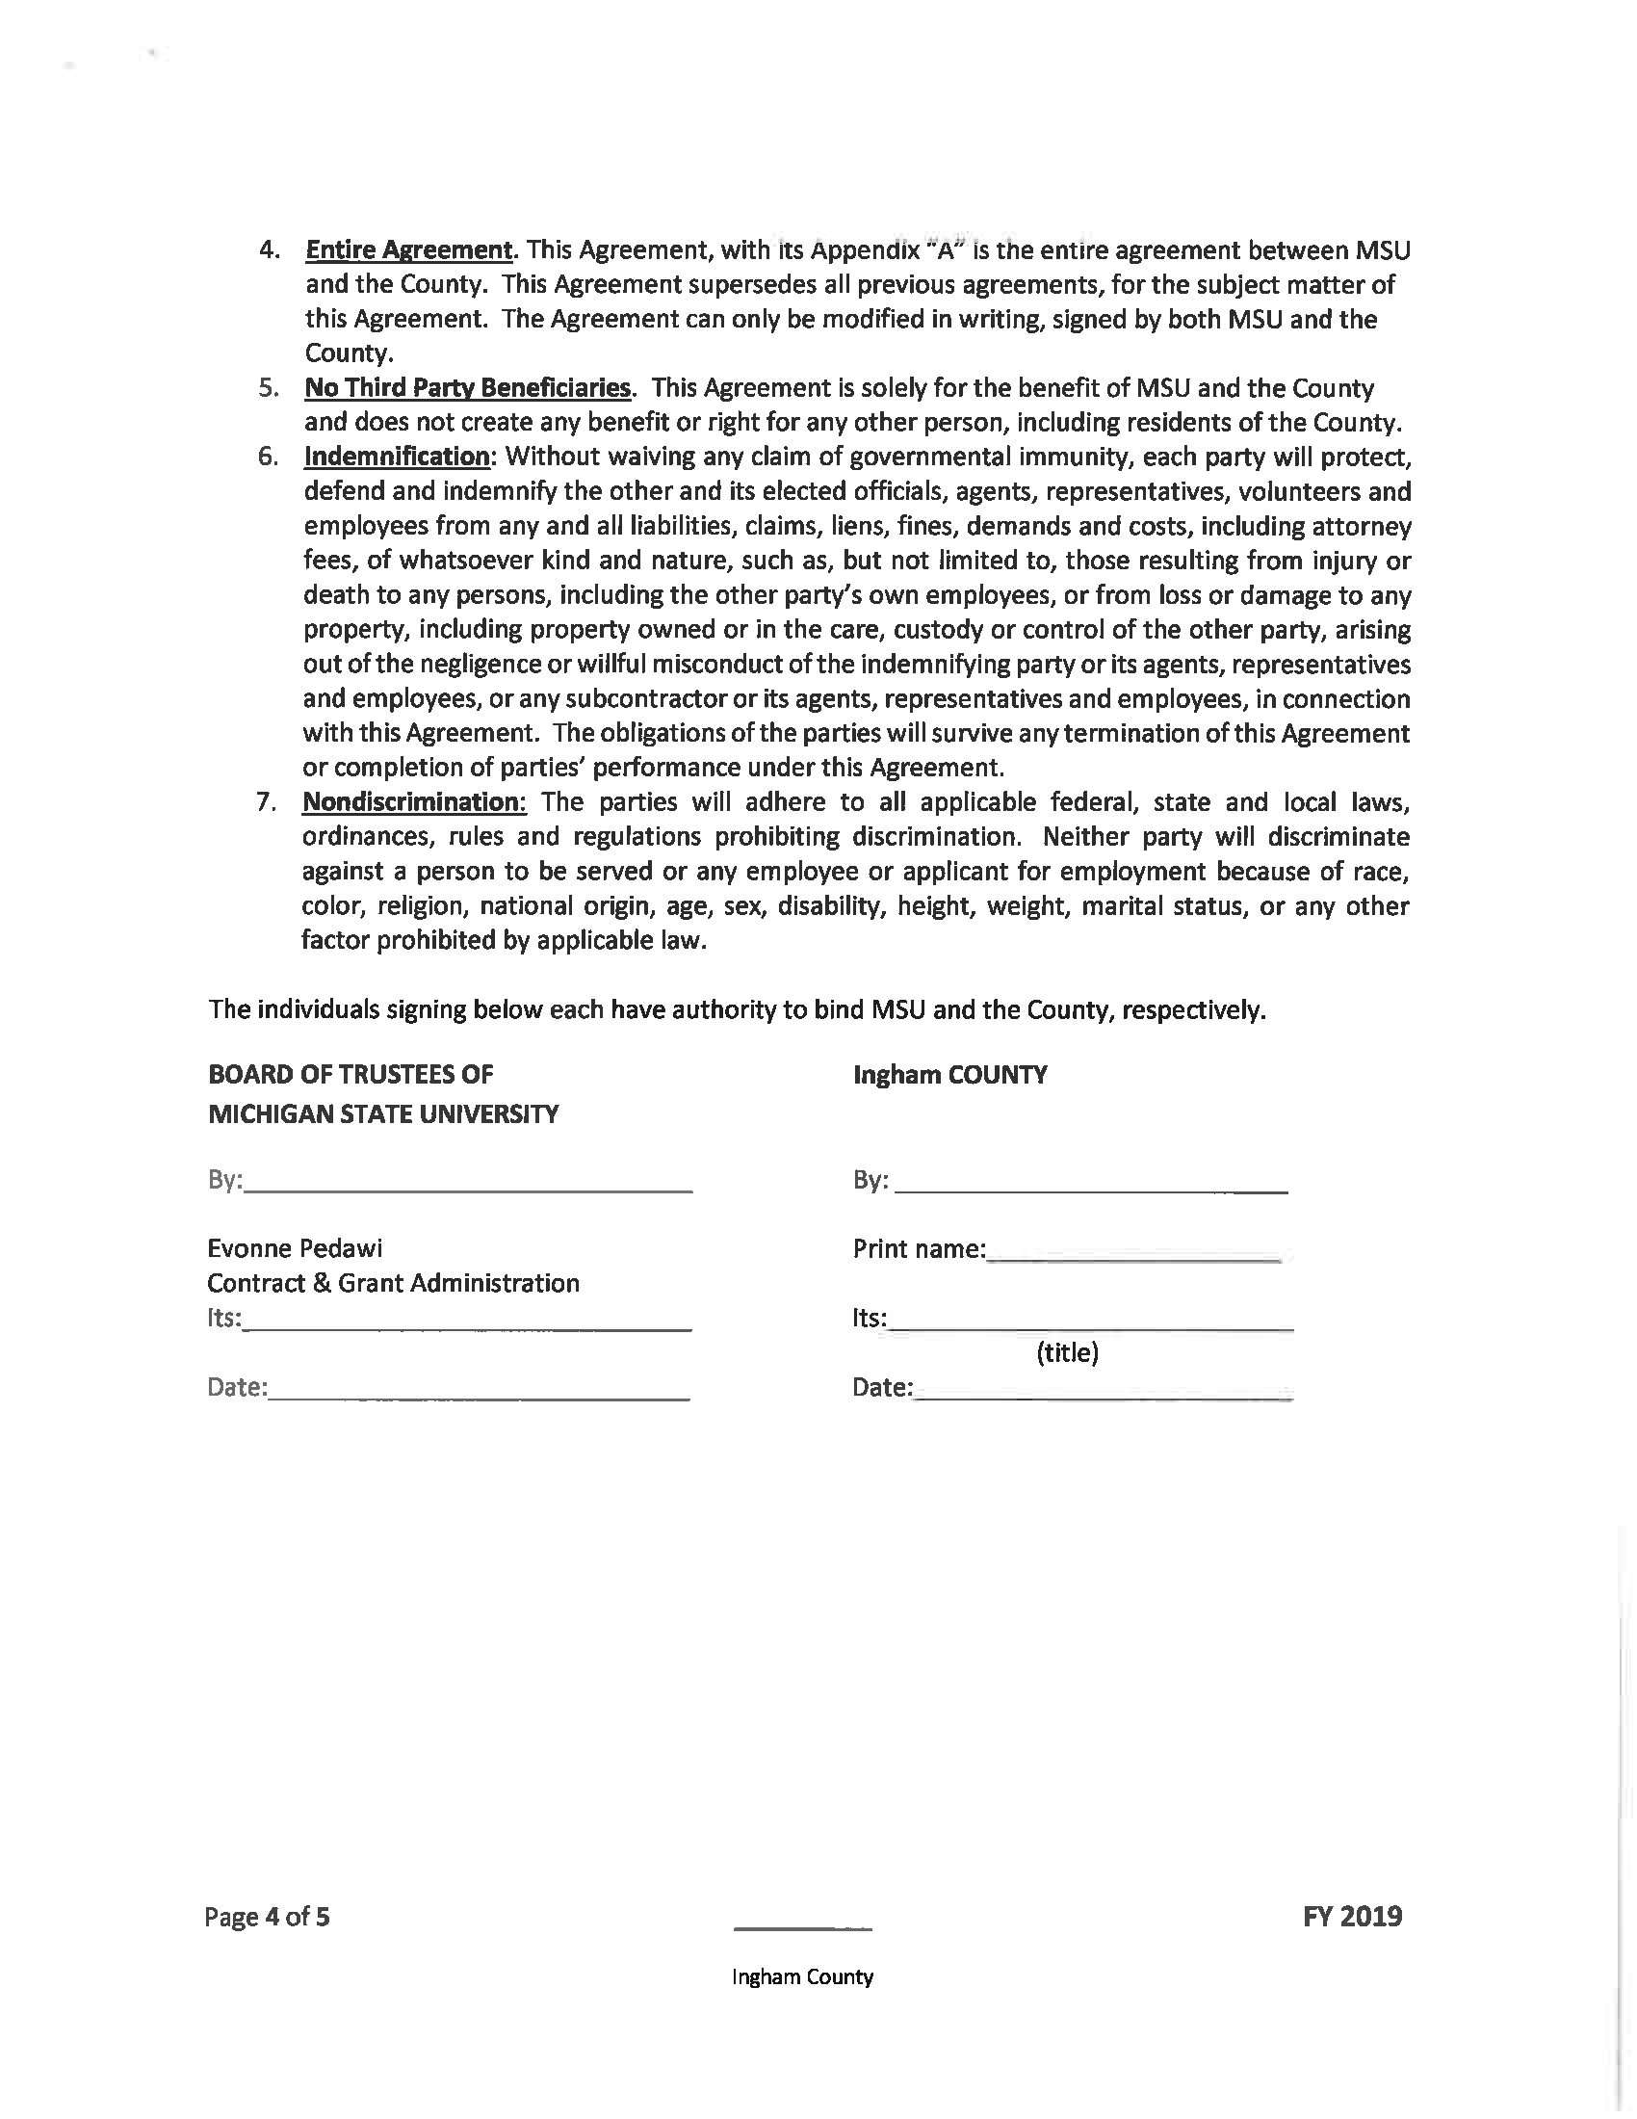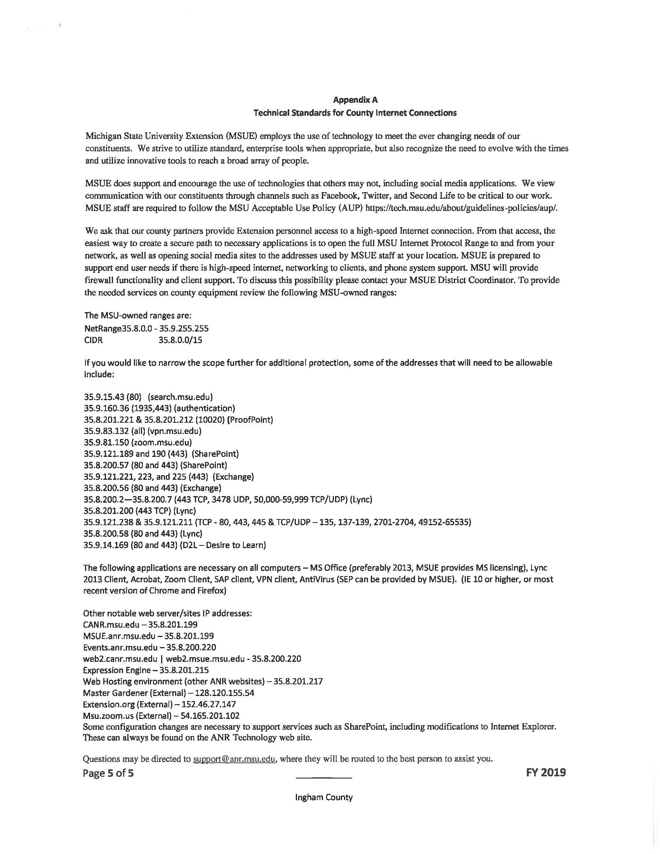
ADOPTED – NOVEMBER 13, 2018
AGENDA ITEM NO. 22

Introduced by the Human Services and Finance Committees of the:

INGHAM COUNTY BOARD OF COMMISSIONERS

RESOLUTION AUTHORIZING RENEWING A CONTRACT WITH SPICER GROUP, INC. TO PROVIDE CONSULTING SERVICES TO AND ASSIST THE INGHAM COUNTY PARKS STAFF WITH THE DELIVERY OF CERTAIN MILLAGE RELATED ITEMS

RESOLUTION # 18 – 469

WHEREAS, the Board of Commissioners passed a motion at their December 13, 2016 meeting to authorize a two year contract with Spicer Group Inc., a consultant with various personnel with very diverse skill sets to assist County staff with the Trails and Park Millage; and

WHEREAS, the Board of Commissioners approved an option to renew the contract for an additional two year period provided the annual cost increases should not exceed the Consumer Price Index’s Annual Inflation rate or 1%, whichever is greater, during the term of the Agreement; and

WHEREAS, after careful review and evaluation of the deliverables completed by Spicer Group Inc. over the current contract, the Park Commission recommends that the contract with Spicer Group, Inc. be renewed for two additional years.

THEREFORE BE IT RESOLVED, the Ingham County Board of Commissioners hereby authorizes awarding a contract to Spicer Group, Inc., for an estimated third-year cost of $99,883.00 and an estimated fourth-year cost of $101,873.00 for a combined two-year total not to exceed $201,756.00 from the Trails and Parks Millage to provide consulting services to and assist the Ingham County Parks staff with the delivery of certain millage related items.

BE IT FURTHER RESOLVED, the term of the contract is January 1, 2019-December 31, 2020.

BE IT FURTHER RESOLVED, the Board of Commissioners also authorizes Spicer Group’s attendance at Park Commission or Board of Commissioners meeting(s), if required and requested, at a cost of $365.00 per meeting.

BE IT FURTHER RESOLVED, that the Controller/Administrator is authorized to make any necessary budget adjustments consistent with this resolution.

BE IT FURTHER RESOLVED, that the Chairperson of the Board of Commissioners is hereby authorized to sign any necessary contract documents on behalf of the County after approval as to form by the County Attorney.

HUMAN SERVICES: Yeas: Banas, Tennis, Sebolt, Morgan
Nays: None Absent: Nolan, Naeyaert Approved 11/05/2018

FINANCE: Yeas: Grebner, Crenshaw, Tennis, Morgan, Schafer
Nays: None Absent: Anthony Approved 11/07/2018

ADOPTED – NOVEMBER 13, 2018
AGENDA ITEM NO. 23

Introduced by the Human Services and Finance Committees of the:

INGHAM COUNTY BOARD OF COMMISSIONERS

RESOLUTION TO AUTHORIZE AMENDMENT # 1 TO THE 2018-2019 COMPREHENSIVE AGREEMENT WITH THE MICHIGAN DEPARTMENT OF HEALTH AND HUMAN SERVICES

RESOLUTION # 18 – 470

WHEREAS, Ingham County Health Department (ICHD) wishes to amend the 2018-19 Comprehensive agreement by increasing funding received from the Michigan Department of Health & Human Services (MDHHS) from $5,217,733 to $5,383,598, for a total increase of $165,863; and

WHEREAS, the responsibility for protecting the health of the public is a shared responsibility between the State and County governments in Michigan; and

WHEREAS, MDHHS and local health departments enter into contracts to clarify the role and responsibilities of each party in protecting public health; and

WHEREAS, the Board of Commissioners (BOC) authorized the 2018-2019 Comprehensive Agreement through Resolution #18-351; and

WHEREAS, the Comprehensive Agreement is the annual process whereby MDHHS annually transmits State and Federal Funds to Ingham County to support public health programs; and

WHEREAS, MDHHS has proposed Amendment # 1 to the current Agreement to adjust grant funding levels and clarify agreement procedures; and

WHEREAS, the Health Officer has recommended that the Board of Commissioners authorize this Amendment.

THEREFORE BE IT RESOLVED, that the Ingham County Board of Commissioners authorizes Amendment # 1 to the 2018-2019 Comprehensive Agreement with Michigan Department of Health & Human Services (MDHHS) effective October 1, 2018 through September 30, 2019.

BE IT FURTHER RESOLVED, that the total amount of the Comprehensive Agreement funding shall increase from $5,217,733 to $5,383,598 for a total increase of $165,863.

BE IT FURTHER RESOLVED, that the increase consists of the following specific change to program budget:

Children’s Special Health Care Outreach & Advocacy: increase of $5,676 from $172,000 to $177,676
Public Health Emergency Preparedness: increase of $2,233 from $115,362 to $117,595
Essential Local Public Health Services (ELPHS): increase of $117,521 from $924,331 to $1,041,852
Private & Type III Water Supply ELPHS: increase of $5,348 from $48,235 to $53,583
Food ELPHS: increase of $24,227 from $218,513 to $242,740
On Site Wastewater Treatment ELPHS: increase of $10,858 from $97,934 to $108,792

BE IT FURTHER RESOLVED, that the Controller/Administrator is authorized to make any necessary adjustments consistent with this resolution.

BE IT FURTHER RESOLVED, that the Health Officer is authorized to submit Amendment #1 of the 2018-2019 Comprehensive Agreement electronically through the Mi-E Grants system after approval as to form by the County Attorney.

HUMAN SERVICES: Yeas: Banas, Tennis, Sebolt, Morgan
Nays: None Absent: Nolan, Naeyaert Approved 11/05/2018

FINANCE: Yeas: Grebner, Crenshaw, Tennis, Morgan, Schafer
Nays: None Absent: Anthony Approved 11/07/2018

ADOPTED – NOVEMBER 13, 2018
AGENDA ITEM NO. 24

Introduced by the Human Services and Finance Committees of the:

INGHAM COUNTY BOARD OF COMMISSIONERS
RESOLUTION TO AUTHORIZE AN AGREEMENT WITH THE
MICHIGAN DEPARTMENT OF ENVIRONMENTAL QUALITY FOR 2018-2019

RESOLUTION # 18 – 471

WHEREAS, Ingham County Health Department (ICHD) wishes to partner with the Michigan Department of Environmental Quality (MDEQ) to conduct environmental monitoring and inspections of MDEQ Non-Community programs; and

WHEREAS, MDEQ will reimburse ICHD for expenses related to monitoring and inspection services; and

WHEREAS, this practice began after the State of Michigan reorganized services and moved many of its environmental protection programs and services to (MDEQ); and

WHEREAS, MDEQ proposes to clarify the responsibilities for some environmental services and arrange to purchase environmental monitoring and inspection services from ICHD; and

WHEREAS, the Public Health Code still locates the primary responsibility for environmental protection at the community level with local public health departments; and

WHEREAS, the Health Officer recommends that the Board of Commissioners authorize an agreement with MDEQ.

THEREFORE BE IT RESOLVED, that the Ingham County Board of Commissioners authorizes an agreement with MDEQ for Non-Community Programs.

BE IT FURTHER RESOLVED, that the agreement shall be effective October 1, 2018 through September 30, 2019.

BE IT FURTHER RESOLVED, that MDEQ shall reimburse ICHD up to $32,743.00 for expenses related to testing and inspection services as follows:

- Non-Community Public Water Supply Program – up to $25,168
- Drinking Water Long-Term Monitoring – up to $500
- Public Swimming Pools – up to $5,500
- Campground Requirements – up to $225
- Capacity Development & Source Water Assessment- up to $1350

BE IT FURTHER RESOLVED, that the Chairperson of the Board of Commissioners is hereby authorized to sign any necessary contract documents on behalf of the County after approval as to form by the County Attorney.

HUMAN SERVICES: Yeas: Banas, Tennis, Sebolt, Morgan
Nays: None Absent: Nolan, Naeyaert Approved 11/05/2018

FINANCE: Yeas: Grebner, Crenshaw, Tennis, Morgan, Schafer
Nays: None Absent: Anthony Approved 11/07/2018

ADOPTED – NOVEMBER 13, 2018
AGENDA ITEM NO. 25

Introduced by the Human Services and Finance Committees of the:

INGHAM COUNTY BOARD OF COMMISSIONERS

RESOLUTION TO ESTABLISH A TRUST AND AGENCY ACCOUNT FOR THE
MASON CAPITAL AREA PRESCRIPTION DRUG TASK FORCE

RESOLUTION # 18 – 472

WHEREAS, the Mason Capital Area Prescription Drug Task Force approached Ingham County, requesting that Ingham County Health Department (ICHD) act as a fiduciary for donations and fundraising dollars received to educate and raise awareness of Ingham County’s prescription drug abuse problems; and

WHEREAS, Ingham County will assume these duties upon a signed agreement between Ingham County and Mason Capital Area Prescription Drug Task Force; and

WHEREAS, the task force is a collaboration of professional, community members and law enforcement that advocate prescription medication practices that enhance and promote family and community wellness; and

WHEREAS, the donations and fundraising dollars will be used to purchase commercial air time, Naloxone, and other pertinent items to further their mission; and

WHEREAS, it is necessary to set up a Trust and Agency Account and also get the Board of Commissioners to approve the account/spending plan.

THEREFORE BE IT RESOLVED, upon a signed agreement between Ingham County and Mason Capital Area Prescription Drug Task Force, a Trust and Agency account will be established for the purposes of furthering the Mason Capital Area Prescription Drug Task Force mission.

BE IT FURTHER RESOLVED, that the Ingham County Board of Commissioners authorizes Ingham County to accept any and all future donations to the Trust and Agency Accounts.

BE IT FURTHER RESOLVED, that the Controller/Administrator is authorized to make any necessary budget adjustments consistent with this resolution.

BE IT FURTHER RESOLVED, that that the that the Chairperson of the Ingham County Board of Commissioners is authorized to sign any necessary contract documents on behalf of the County after approval as to form by the County Attorney.

HUMAN SERVICES: Yeas: Banas, Tennis, Sebolt, Morgan
Nays: None Absent: Nolan, Naeyaert Approved 11/05/2018

FINANCE: Yeas: Grebner, Crenshaw, Tennis, Morgan, Schafer
Nays: None Absent: Anthony Approved 11/07/2018

ADOPTED – NOVEMBER 13, 2018
AGENDA ITEM NO. 26

Introduced by the Human Services and Finance Committees of the:

INGHAM COUNTY BOARD OF COMMISSIONERS

RESOLUTION TO EXTEND KRESGE AGREEMENT & CONTRACT
WITH ANKER ELEKTRA LLC

RESOLUTION # 18 – 473

WHEREAS, Ingham County Health Department (ICHD) wishes to extend the agreement with the Kresge Foundation through March 31, 2019 and wishes to enter into an agreement with Anker Eleckra LLC to provide the Executive Coaching component for the Kresge Grant work; and
WHEREAS, resolution # 17-385 authorized acceptance of the Kresge Foundation’s Emerging Leaders in Public Health (ELPH) Grant funds for a project totaling $125,000 effective August 1, 2017 through September 30, 2018; and

WHEREAS, under this grant, ICHD is required to establish a new role for ICHD in creating a designation of best practice for exemplifying Health Equity & Social Justice (HESJ) in everyday practice and service; and

WHEREAS, through the Kresge Grant, ICHD is able to continue to transform public health practice by intentionally incorporating a health equity and social justice framework into their operations, policies and practices through the following components: A Health Equity Assessment including a staff survey component, a manager interview component, a community partner component and a staff focus group option, a communications component for disseminating the newly developed HESJ Tool Kit, and an Executive Coaching component to provide training for implementing the tools; and

WHEREAS, in order to complete the final Executive Coaching component, following a Request for Proposals process overseen by the Purchasing Department, ICHD selected Anker Elektra LLC to provide executive coaching services including the following elements:

1. One-one coaching with up to six executives from ICHD;
2. A half-day StrengthsFinder workshop for the Leadership Team;
3. Team Coaching for the ICHD Executive Team; and

WHEREAS, the cost of this agreement totaling $6,940 is completely funded by the Kresge ELPH Grant and will be effective upon execution of the agreement through March 31, 2019; and

WHEREAS, the Health Officer recommends extending the Kresge agreement through March 31, 2019 and recommends entering into an agreement with Anker Elektra LLC for the purpose of providing the Executive Coaching component for the Kresge Grant work.

THEREFORE BE IT RESOLVED, that the Ingham County Board of Commissioners authorizes extending the Kresge agreement through March 31, 2019 and authorizes entering into an agreement with Anker Elektra LLC in an amount not to exceed $6,940 effective upon execution of the agreement through March 31, 2019 for the purpose of providing the Executive Coaching component of the Kresge Grant work.

BE IT FURTHER RESOLVED, that the Kresge Grant allows for the development of the following components: A Health Equity Assessment including a staff survey component, a manager interview component and a community partner component and a staff focus group option, a communications component for disseminating the newly developed HESJ Tool Kit, and Executive Coaching to provide training for implementing the tools.

BE IT FURTHER RESOLVED, that in order to complete the Executive Coaching component, following a Request for Proposals process overseen by the Purchasing Department, ICHD selected Anker Elektra LLC to provide executive coaching services including the following elements:

1. One-one coaching with up to six executives from ICHD;
2. A half-day StrengthsFinder workshop for the Leadership Team;
3. Team Coaching for the ICHD Executive Team.

BE IT FURTHER RESOLVED, that the Controller/Administrator is authorized to make any necessary budget adjustments consistent with this resolution.

BE IT FURTHER RESOLVED, that the Chairperson of the Board of Commissioners is hereby authorized to sign any necessary contract documents on behalf of the County after approval as to form by the County Attorney.

HUMAN SERVICES: Yeas: Banas, Tennis, Sebolt, Morgan
Nays: None Absent: Nolan, Naeyaert Approved 11/05/2018

FINANCE: Yeas: Grebner, Crenshaw, Tennis, Morgan, Schafer
Nays: None Absent: Anthony Approved 11/07/2018

ADOPTED – NOVEMBER 13, 2018
AGENDA ITEM NO. 27

Introduced by the Law & Courts Committee of the:

INGHAM COUNTY BOARD OF COMMISSIONERS

RESOLUTION TO HONOR SERGEANT MATTHEW FLINT
OF THE INGHAM COUNTY SHERIFF’S OFFICE

RESOLUTION # 18 – 474

WHEREAS, Sergeant Matthew Flint has been a distinguished member of the Law Enforcement Community since 1993; and

WHEREAS, Sergeant Matthew Flint began his career with the Ingham County Sheriff’s Office as a Deputy Sheriff/Paramedic in 1993; and

WHEREAS, Matthew Flint started in the county road patrol where he remained until 2000, at which time he was promoted to the rank of Sergeant and transferred to supervise the Training Division. In this assignment, he led the FTO program, the Emergency Vehicle Operations program and led numerous regional law enforcement training efforts; and

WHEREAS, in 2002, Sergeant Flint returned to Field Services to supervise the Paramedic Division and County Road Patrol; and

WHEREAS, in 2005, Sergeant Flint was transferred to the Delhi Division of the Sheriff’s Office to lead the road patrol efforts in Delhi Township; and

WHEREAS, in 2006, Sergeant Flint was transferred to the Detective Bureau, where he supervised the Detectives and coordinated a number of high profile criminal investigations including two homicides, several violent felonies and a high profile kidnapping case; and

WHEREAS, Sergeant Flint continued to serve throughout the Sheriff’s Office in the Detective Bureau, Corrections Division and returned once again to Field Services to supervise the Road Patrol in the Delhi Township Division in 2011. From 2011 until his retirement in 2018, Sergeant Flint served the Ingham County Sheriff’s Office, Delhi Township Division, with distinction in establishing the Delhi Division as one of the finest areas of the Ingham County Sheriff’s Office; and

WHEREAS, during his long distinguished career serving the citizens of Ingham County, Sergeant Flint served at the highest level of professionalism and dedication, setting the standard for other Law Enforcement professionals in the Capital Area; and

WHEREAS, during his law enforcement career, Sergeant Flint was the recipient of numerous police awards to include: Employee of the Year 2018, Meritorious Service, Life Saving Award and 19 separate Unit Citations; and

WHEREAS, after 25 years of dedicated service to the citizens of Ingham County, Sergeant Matthew Flint is retiring from his law enforcement career on December 14, 2018.

THEREFORE BE IT RESOLVED, that the Ingham County Board of Commissioners hereby honors Sergeant Matthew Flint for 25 years of dedicated police service to the citizens of Ingham County and the great State of Michigan while wishing him continued success in all of his future endeavors.

LAW & COURTS: Yeas: Crenshaw, Celentino, Banas, Schafer, Maiville
Nays: None Absent: Hope, Anthony Approved 11/01/2018

ADOPTED – NOVEMBER 13, 2018
AGENDA ITEM NO. 28

Introduced by Law & Courts, County Services and Finance Committees of the:

INGHAM COUNTY BOARD OF COMMISSIONERS

RESOLUTION TO ELIMINATE ONE SPECIAL PART-TIME DEPUTY COURT OFFICER POSITION ASSIGNED TO THE 55TH DISTRICT COURT AND TO INCREASE ONE PART-TIME COURT OFFICER POSITION IN THE 55TH DISTRICT TO FULL-TIME

RESOLUTION # 18 – 475

WHEREAS, Resolution #12-94 eliminated a full-time court officer position in the 55th District Court and created two part-time deputy positions within the Ingham County Sheriff Office to be assigned to the 55th District Court to serve as court officers; and

WHEREAS, the 55th District Court has maintained an additional part-time court officer position on and off (depending on budgetary constraints/priorities) since 2006; and

WHEREAS, the 55th District Court currently has $40,858 budgeted to pay for court officer services provided by the Ingham County Sheriff’s Office and $38,497 to pay the part-time court officer position on District Court staff; and

WHEREAS, the estimated cost to employ a full-time court officer in the 55th District Court is $6,383 above the current budgeted amount in the 55th District Court budget; and

WHEREAS, one of the Ingham County Sheriff Office’s part-time court officers (½ FTE) has submitted a letter of resignation; and

WHEREAS, the District Court employed court officer (½ FTE), has enrolled in the Michigan State Police Trooper’s Academy and, therefore, left the court’s employment; and

WHEREAS, through strategic planning the court has established a goal to enhance security measures at the 55th District Court and in light of the existing vacancy and the pending resignation the Court has reviewed its current court security measures; and

WHEREAS, the 55th District Court has reviewed applications and conducted interviews and determined that hiring a full-time court officer on the District Court staff is the best next step in continued focus on enhanced security measures; and

WHEREAS, the 55th District Court believes that a full-time court officer position provides for a more consistent application of operating principles.

THEREFORE BE IT RESOLVED, that upon passage of this resolution, one of the two part-time deputy positions within the Ingham County Sheriff’s Office (assigned to the 55th District Court) (Position 301231, CCLP LE/special part-time Deputy) be eliminated and the part-time court officer position (Position 137033, UAW/E) on District Court staff be increased from part-time to full-time.

BE IT FURTHER RESOLVED, that the Controller/Administrator is authorized to make any necessary adjustments to the budget and the position allocation list consistent with this resolution.

LAW & COURTS: Yeas: Crenshaw, Celentino, Banas, Schafer, Maiville
Nays: None Absent: Hope, Anthony Approved 11/01/2018
COUNTY SERVICES: The County Services Committee will meet on 11/08/2018

FINANCE: Yeas: Grebner, Crenshaw, Tennis, Morgan, Schafer
Nays: None Absent: Anthony Approved 11/07/2018

ADOPTED – NOVEMBER 13, 2018
AGENDA ITEM NO. 29

Introduced by the Law & Courts and Finance Committees of the:

INGHAM COUNTY BOARD OF COMMISSIONERS

RESOLUTION TO AUTHORIZE A GRANT BETWEEN THE STATE OF MICHIGAN,
MICHIGAN INDIGENT DEFENSE COMMISSION (MIDC), DEPARTMENT OF LICENSING AND REGULATORY AFFAIRS (LARA) AND INGHAM COUNTY TO PROVIDE FUNDING TO ASSIST THE COUNTY IN COMPLYING WITH THE COMPLIANCE PLAN AND COST ANALYSIS APPROVED BY MIDC AND RESOLUTION #17-445

RESOLUTION # 18 – 476

WHEREAS, the Michigan Indigent Defense Commission (MIDC) approved Ingham County’s Compliance Plan and Cost Analysis, which creates a Public Defenders Office administered by Ingham County to provide indigent defense and related services at the 30th Circuit Court, 54A District Court, 54B District Court, and the 55th District Court; and

WHEREAS, this plan was accepted and approved by Ingham County Board Resolution #17-445; and

WHEREAS, the grant is recommended as presented in the attached Grant between the State of Michigan, Michigan Indigent Defense Commission (MIDC), Department of Licensing and Regulatory Affairs (LARA) and Ingham County, including the attached budget; and

WHEREAS, positions included in this budget and not already authorized by the Board of Commissioners will be brought forward for authorization by separate resolution(s).

THEREFORE BE IT RESOLVED, that the Ingham County Board of Commissioners accepts the attached Grant between the State of Michigan, Michigan Indigent Defense Commission (MIDC), Department of Licensing and Regulatory Affairs (LARA) and Ingham County, including the attached budget.

BE IT FURTHER RESOLVED, that the grant period is October 1, 2018 through September 30, 2019, and the budget is approved for an amount of up to $5,422,599, including a local share of $902,021.

BE IT FURTHER RESOLVED, that the Chairperson of the Ingham County Board of Commissioners is hereby authorized to sign any necessary grant and contract documents, on behalf of the County, after approved as to form by the County Attorney.

BE IT FURTHER RESOLVED, that the Controller/Administrator is authorized to make any necessary budget adjustments consistent with this resolution.

LAW & COURTS: Yeas: Crenshaw, Celentino, Banas, Schafer, Maiville
Nays: None Absent: Hope, Anthony Approved 11/01/2018

FINANCE: Yeas: Grebner, Crenshaw, Tennis, Morgan, Schafer
Nays: None Absent: Anthony Approved 11/07/2018

GRANT NO. 2019-73

GRANT BETWEEN
THE STATE OF MICHIGAN
MICHIGAN INDIGENT DEFENSE COMMISSION (MIDC)
DEPARTMENT OF LICENSING AND REGULATORY AFFAIRS (LARA)
AND
Ingham County

GRANTEE/ADDRESS:

Victor Celentino
Chairman, County Commission
341 S. Jefferson
Mason, MI 48854
517-676-7200

GRANT ADMINISTRATOR/ADDRESS:

Michigan Indigent Defense Commission
Department of Licensing and Regulatory Affairs
200 N. Washington Square 3rd Floor
Lansing, MI 48933
517-657-3066
866-291-0874

GRANT PERIOD:

From October 1, 2018 to September 30, 2019

TOTAL AUTHORIZED BUDGET: $5,422,508.00

State Grant Contribution: $4,520,487.00
Local Share Contribution: $902,021.00

ACCOUNTING DETAIL: Accounting Template No.: 6412503T007

SIGMA Vendor Code: 0048161

GRANT

This is Grant #2019-73 between the Michigan Indigent Defense Commission (MIDC) (Grantor), and Ingham County (Grantee), subject to terms and conditions of this grant agreement (Agreement).

1.0 Statement of Purpose

The purpose of this Grant is to provide funding to assist the Grantee to comply with the Compliance Plan and Cost Analysis approved by the MIDC for the provision of indigent criminal defense services through the Standards approved by LARA on May 22, 2017, and the process described in the Michigan Indigent Defense Act, as amended effective 12/23/18 by Public Act 214 of 2018.

1.1 Statement of Work

The Grantee agrees to undertake, perform, and complete the following project:

The Grantee agrees to undertake, perform and complete the services described in their approved Compliance Plan and in accordance with the Michigan Indigent Defense Act, created by Public Act 93 of 2013, specifically Standards 1 through 4. Consistent with MCL 780.993, Sec. 13(11), as amended effective 12/23/18, an indigent criminal defense system shall comply with the terms of the grant in bringing its system into compliance with the minimum standards established by the MIDC within 180 days after receiving funds from the MIDC. Grantee’s Compliance Plan, as submitted and approved by the MIDC (Attachment A), addresses the prescribed methods the grantee has chosen to provide indigent criminal defense services pursuant to MCL 780.993(3). Any changes to the work described in the Compliance Plan must be submitted to the MIDC for approval prior to any changes being implemented. All provisions and requirements of this agreement shall apply to any agreements the Grantee may enter into in furtherance of its obligations under this agreement and shall be responsible for the performance of any contracted work.

1.2 Detailed Budget

A. This Agreement does not commit the State of Michigan (State) or the Department of Licensing and Regulatory Affairs (LARA) to approve requests for additional State Grant funds at any time.

B. If applicable, travel expenses will not be reimbursed at rates greater than the State Travel Rates, Attachment C, without the prior written consent of the MIDC.

C. Attachment B is the Budget. The Grantee agrees that all funds shown in the Budget are to be spent as detailed in the Budget.
D. Grantee will establish and maintain a new restricted fund within their Local Chart of Accounts for the expressed purpose of accounting for the expenses and revenue sources for operation of this grant and the local adult indigent defense system.

E. Any adjustments to the budget must be made in accordance with the policies and procedures of the Michigan Indigent Defense Commission and communicated promptly to Commission staff. A budget adjustment involving less than 5%
of the budget category total, must be reported in the next quarterly Financial Status Report. A budget adjustment involving 5% or more within the budget category or any adjustment redistributing monies between categories of funding requires prior written approval by Commission staff. Any substantial change to a local system’s compliance plan requires prior staff and Commission approval. A “substantial change” is a change to the compliance plan or cost analysis that alters the method of meeting the objectives of the standard(s) in the approved plan.

1.3 Payment Schedule

The maximum amount of grant assistance offered is $ 4,520,487.00. An initial advance of 50% of the State Grant shall be made to the Grantee upon receipt by the Grantor of a signed Agreement. The Grantor shall make subsequent disbursements of 25% up to the total state grant. amount in accordance with the following schedule:

Initial Advance of 50% of total grant – Within 15 days of receipt of executed agreement
25% disbursement – April 15, 2019
25% disbursement – July 15, 2019 (final payment).

The above schedule of disbursement of funds is contingent upon receipt of quarterly reporting as addressed in this section and section 1.4 of this document. The financial status report must indicate grant funds received to date, expenditures to date and be supported by documentation of those expenditures; such as computer printouts of accounts, general ledger sheets, balance sheets, etc.). Backup documentation such as computer printouts of accounts, ledger sheets, invoices, etc. shall be maintained according to record retention policies for audit purposes in order to comply with this Agreement. Grantee will be held to the full contribution of the Local Share within the original one-year grant period.

The quarterly financial status report (FSR) and standards compliance report as addressed in Section 1.4, shall be provided in accordance with the following schedule:

Initial FSR and compliance report – January 15, 2019
2nd FSR and compliance report – April 1, 2019
3rd FSR and compliance report – July 1, 2019
Final FSR and compliance report – October 15, 2019

Public Act 279 of 1984 states that the state shall take all steps necessary to assure that payment for goods or services, is mailed within 45 days after receipt of the goods or services, a complete invoice for goods or services, or a complete contract for goods or services, whichever is later.

1.4 Monitoring and Reporting Program Performance

A. Monitoring. The Grantee shall monitor performance to assure that time schedules are being met and projected work by time period is being accomplished.

B. Quarterly Reports. The Grantee shall submit to the Grantor quarterly progress reports on compliance with the standards and participate in follow up and evaluation activities. A quarterly reporting template shall be provided by the MIDC and require the following information:

- A description on progress toward compliance with standards 1-4, including a description of problems or delays, real or anticipated and any significant deviation from previously approved Compliance Plan submitted to the MIDC per PA93 of 2013 (Attachment A), which should be brought to the attention of the Grantor.

- Specific standards compliance information as requested by MIDC and collected by the local system.

- Local systems must provide complete compliance reporting. If a local system believes that it is unable to provide the compliance reporting as requested by MIDC, or that providing the requested information would pose an undue financial burden, the local system must take the following steps as to each requested performance metric that has asserted it is unable to provide:

a. Demonstrate that system stakeholders have reviewed requested performance metrics and assessed what is currently available and how to retrieve it. This should include documentation of conversations with court administrators, clerks, and IT employees or vendors, depending on whether it is an internally or externally provided system, as well as an assessment of data fields that could be added or repurposed to collect the requested data.

b. If these options do not enable the local system to provide the requested performance metrics, local systems must contact and work with MIDC Research staff to seek additional options or ideas.

c. Receive confirmation from MIDC Research staff and local Regional Manager that the data collection would constitute an undue financial or labor burden that is untenable within the initial year of the grant.
PART II - GENERAL PROVISIONS

2.1 Project Changes

Grantee must obtain prior written approval for substantial changes to the compliance plan from the Grantor.

2.2 Delegation

. Grantee must notify the State at least 90 calendar days before the proposed delegation, and provide the State any information it requests to determine whether the delegation is in its best interest. If any obligations under this grant are delegated, Grantee must: (a) be the sole point of contact regarding all contractual project matters, including payment and charges for all Grant Activities; (b) make all payments to the subgrantee; and (c) incorporate the terms and conditions contained in this Grant in any subgrant with a subgrantee. Grantee remains responsible for the completion of the Grant Activities, compliance with the terms of this Grant, and the acts and omissions of the subgrantee. The State, in its sole discretion, may require the replacement of any subgrantee.

2.3 Program Income

To the extent that it can be determined that interest was earned on advances of funds, such interest shall be remitted to the Grantor or dedicated to the project up to the grant award. The grant award shall not be increased by the amount of interest earned. Any grant funds attributable to interest and not spent at the end of the grant period shall be returned to the State as required under Sec. 2.7 - Records Maintenance, Inspection, Examination, and Audit.

2.4 Share-in-savings

The Grantor expects to share in any cost savings realized by the Grantee. Therefore, Grantee reimbursement will be based on actual expenditures.

2.5 Purchase of Equipment

The purchase of equipment not specifically listed in the Budget, Attachment B, must have prior written approval of the Grantor. Equipment is defined as non-expendable personal property having a useful life of more than one year. Such equipment shall be retained by the Grantee unless otherwise specified at the time of approval.

2.6 Accounting

The Grantee shall adhere to the Generally Accepted Accounting Principles and shall maintain records which will allow, at a minimum, for the comparison of actual outlays with budgeted amounts. The Grantee's overall financial management system must ensure effective control over and accountability for all funds received. Accounting records must be supported by source documentation including, but not limited to, balance sheets, general ledgers, time sheets and invoices. The expenditure of state funds shall be reported by line item and compared to the Budget.

2.7 Records Maintenance, Inspection, Examination, and Audit

The State or its designee may audit Grantee to verify compliance with this Grant. Grantee must retain and provide to the State or its designee upon request, all financial and accounting records related to the Grant through the term of the Grant and for 7 years after the latter of termination, expiration, or final payment under this Grant or any extension (“Audit Period”). If an audit, litigation, or other action involving the records is initiated before the end of the Audit Period, Grantee must retain the records until all issues are resolved.

Within 10 calendar days of providing notice, the State and its authorized representatives or designees have the right to enter and inspect Grantee's premises or any other places where Grant Activities are being performed, and examine, copy, and audit all records related to this Grant. Grantee must cooperate and provide reasonable assistance. If any financial errors are revealed, the amount in error must be reflected as a credit or debit on subsequent invoices until the amount is paid or refunded. Any remaining balance must be reported by the Grantee to the Grantor by October 31 of each year as required under MCL 780.993, Sec. 13(15), as amended 12/23/18.

This Section applies to Grantee, any parent, affiliate, or subsidiary organization of Grantee, and any subgrantee that performs Grant Activities in connection with this Grant.

If the Grantee is a governmental or non-profit organization and expends the minimum level specified in OMB Uniform Guidance ($750,000 as of December 26, 2013) or more in total federal funds in its fiscal year, then Grantee is required to submit an Audit Report to the Federal Audit Clearinghouse (FAC) as required in 200.36.

2.8 Competitive Bidding

The Grantee agrees that all procurement transactions involving the use of state funds shall be conducted in a manner that provides maximum open and free competition. When competitive selection is not feasible or practical, the Grantee agrees to obtain the written approval of the Grantor before making a sole source selection. Sole source contracts should be negotiated to the extent that such negotiation is possible. Attorney contracts are exempt from a competitive bid process, but must meet standard internal procurement policies.

3.0 Liability

The State is not liable for any costs incurred by the Grantee before the start date or after the end date of this Agreement. Liability of the State is limited to the terms and conditions of this Agreement and the total grant amount

3.1 Safety

The Grantee, and all subgrantees are responsible for insuring that all precautions are exercised at all times for the protection of persons and property. Safety provisions of all Applicable Laws and building and construction codes shall be observed. The Grantee, and every subgrantee are responsible for compliance with all federal, state and local laws and regulations in any manner affecting the work or performance of this Agreement and shall at all times carefully observe and comply with all rules, ordinances, and regulations. The Grantee, and all subgrantees shall secure all necessary certificates and permits from municipal or other public authorities as may be required in connection with the performance of this Agreement.

3.2 General Indemnification

Inasmuch as each party to this grant is a governmental entity of the State of Michigan, each party to this grant must seek its own legal representation and bear its own costs; including judgments, in any litigation which may arise from the performance of this grant. It is specifically understood and agreed that neither party will indemnify the other party in such litigation.

3.3 Failure to Comply and Termination

- Failure to comply with the requirements of the grant program including implementation of the approved compliance plan, the submission of financial reports, progresss reports, or data collection will result in the Commission implementing the procedures identified in section 15 and 17 of Public Act 93 of 2013, as amended effective 12/23/18 by Public Act 214 of 2018. Other breaches of this grant agreement, including failure to adhere to the requirements in the grant contract, proposing or implementing substantial program changes that deviate from the expressed purpose of the grant or filing a false certification for this grant or any documents or reports requested by the MIDC for this grant, will result in action being taken pursuant to sections 15 and 17 of Public Act 93 of 2013, as amended effective 12/23/18.

- Termination for Convenience

The State may immediately terminate this Grant in whole or in part without penalty and for any reason, including but not limited to, appropriation or budget shortfalls. If the State terminates this Grant for convenience, the State will pay all reasonable costs, as determined by the State, for State approved Grant Responsibilities.

3.4 Conflicts and Ethics

Grantee will uphold high ethical standards and is prohibited from: (a) holding or acquiring an interest that would conflict with this Grant; (b) doing anything that creates an appearance of impropriety with respect to the award or performance of the Grant; (c) attempting to influence or appearing to influence any State employee by the direct or indirect offer of anything of value; or (d) paying or agreeing to pay any person, other than employees and consultants working for Grantee, any consideration contingent upon the award of the Grant. Grantee must immediately notify the State of any violation or potential violation of these standards. This Section applies to Grantee, any parent, affiliate, or subsidiary organization of Grantee, and any subgrantee that performs Grant Activities in connection with this Grant.

3.5 Non-Discrimination

Under the Elliott-Larsen Civil Rights Act, 1976 PA 453, MCL 37.2101, et seq., and the Persons with Disabilities Civil Rights Act, 1976 PA 220, MCL 37.1101, et seq., Grantee and its subgrantees agree not to discriminate against an employee or applicant for employment with respect to hire, tenure, terms, conditions, or privileges of employment, or a matter directly or indirectly related to employment, because of race, color, religion, national origin, age, sex,

height, weight, marital status, or mental or physical disability. Breach of this covenant is a material breach of this Grant.

3.6 Unfair Labor Practices

Under MCL 423.324, the State may void any Grant with a Grantee or subgrantee who appears on the Unfair Labor Practice register compiled under MCL 423.322.

3.7 Force Majeure

Neither party will be in breach of this Grant because of any failure arising from any disaster or acts of god that are beyond their control and without their fault or negligence. Each party will use commercially reasonable efforts to resume performance. Grantee will not be relieved of a breach or delay caused by its subgrantees except where the Commission determines that an unforeseeable condition prohibits timely compliance pursuant to MCL 780.993, Sec. 13(11), as amended effective 12/23/18.

4.0 Certification Regarding Debarment

The Grantee certifies, by signature to this Agreement, that neither it nor its principals are presently debarred, suspended, proposed for debarment, declared ineligible, or voluntarily excluded from participation in this Agreement by any federal or State department or agency. If the Grantee is unable to certify to any portion of this statement, the Grantee shall attach an explanation to this Agreement.

4.1 Illegal Influence

The Grantee certifies, to the best of his or her knowledge and belief that:

- No federal appropriated funds have been paid nor will be paid, by or on behalf of the Grantee, to any person for influencing or attempting to influence an officer or employee of any agency, a member of Congress, an officer or employee of Congress, or an employee of a member of Congress in connection with the awarding of any federal contract, the making of any federal grant, the making of any federal loan, the entering into of any cooperative agreement, and the extension, continuation, renewal, amendment, or modification of any federal contract, grant, loan or cooperative agreement.

- If any funds other than federal appropriated funds have been paid or will be paid to any person for influencing or attempting to influence an officer or employee of any agency, a member of Congress, an officer or employee of Congress, or an employee of a member of Congress in connection with this grant, the Grantee shall complete and submit Standard Form-LLL, “Disclosure Form to Report Lobbying,” in accordance with its instructions.

C. The Grantee shall require that the language of this certification be included in the award documents for all grants or subcontracts and that all subrecipients shall certify and disclose accordingly.

The State has relied upon this certification as a material representation. Submission of this certification is a prerequisite for entering into this Agreement imposed by 31 USC § 1352. Any person who fails to file the required certification shall be subject to a civil penalty of not less than $10,000 and not more than $100,000 for each such failure.

The Grantee certifies, to the best of his or her knowledge and belief that no state funds have been paid nor will be paid, by or on behalf of the Grantee, to any person for influencing or attempting to influence an officer or employee of any State agency, a member of the Legislature, or an employee of a member of the Legislature in connection with the awarding of any state contract, the making of any state grant, the making of any state loan, the entering into of any cooperative agreement, and the extension, continuation, renewal, amendment, or modification of any state contract, grant, loan or cooperative agreement.

4.2 Governing Law

This Grant is governed, construed, and enforced in accordance with Michigan law, excluding choice-of-law principles, and all claims relating to or arising out of this Grant are governed by Michigan law, excluding choice-of-law principles. Any dispute arising from this Grant must be resolved as outlined in Sec. 15 of PA93 of 2013, as amended.

4.3 Compliance with Laws

Grantee must comply with all federal, state and local laws, rules and regulations.

4.4 Disclosure of Litigation, or Other Proceeding

Grantee must notify the State within 14 calendar days of receiving notice of any litigation, investigation, arbitration, or other proceeding (collectively, “Proceeding”) involving a public defender office or attorney employed by a public defender office funded by Grantee that arises during the term of the Grant and involves: (a) a criminal Proceeding; (b) a civil Proceeding involving: (1) a claim that might reasonably be expected to adversely affect Grantee’s viability; or (2) a governmental or public entity’s claim or written allegation of fraud; or (e) a Proceeding involving any license that an attorney practicing on behalf of a public defender office is required to possess in order to perform under this Grant.

4.6 Assignment

Grantee may not assign this Grant to any other party without the prior approval of the State. Upon notice to Grantee, the State, in its sole discretion, may assign in whole or in part, its rights or responsibilities under this Grant to any other party. If the State determines that a novation of the Grant to a third party is necessary, Grantee will agree to the novation, provide all necessary documentation and signatures, and continue to perform, with the third party, its obligations under the Grant.

4.7 Entire Grant and Modification

This Grant is the entire agreement and replaces all previous agreements between the parties for the Grant Activities. This Grant may not be amended except by signed agreement between the parties.
4.8 Grantee Relationship

Grantee assumes all rights, obligations and liabilities set forth in this Grant. Grantee, its employees, and agents will not be considered employees of the State. No partnership or joint venture relationship is created by virtue of this Grant. Grantee, and not the State, is responsible for the payment of wages, benefits and taxes of Grantee’s employees and any subgrantees. Prior performance does not modify Grantee’s status as an independent Grantee.

4.9 Dispute Resolution

The parties will endeavor to resolve any Grant dispute in accordance with section 15 of Public Act 93 of 2013, as amended 12/23/18. The dispute will be referred to the parties' respective Grantors or Program Managers. Such referral must include a description of the issues and all supporting documentation. The parties will continue performing while a dispute is being resolved, unless the dispute precludes performance. A dispute involving payment does not preclude performance.

5.0 Severability

If any part of this Grant is held invalid or unenforceable, by any court of competent jurisdiction, that part will be deemed deleted from this Grant and the severed part will be replaced by agreed upon language that achieves the same or similar objectives. The remaining Grant will continue in full force and effect.

5.1 Waiver

Failure to enforce any provision of this Grant will not constitute a waiver.

5.2 Signatories

The signatories warrant that they are empowered to enter into this Agreement and agree to be bound by it.

_______________________________________ _________________
LeAnn Droste, Director Date
Bureau of Finance and Administrative Services
Department of Licensing and Regulatory Affairs

______________________________________ _________________
Loren Khogali, Executive Director Date
Michigan Indigent Defense Commission

_______________________________________ _________________
Victor Celentino, County Commission Chairman Date
Ingham County

GRANT NO. 2019-73

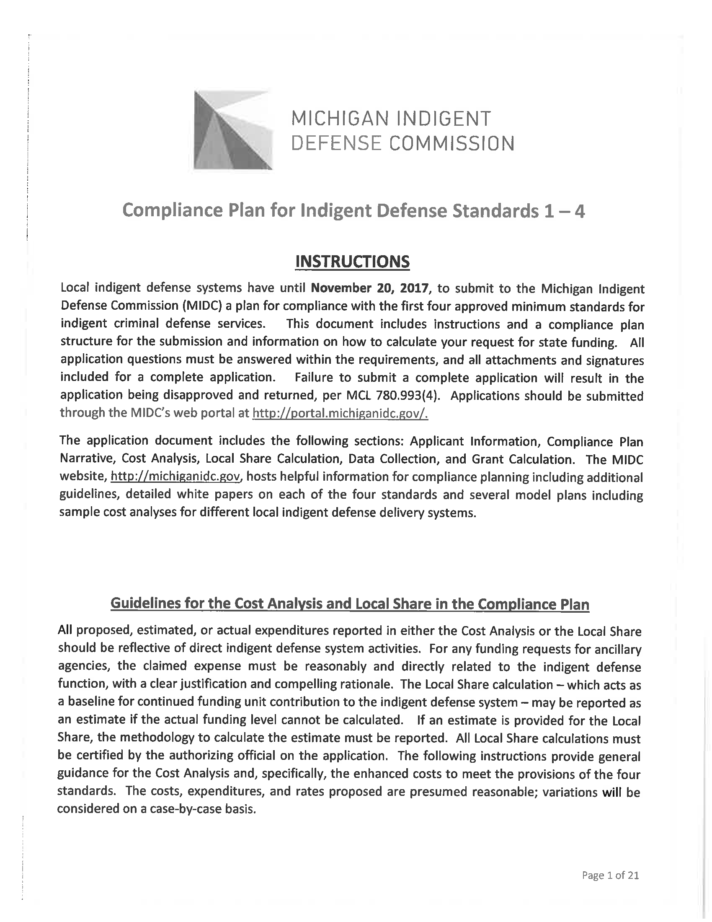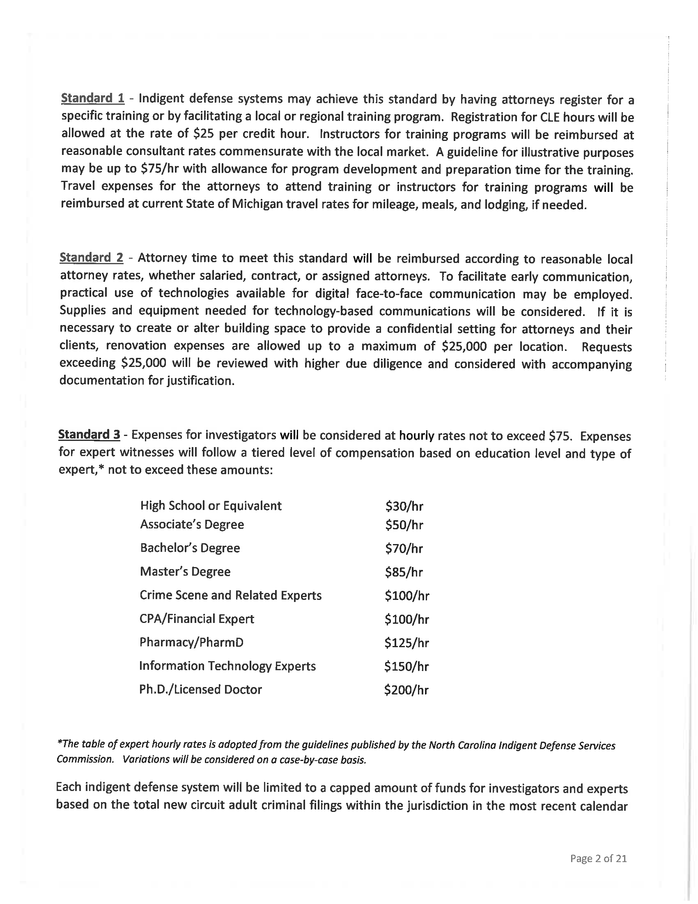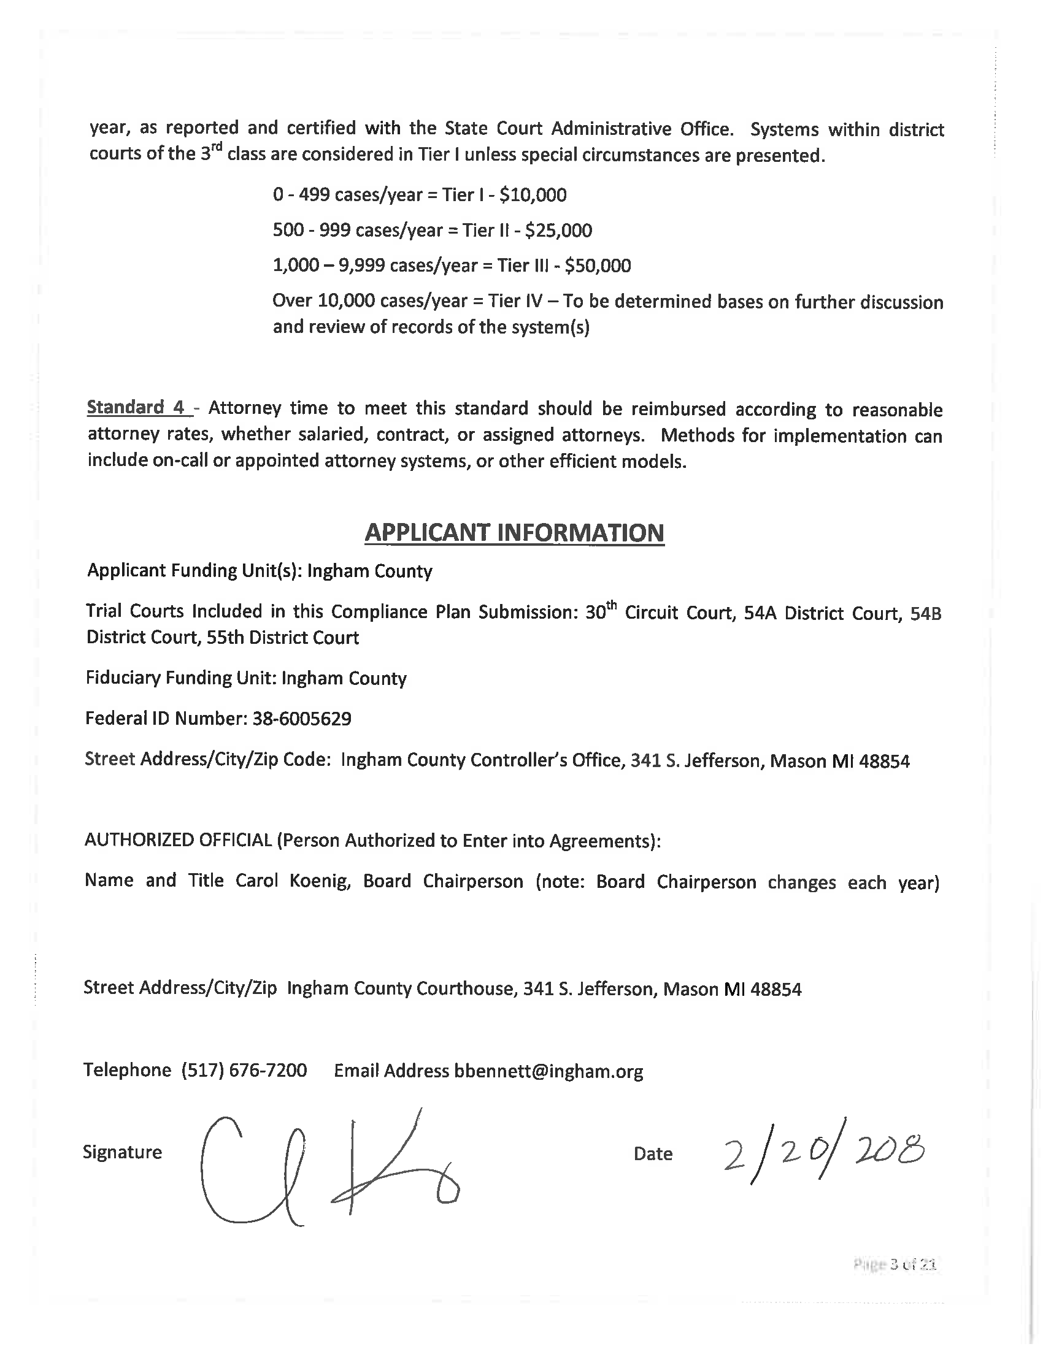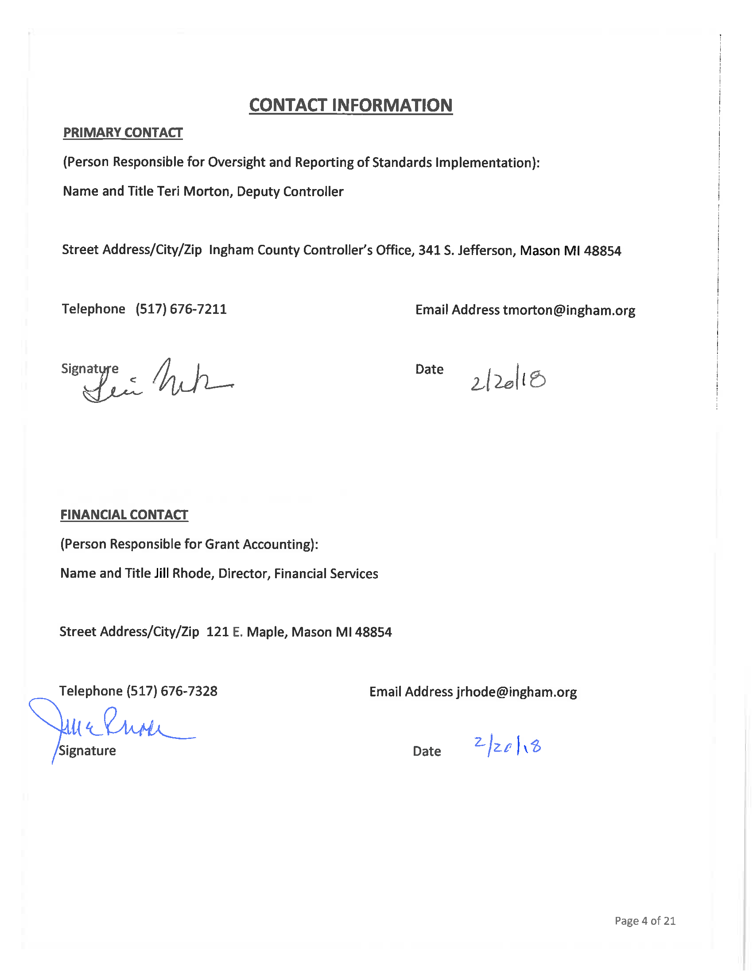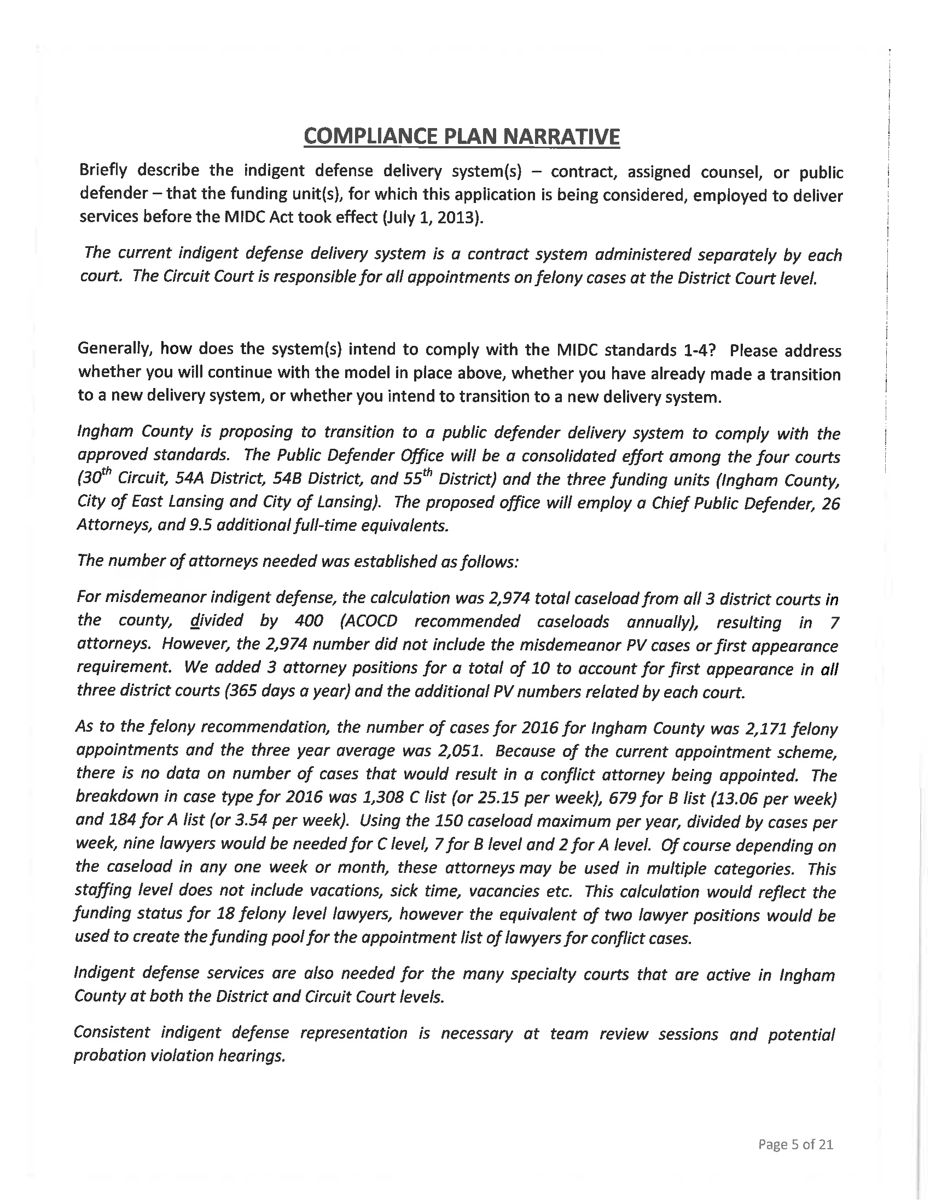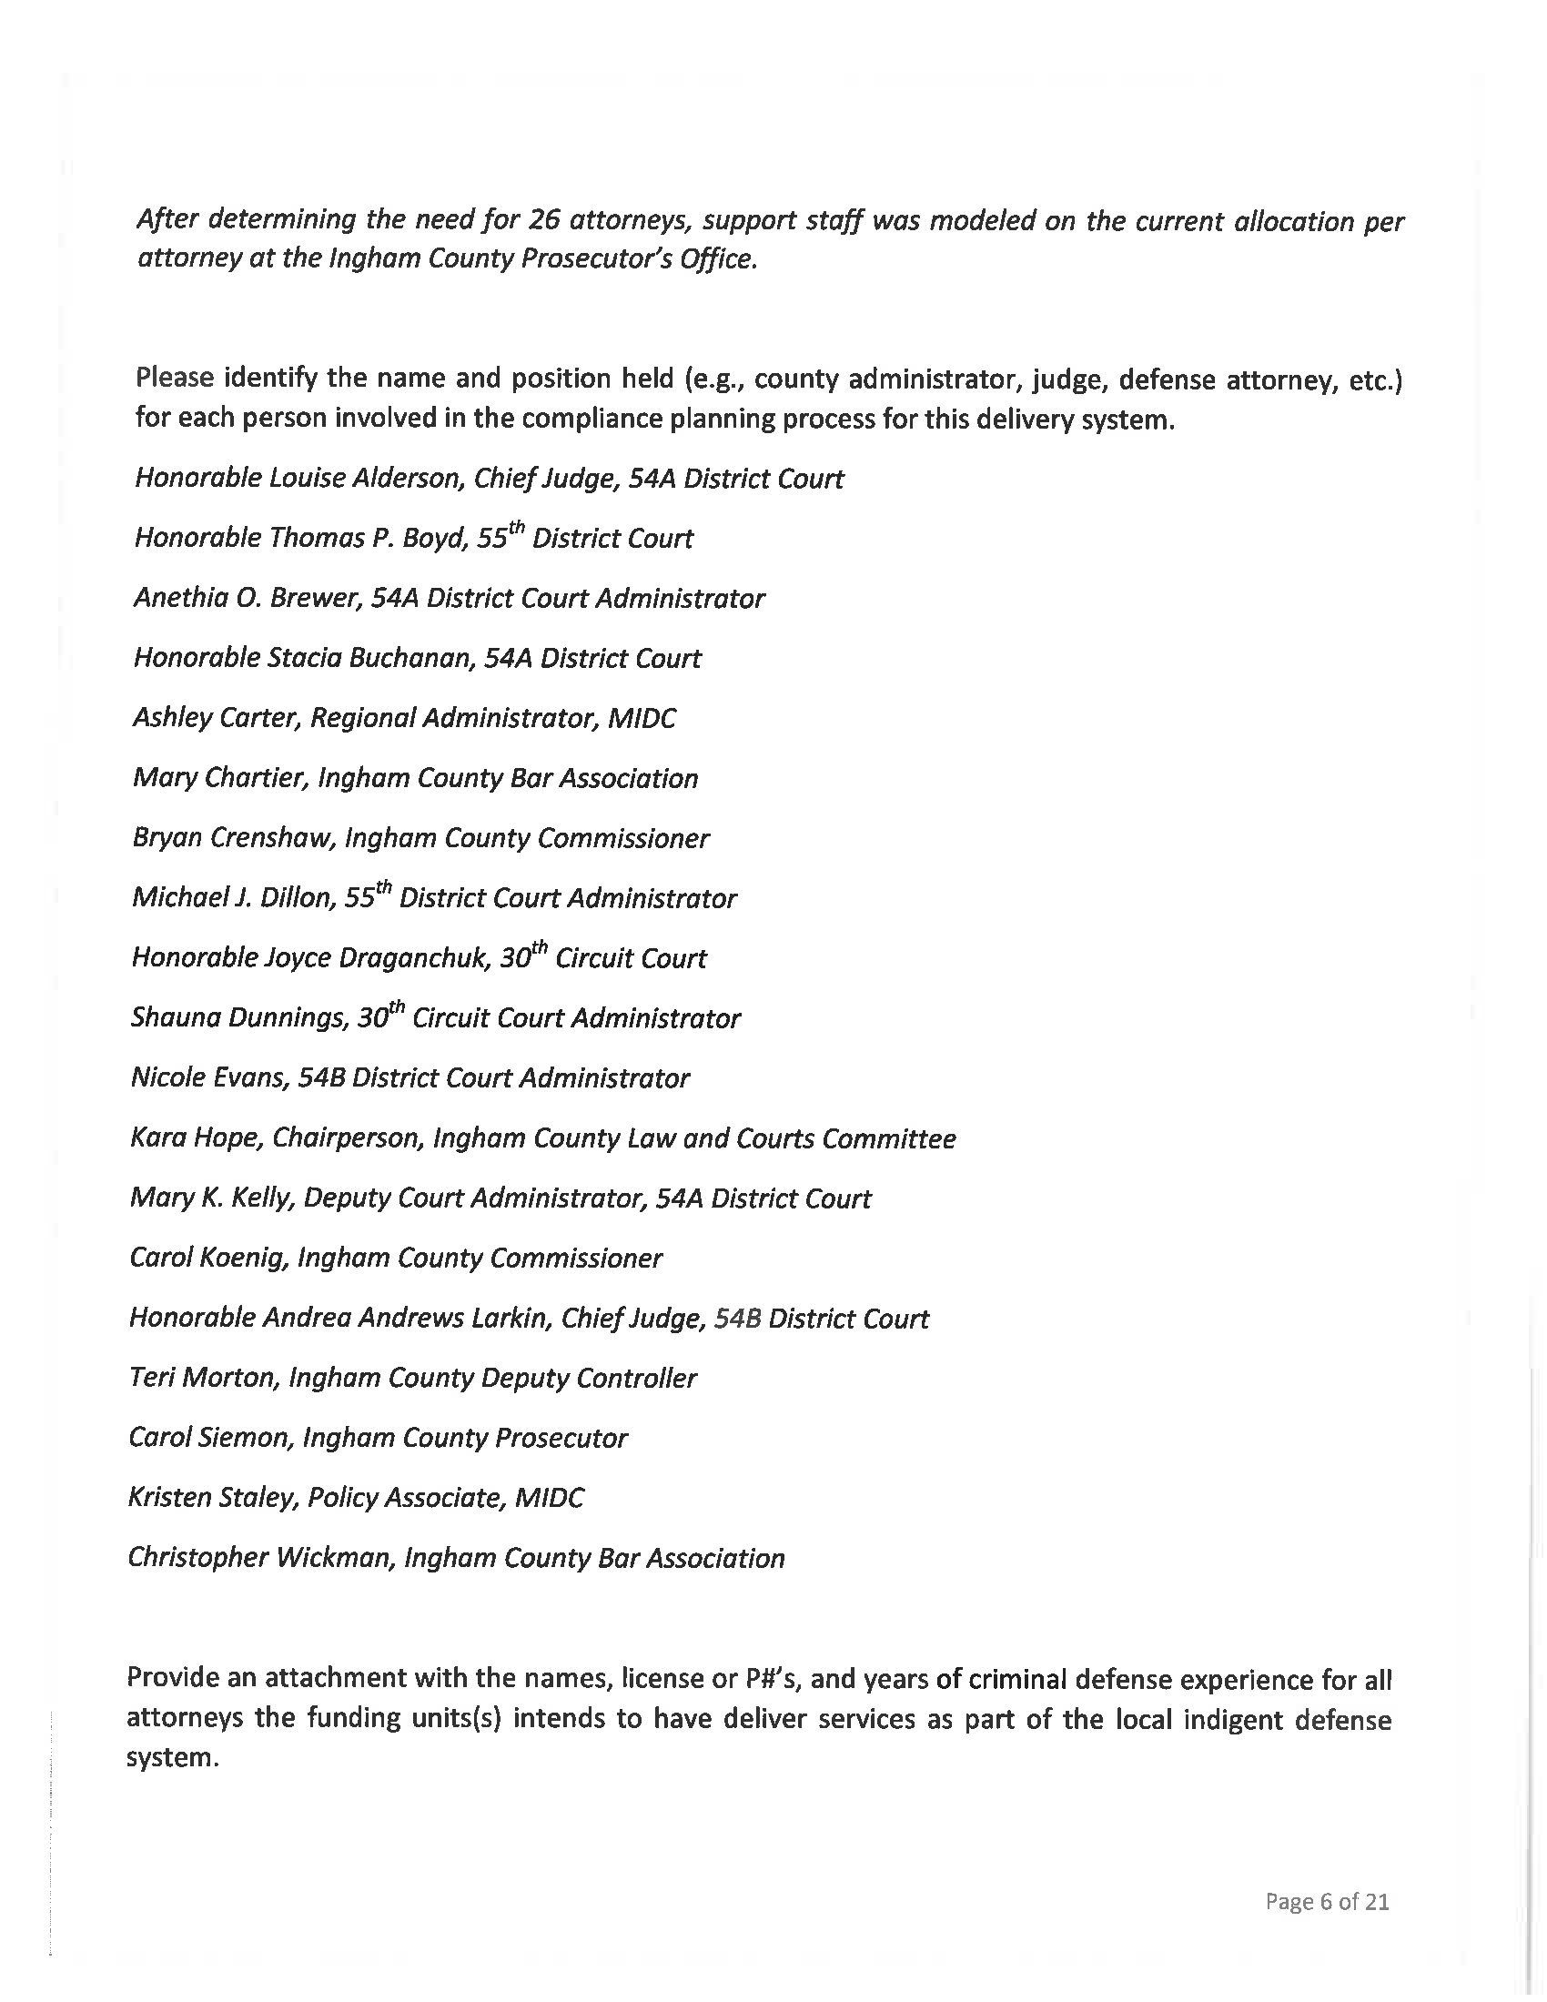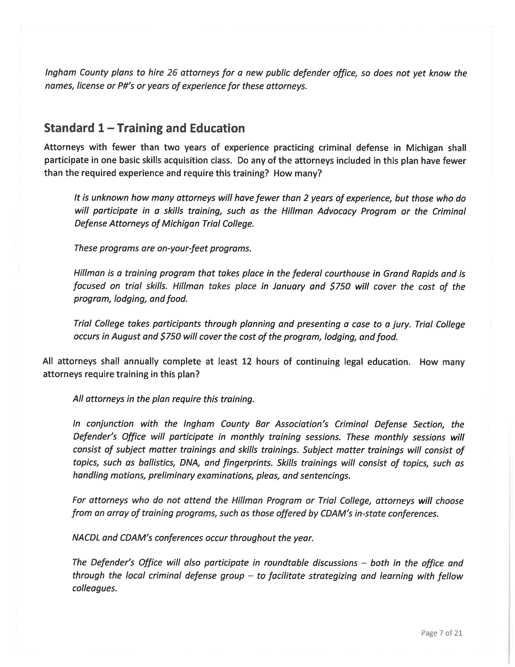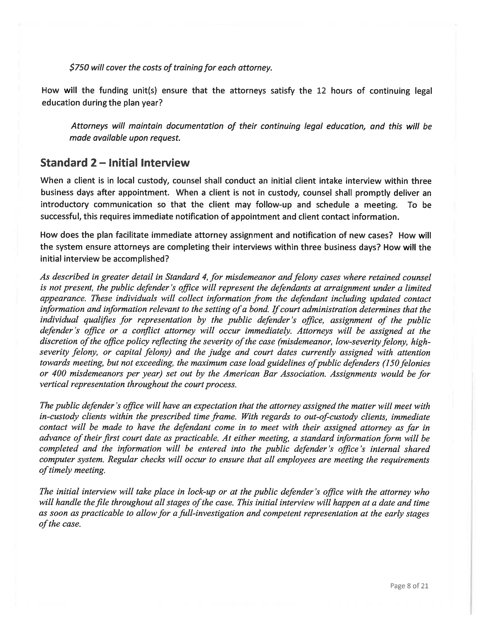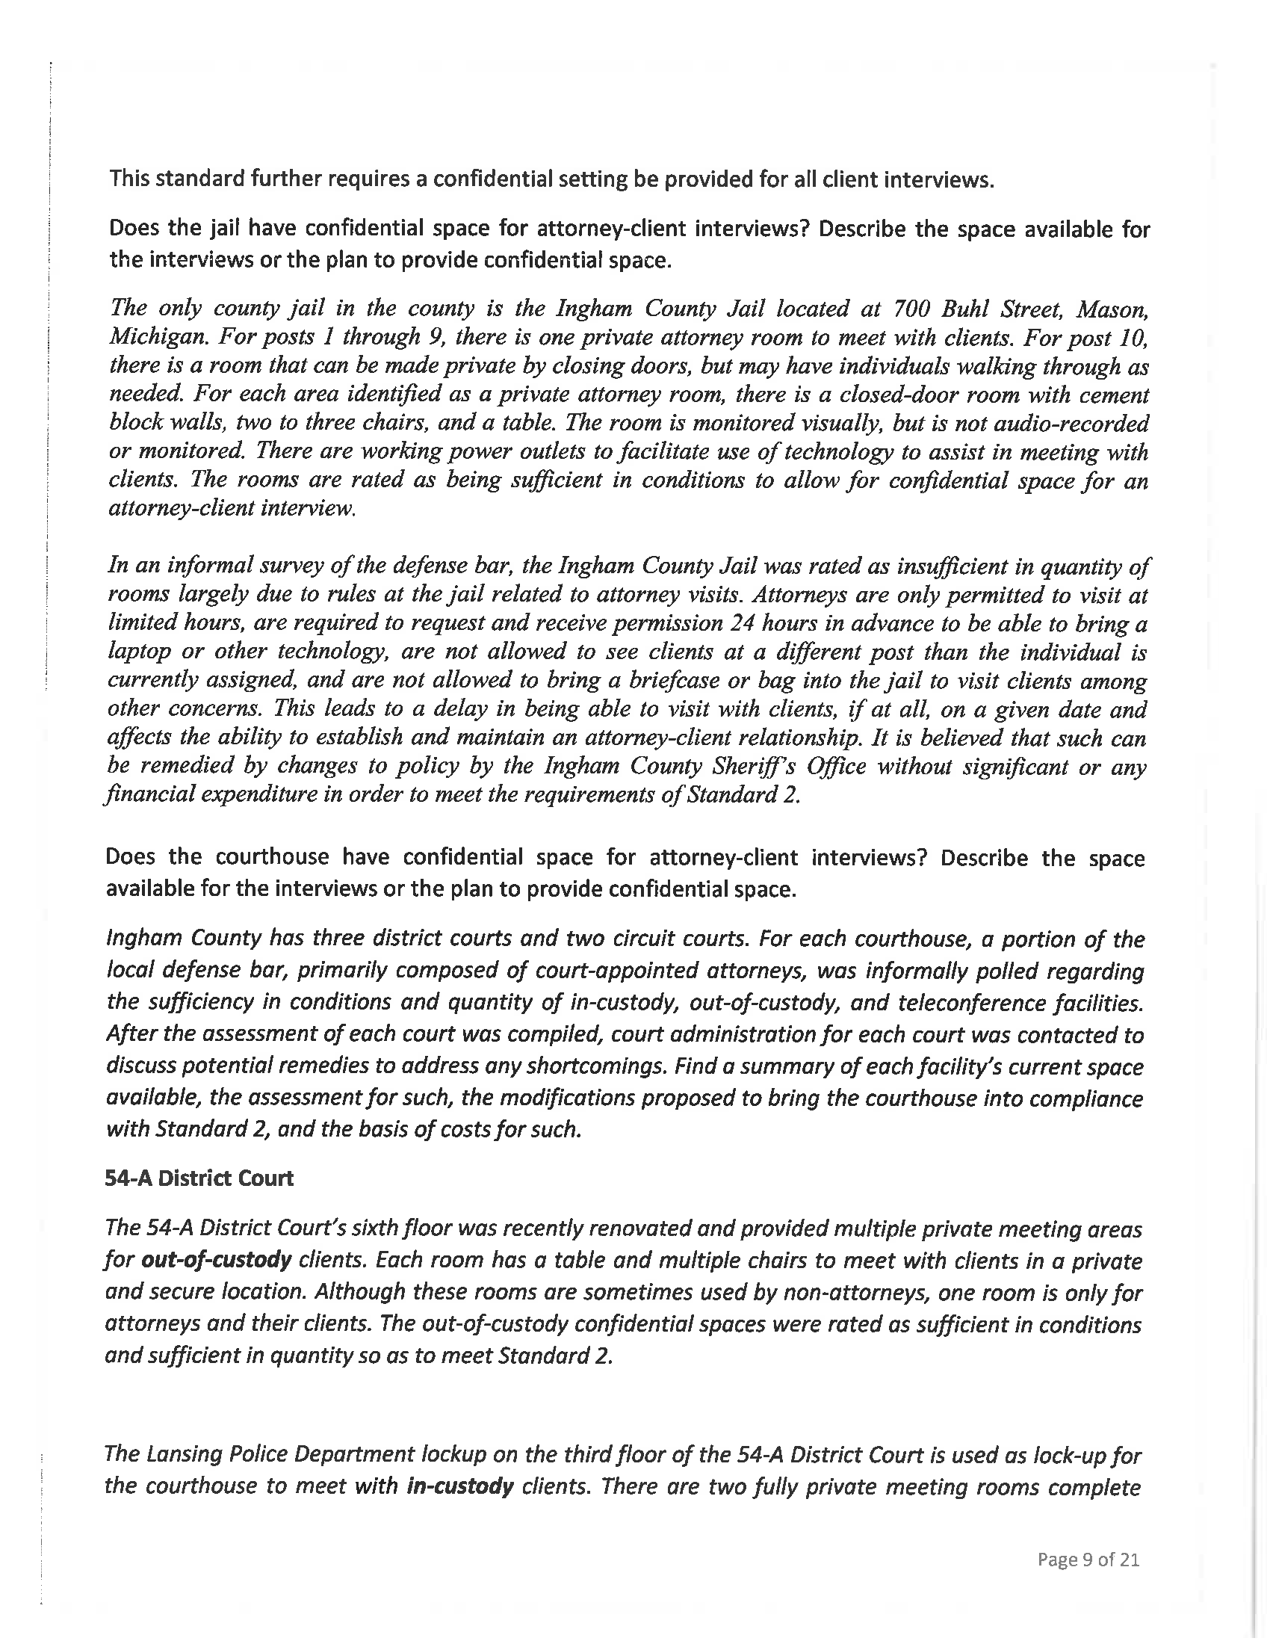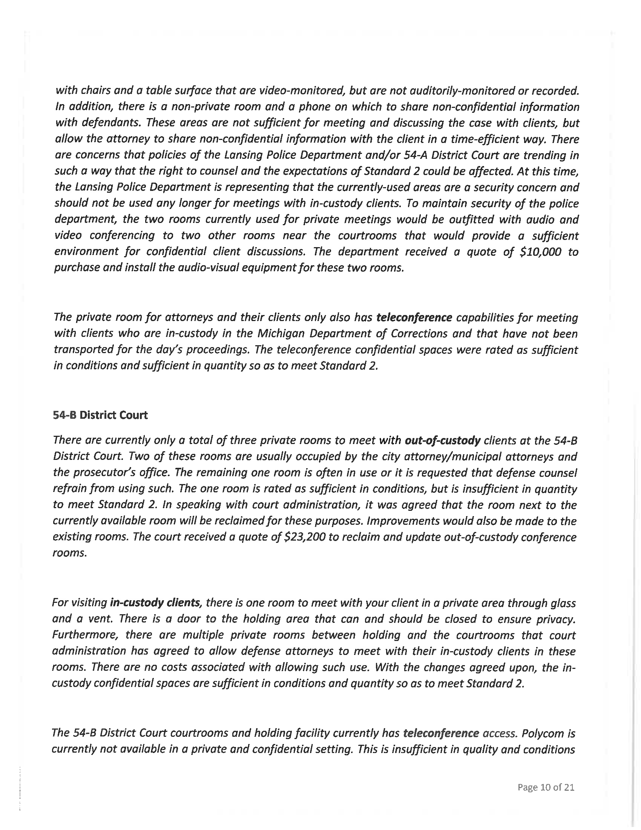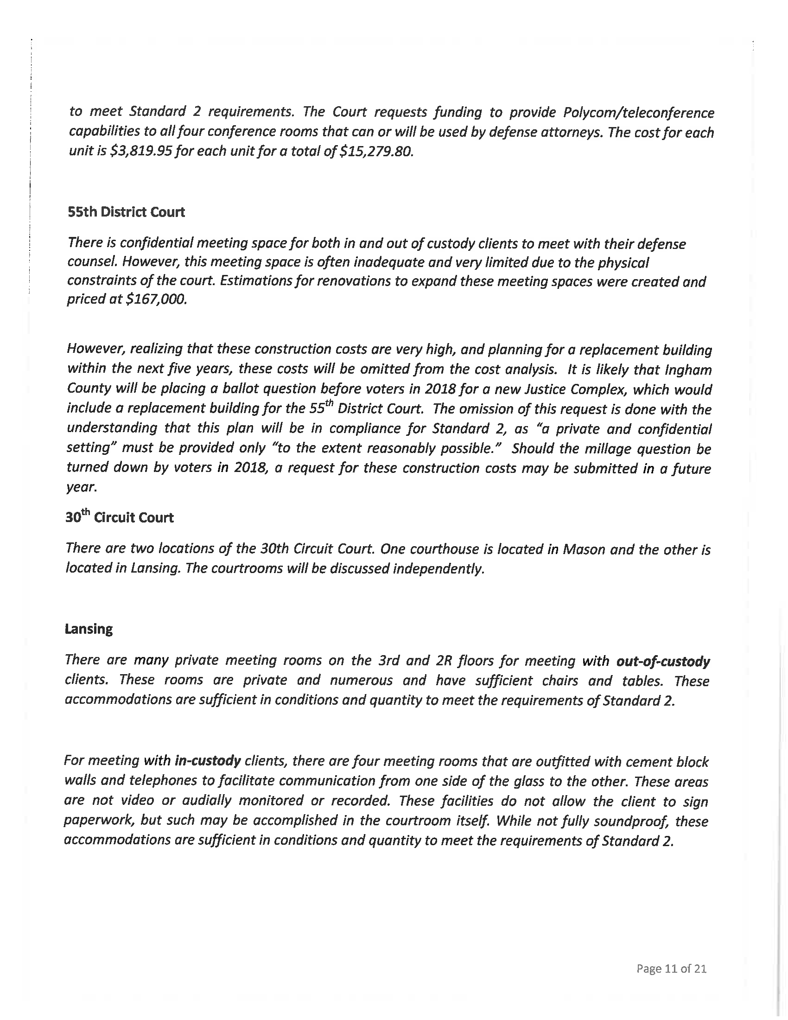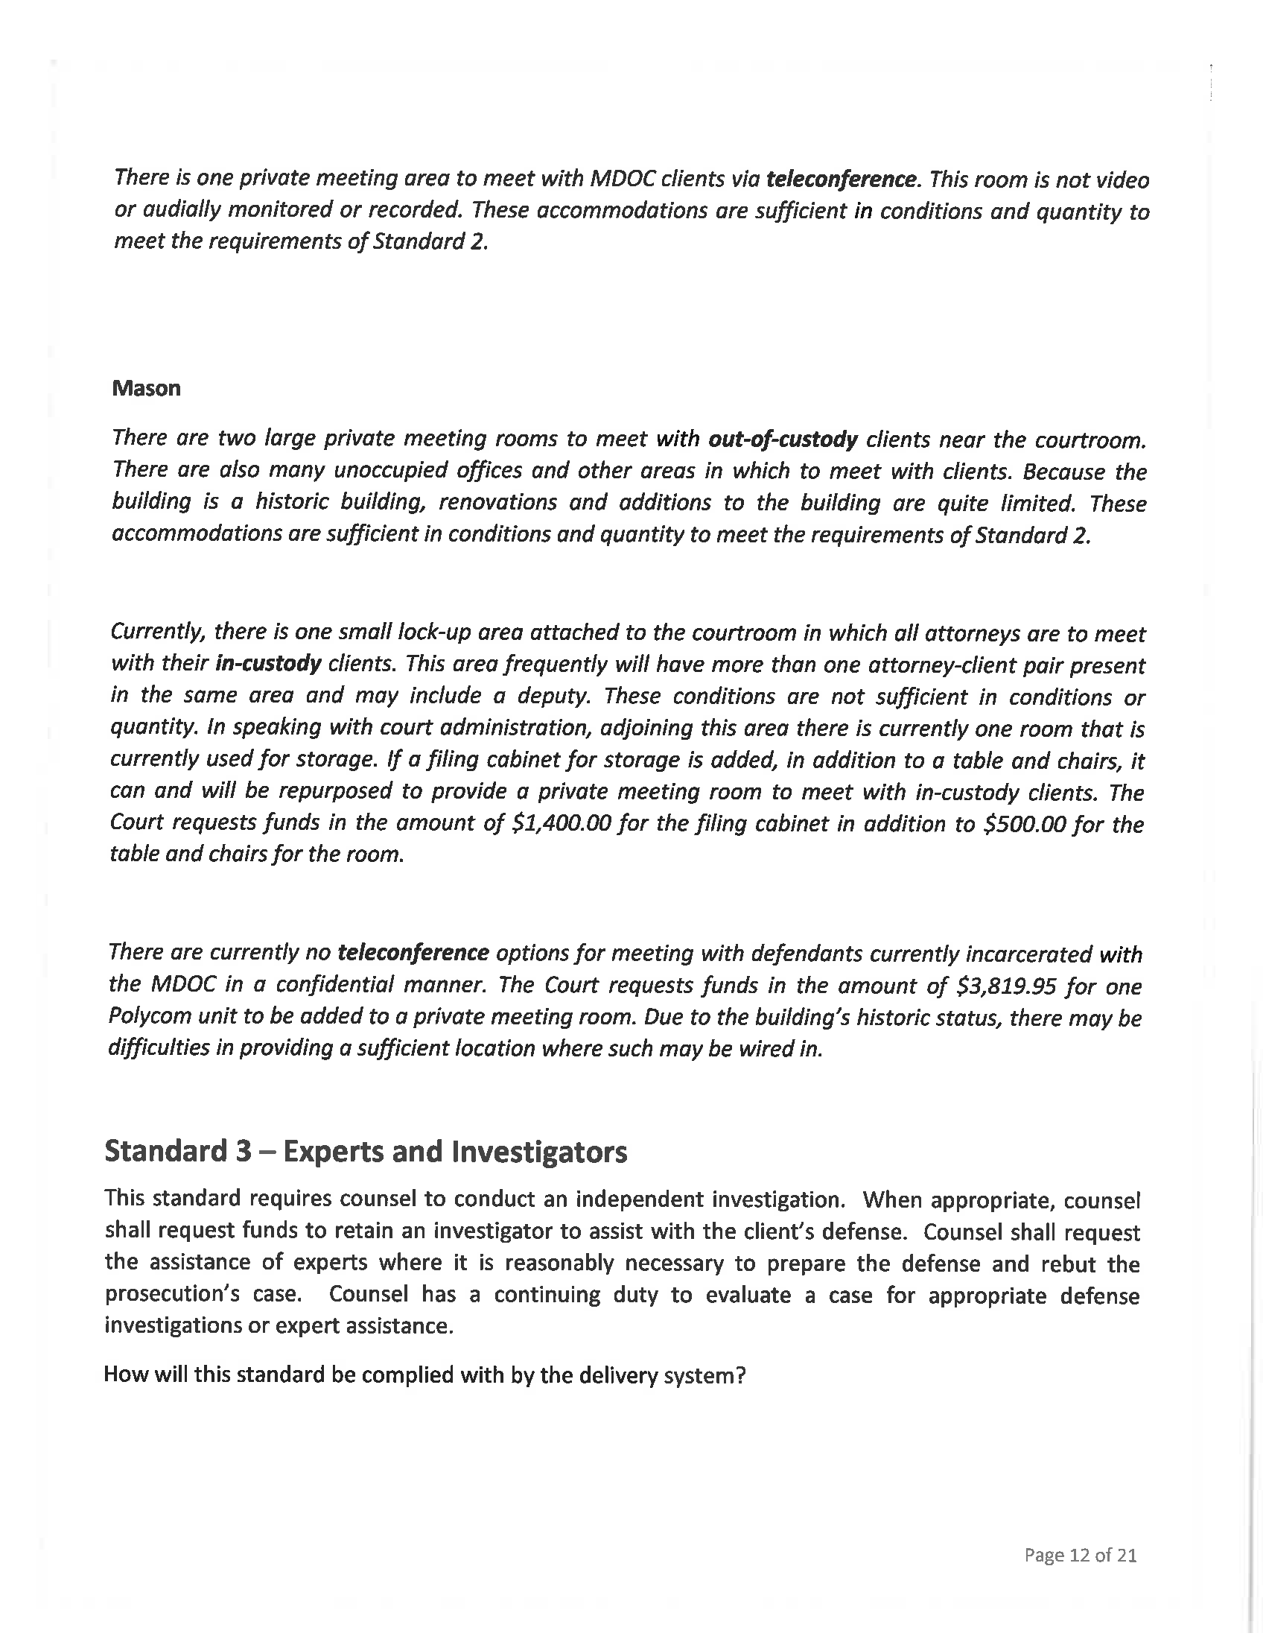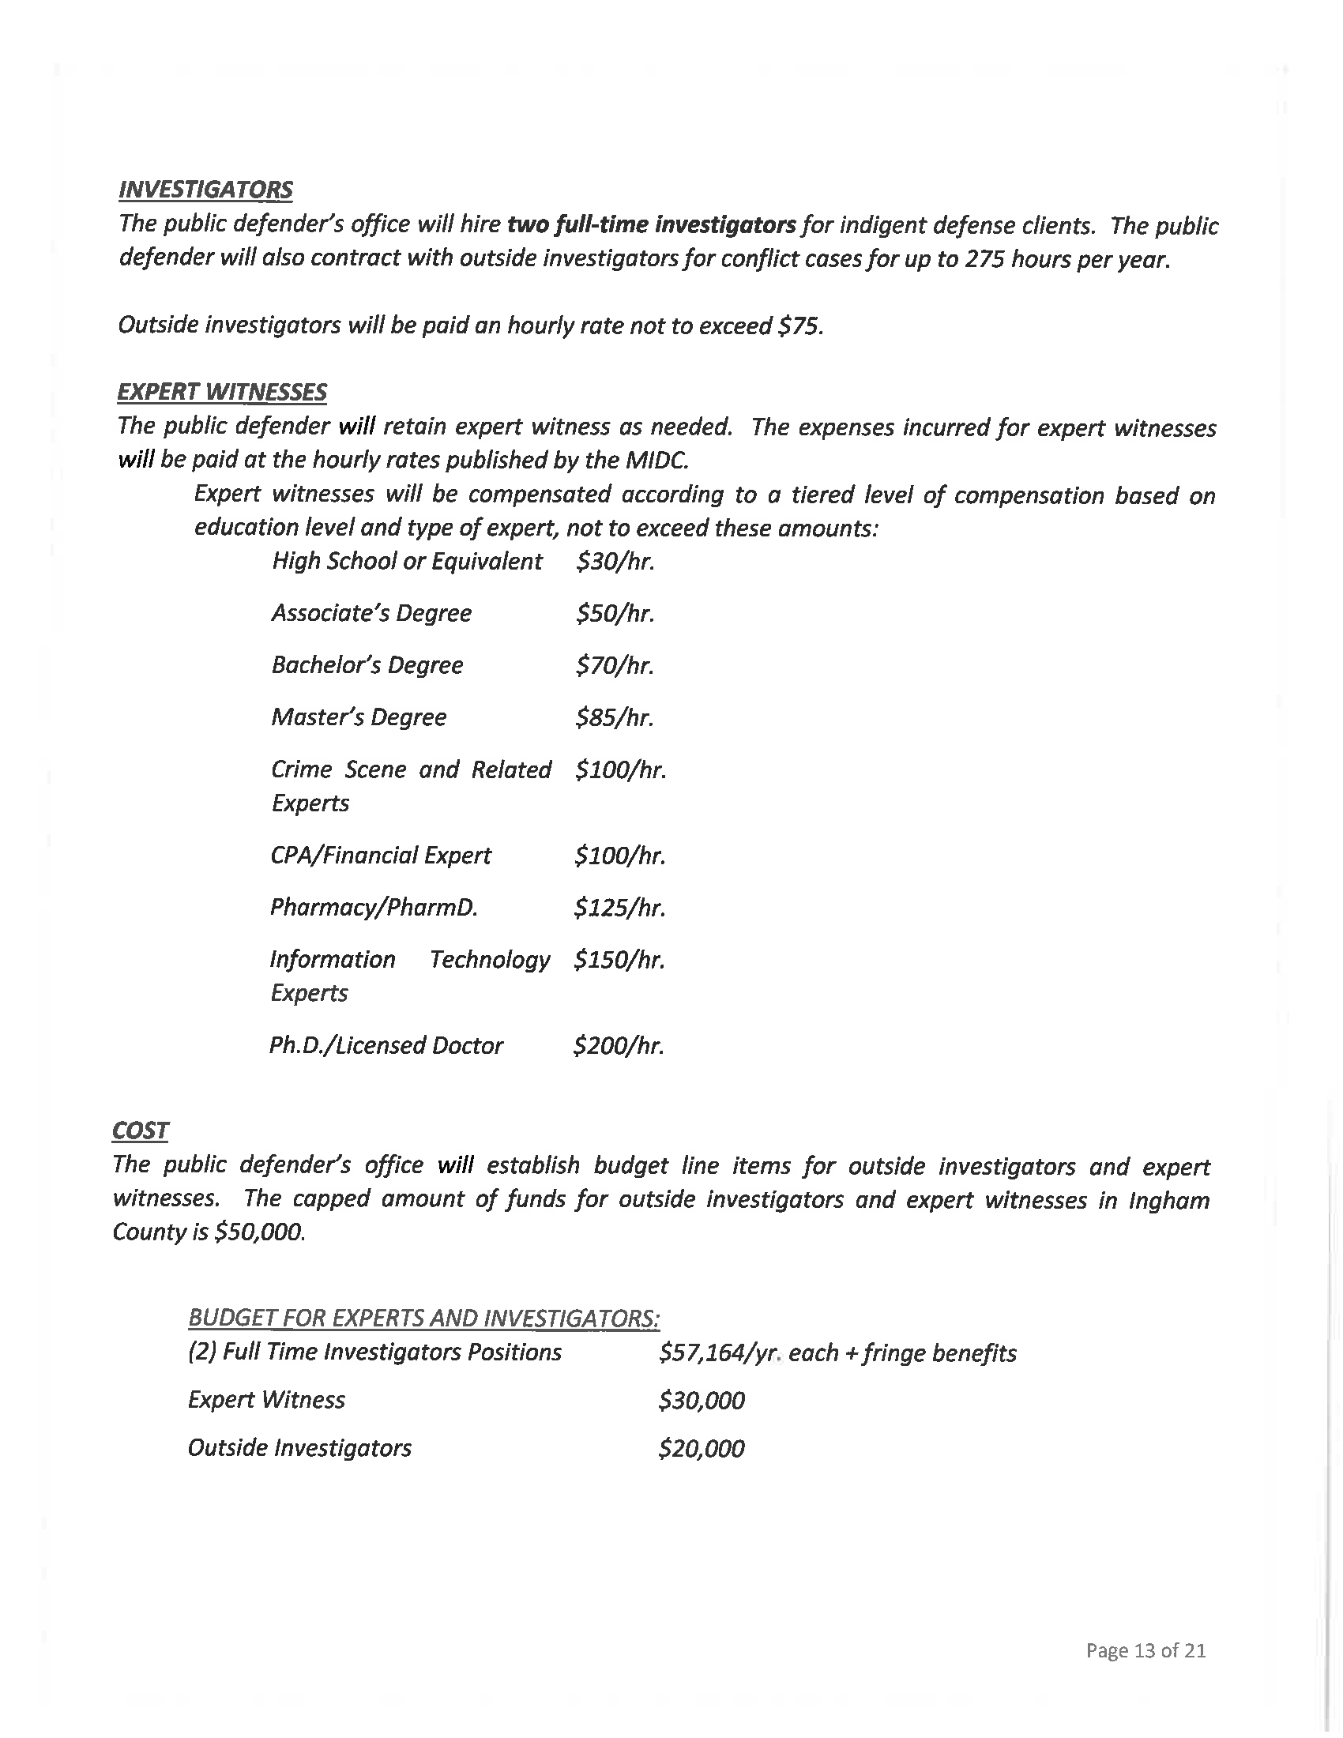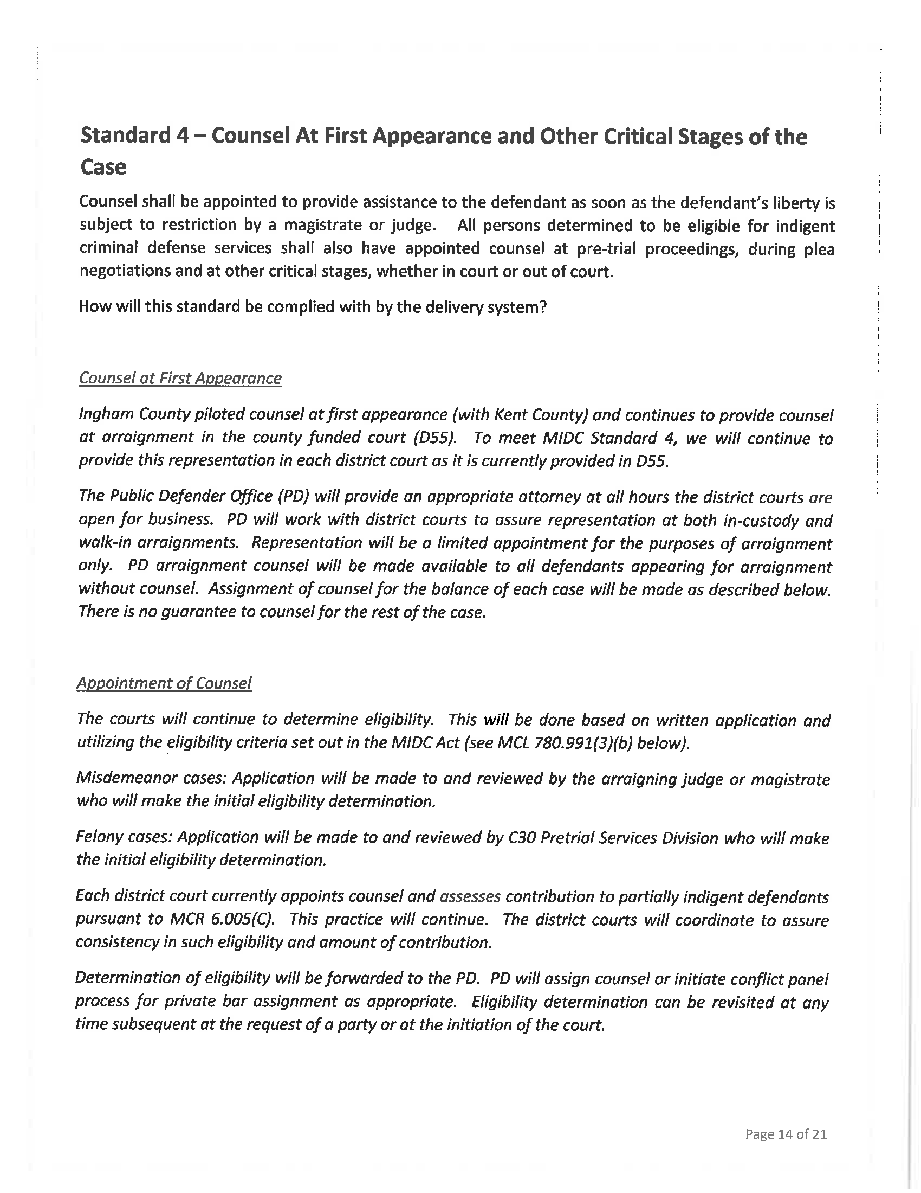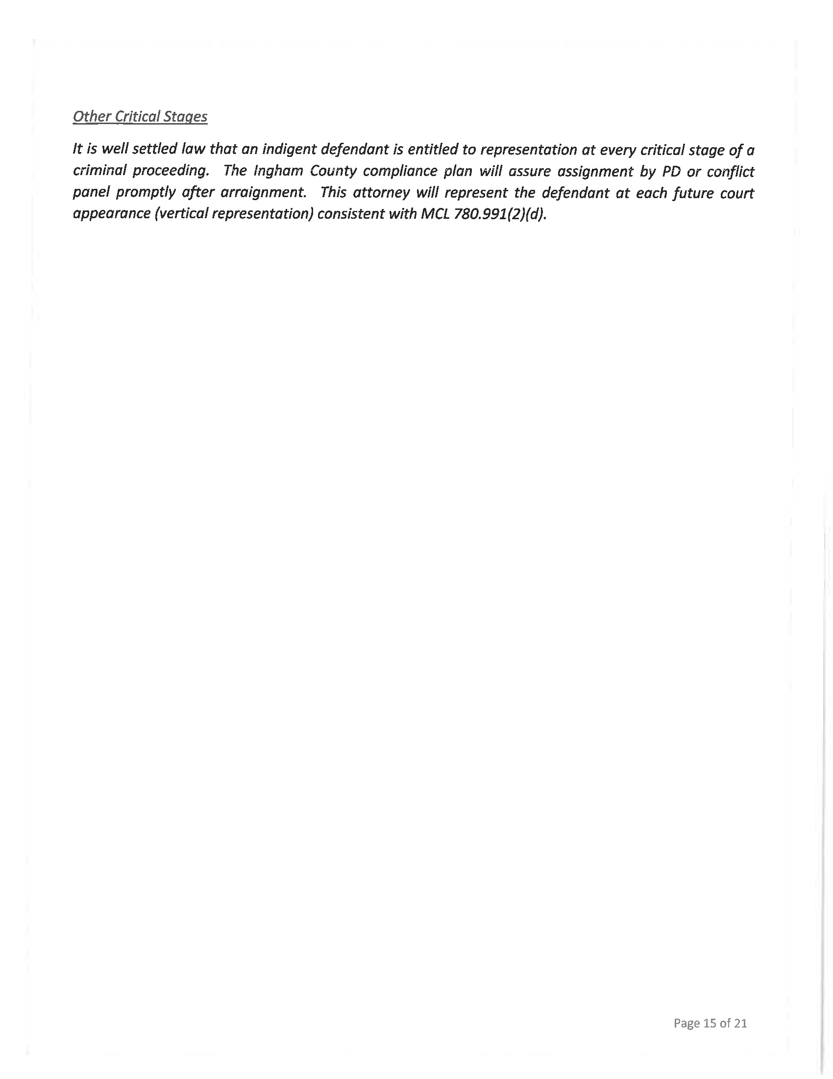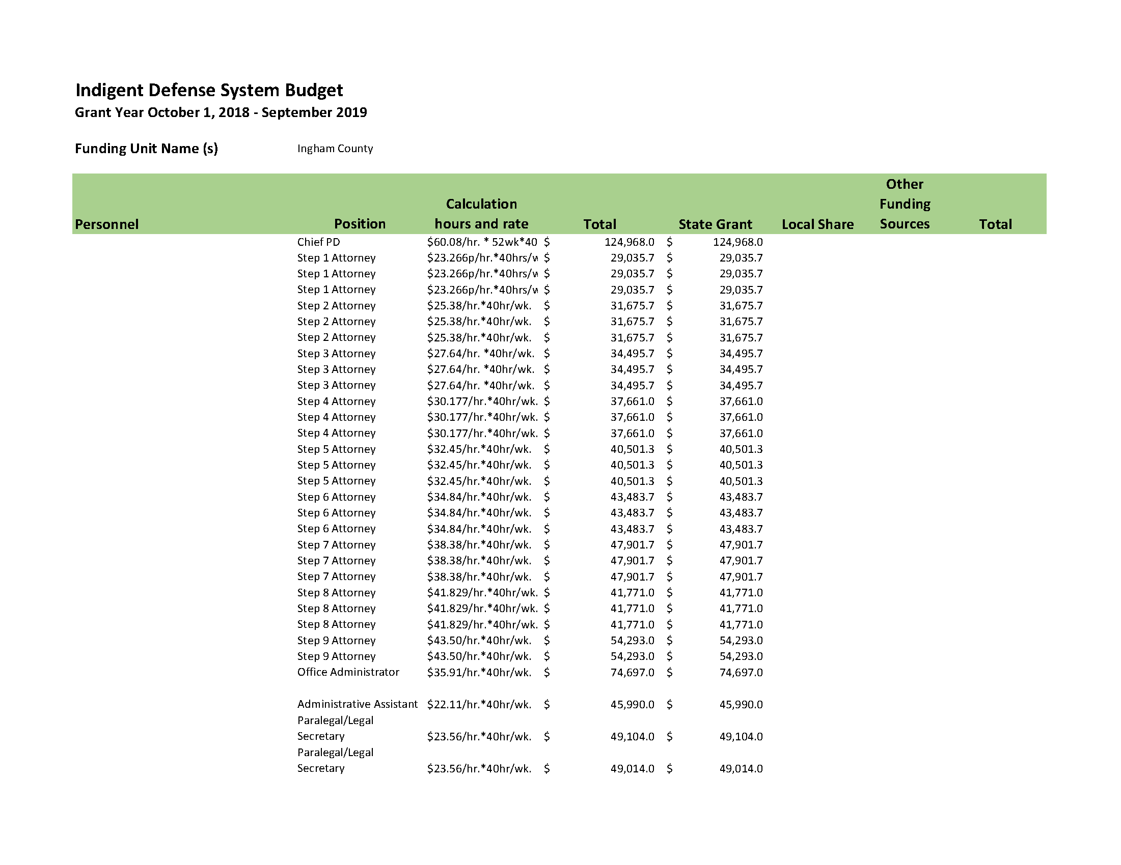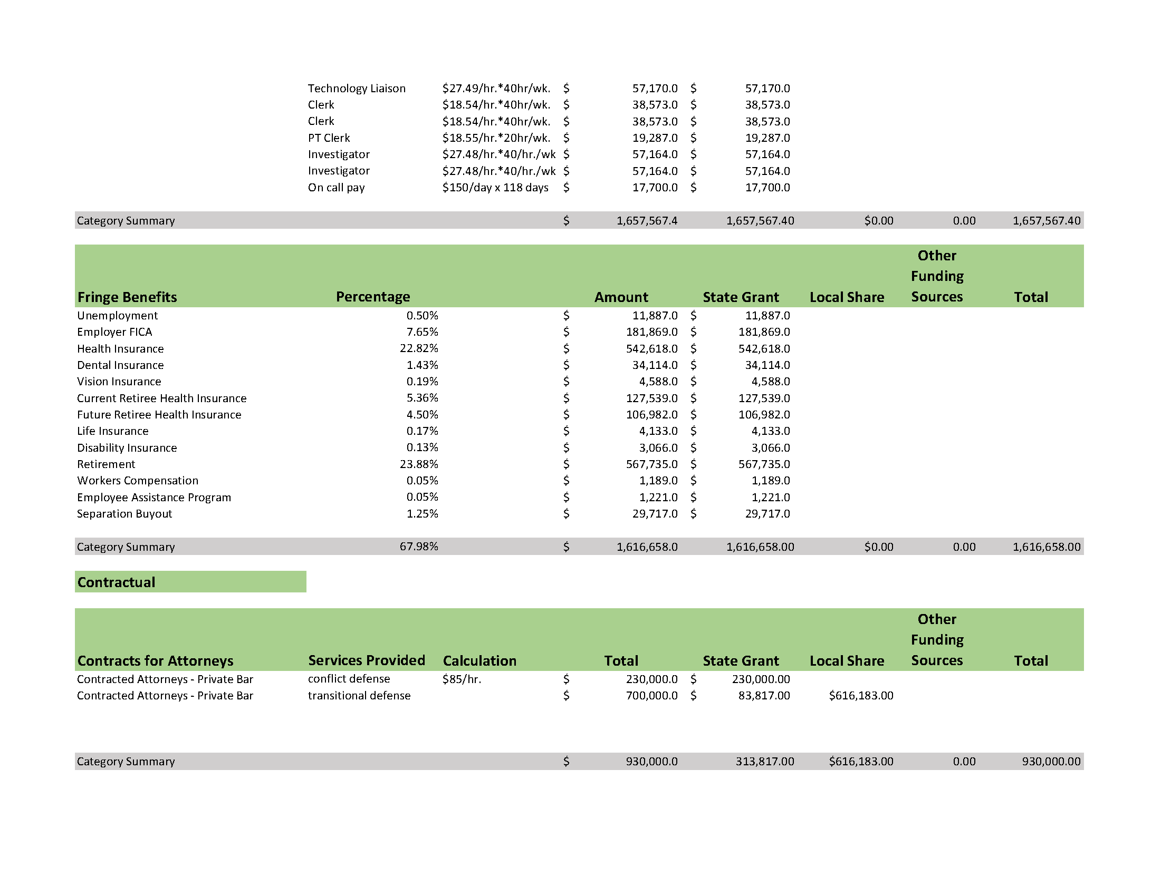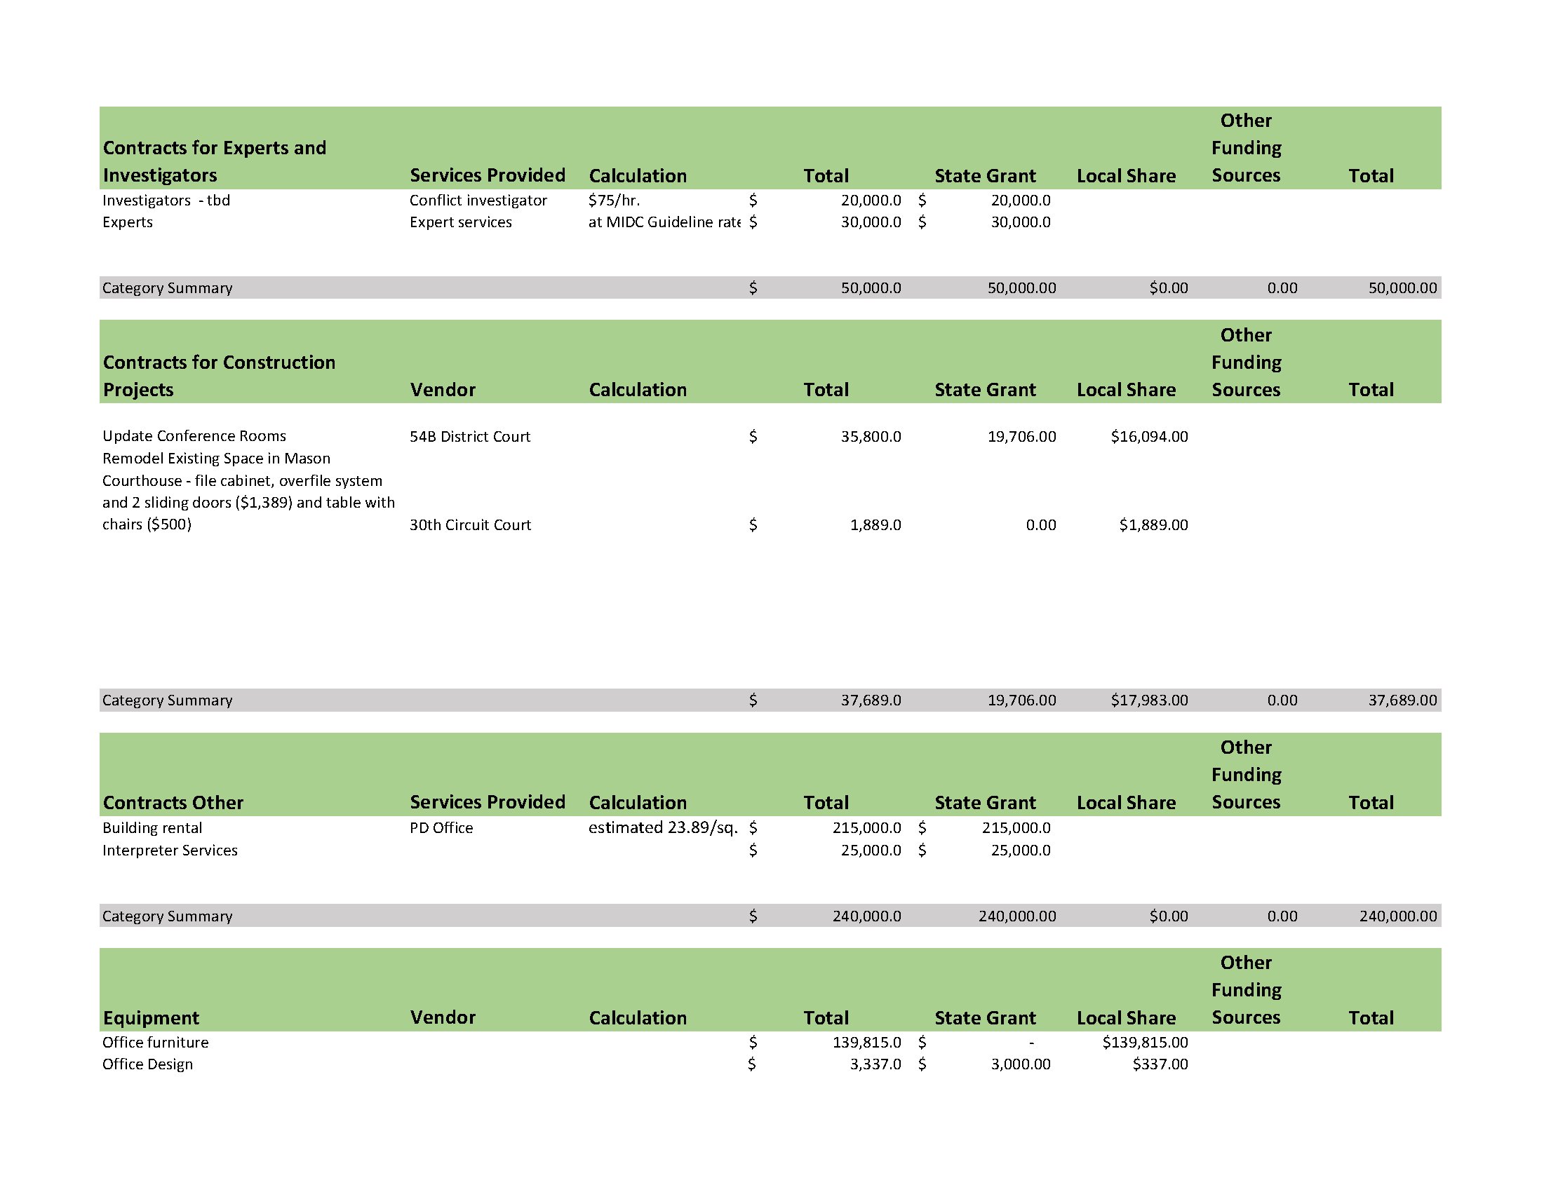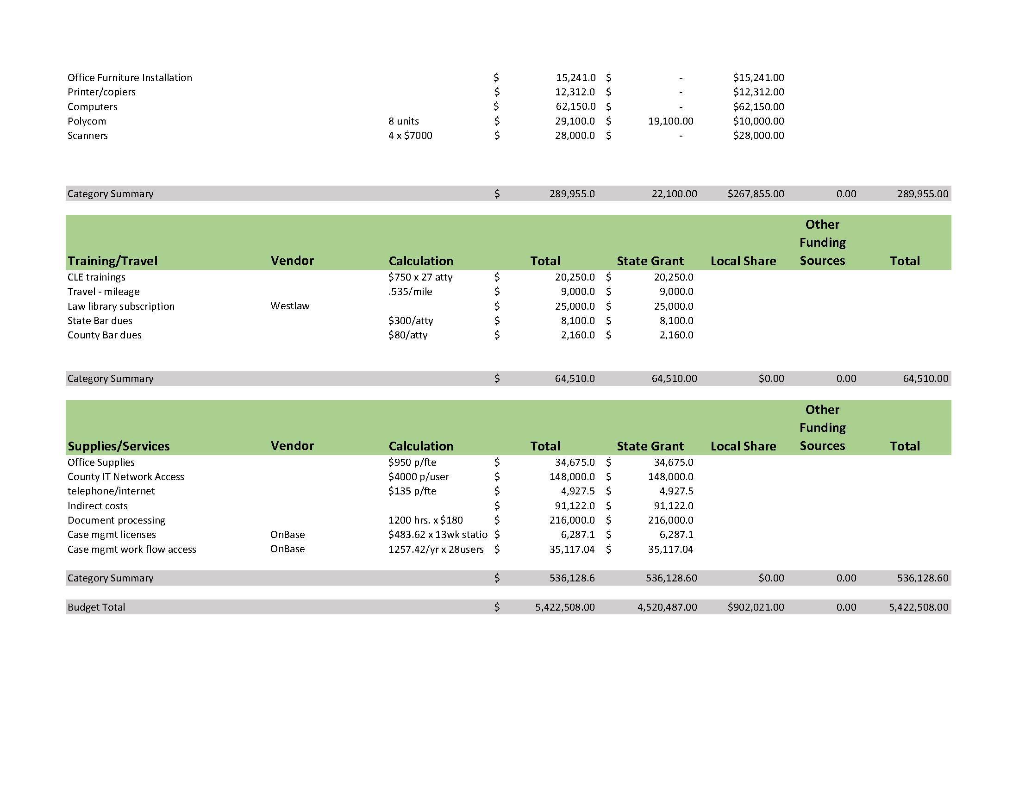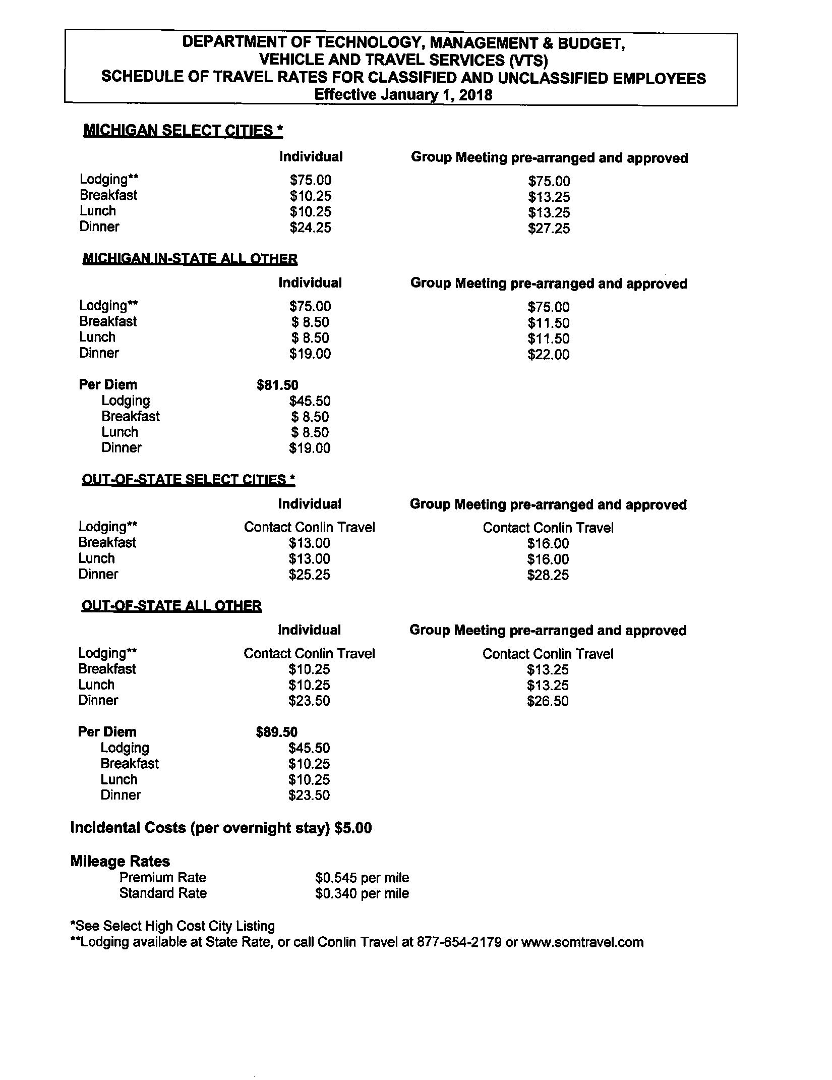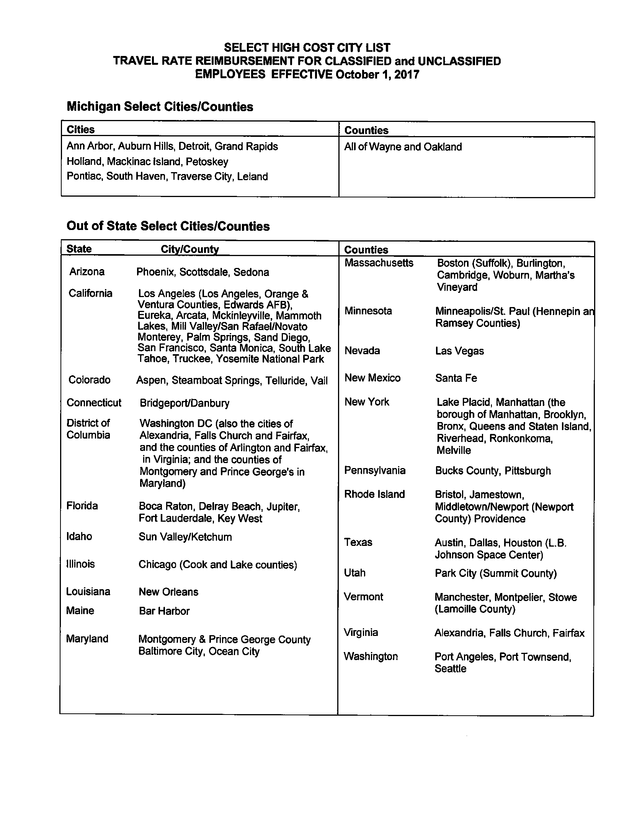

ADOPTED – NOVEMBER 13, 2018
AGENDA ITEM NO. 30

Introduced by the Law & Courts and Finance Committees of the:

INGHAM COUNTY BOARD OF COMMISSIONERS

RESOLUTION TO PURCHASE A USED 2018 BOSTON WHALER BOAT FOR INGHAM COUNTY SHERIFF’S OFFICE MARINE PATROL FROM GULL LAKE MARINE

RESOLUTION # 18 – 477

WHEREAS, the Ingham County Sheriff’s Office is responsible for patrolling and maintaining the safe waterways of Ingham County; and

WHEREAS, the Ingham County Sheriff’s Office is requesting to purchase a used 2018 Boston Whaler Boat from Gull Lake Marine; and

WHEREAS, the used 2018 Boston Whaler comes fully equipped with all equipment to patrol the waterways of Ingham County; and

WHEREAS, the used 2018 Boston Whaler Boat can only be purchased from Gull Lake Marine; and

WHEREAS, no other dealership in Michigan has or can provide the same boat with required equipment as the boat located at Gull Lake Marine; and

WHEREAS, Gull Lake Marine is a sole source company for this equipment; and

WHEREAS, the total expenditure for this proposal is not to exceed $42,920.00.

THEREFORE BE IT RESOLVED, that the Ingham County Board of Commissioners authorizes the Sheriff’s Office to purchase a 2018 Boston Whaler and associated equipment from Gull Lake Marine for a total not to exceed $42,920.00.

BE IT FURTHER RESOLVED, that Ingham County recognizes Gull Lake Marine as a sole source vendor for this equipment.

BE IT FURTHER RESOLVED, that the Controller/Administrator is directed to make the necessary adjustments to the 2018 Sheriff’s Office budget.

BE IT FURTHER RESOLVED, that the Ingham County Board of Commissioners authorizes the Board Chairperson to sign any necessary contract documents or purchase documents that are consistent with this resolution and approved as to form by the County Attorney.

LAW & COURTS: Yeas: Crenshaw, Celentino, Banas, Schafer, Maiville
Nays: None Absent: Hope, Anthony Approved 11/01/2018

FINANCE: Yeas: Grebner, Crenshaw, Tennis, Morgan, Schafer
Nays: None Absent: Anthony Approved 11/07/2018

ADOPTED – NOVEMBER 13, 2018
AGENDA ITEM NO. 31

Introduced by the Law & Courts and Finance Committees of the:

INGHAM COUNTY BOARD OF COMMISSIONERS

RESOLUTION TO AUTHORIZE A CONTRACT WITH THE INGHAM COUNTY
SHERIFF’S OFFICE AND ROBERTSON RESEARCH INSTITUTE

RESOLUTION # 18 – 478

WHEREAS, the Ingham County Sheriff’s Office wishes to enter ino contract with Robertson Research Institute for the services of a wellness program; and

WHEREAS, the Robertson Research Institute will provide a 1 year wellness program that will include health and education programs for 20 employees of the Sheriff’s Office; and

WHEREAS, this wellness program will consist of individual assessments, seminars and one-on-one meetings throughout the 1 year program; and

WHEREAS, the Robertson Research Institute will provide identified information and outcomes of the programs results; and

WHEREAS, the total expenditure for this proposal is not to exceed $10,000.00.

THEREFORE BE IT RESOLVED, that the Ingham County Board of Commissioners authorizes the Sheriff’s Office to enter into a contract agreement with Robertson Research Institute for the period of October 1, 2018 through September 30, 2019 for an amount not to exceed $10,000 for the purpose of providing a wellness program for employees of the Ingham County Sheriff’s Office.

BE IT FURTHER RESOLVED, that Ingham County recognizes Robertson Research Institute a sole source vendor for this program.

BE IT FURTHER RESOLVED, that the Controller/Administrator is directed to make the necessary adjustments to the 2018 Sheriff’s Office budget.

BE IT FURTHER RESOLVED, that the Ingham County Board of Commissioners authorizes the Board Chairperson to sign any necessary contract documents that are consistent with this resolution and approved as to form by the County Attorney.

LAW & COURTS: Yeas: Crenshaw, Celentino, Banas, Schafer, Maiville
Nays: None Absent: Hope, Anthony Approved 11/01/2018

FINANCE: Yeas: Grebner, Crenshaw, Tennis, Morgan, Schafer
Nays: None Absent: Anthony Approved 11/07/2018

ADOPTED – NOVEMBER 13, 2018
AGENDA ITEM NO. 32

Introduced by the Law & Courts and Finance Committees of the:

INGHAM COUNTY BOARD OF COMMISSIONERS

RESOLUTION TO ACCEPT A BISSELL PET FOUNDATION EMPTY THE SHELTERS
FREE ADOPTION GRANT

RESOLUTION # 18 – 479

WHEREAS, the Ingham County Animal Control and Shelter has applied for and has been approved to receive a grant from the BISSELL Pet Foundation; and

WHEREAS, the purpose of this grant is to reimburse Ingham County Animal Control for no fee animal adoptions finalized on December 1st, 2018; and

WHEREAS, the award amount of this grant is dependent on the number of animals adopted on December 1st, 2018, but is anticipated to not exceed $5,000.

THEREFORE BE IT RESOLVED, that the Ingham County Board of Commissioners approves acceptance of the grant from the BISSELL Pet Foundation for an amount to be determined by the number of adoptions finalized on December 1st, 2018, but not to exceed $5,000 with no match requirement.

BE IT FURTHER RESOLVED, the Ingham County Board of Commissioners authorizes the Board Chairperson to sign any necessary contract documents which are consistent with this resolution and approved as to form by the County Attorney.

BE IT FURTHER RESOLVED, the Ingham County Board of Commissioners authorizes the Controller/Administrator to make the necessary budget adjustments to the Ingham County Animal Control budget.

LAW & COURTS: Yeas: Crenshaw, Celentino, Banas, Schafer, Maiville
Nays: None Absent: Hope, Anthony Approved 11/01/2018

FINANCE: Yeas: Grebner, Crenshaw, Tennis, Morgan, Schafer
Nays: None Absent: Anthony Approved 11/07/2018

