ADOPTED – NOVEMBER 27, 2018
AGENDA ITEM NO. 20

Introduced by the Human Services and Finance Committees of the:

INGHAM COUNTY BOARD OF COMMISSIONERS

RESOLUTION TO AUTHORIZE AN ADMINISTRATIVE SERVICE AGREEMENT WITH
BLUE CROSS BLUE SHIELD OF MICHIGAN AT THE INGHAM COUNTY JAIL

RESOLUTION # 18 – 496

WHEREAS, Ingham County Health Department (ICHD) wishes to update the Blue Cross Blue Shield of Michigan (BCBSM) agreement by executing Schedule A, Schedule A – Exhibit 1, and Schedule B (BlueCard Disclosures Inter-Plan Arrangements) effective December 1, 2018 through November 30, 2019; and

WHEREAS, ICHD and BCBSM entered into an agreement in 1996 wherein BCBSM would pay the claims of health care services provided to inmate of Ingham County jail; and

WHEREAS, that agreement is updated annually by executing a Schedule A Administrative Service Contract (ASC), Schedule A – Exhibit 1 and Schedule B (BlueCard Disclosure Inter-Plan Arrangements; and

WHEREAS, BCBSM has proposed a 2018-2019 Schedule A Administrative Service Contract, Schedule A – Exhibit 1 and Schedule B (BlueCard Disclosures Inter-Plan Arrangements; and

WHEREAS, there are no changes to the proposed 2018-2019 Schedule A Administrative Service Contract (ASC), Schedule A – Exhibit 1 and Schedule B (BlueCard Disclosures Inter-Plan Arrangements; and

WHEREAS, the Health Officer recommends that the Board of Commissioners authorize the 2018-2019 Schedule A Administrative Service Contract (ASC), Schedule A – Exhibit 1 and Schedule B (BlueCard Disclosures Inter-Plan Arrangements) for the inmates of Ingham County Jail.

THEREFORE BE IT RESOLVED, that the Board of Commissioners authorize the Schedule A Administrative Service Contract (ASC), Schedule A – Exhibit 1 and Schedule B (BlueCard Disclosures Inter-Plan Arrangements) with BCBSM for paying claims for health care services provided to inmates of the Ingham County Jail.

BE IT FURTHER RESOLVED, that the Schedule A Administrative Service Contract (ASC),
Schedule 1 – Exhibit 1 and Schedule B (BlueCard Disclosure Inter-Plan Arrangements) shall be effective December 1, 2018 through November 30, 2019.

BE IT FURTHER RESOLVED, that there are no other changes to the proposed 2018 -2019 Schedule A Administrative Service Agreement (ASC), Schedule 1 – Exhibit 1 and Schedule (BlueCard Disclosures Inter-Plan Arrangements.

BE IT FURTHER RESOLVED, that the Chairperson of the Board of Commissioners is hereby authorized to sign any necessary contract documents on behalf of the county after approval as to form by the County Attorney.

HUMAN SERVICES: Yeas: Banas, Tennis, Sebolt, Nolan, Morgan, Triplett, Naeyaert
Nays: None Absent: None Approved 11/19/2018

FINANCE: Yeas: Grebner, Crenshaw, Tennis, Slaughter, Triplett, Schafer
Nays: None Absent: Morgan Approved 11/20/2018

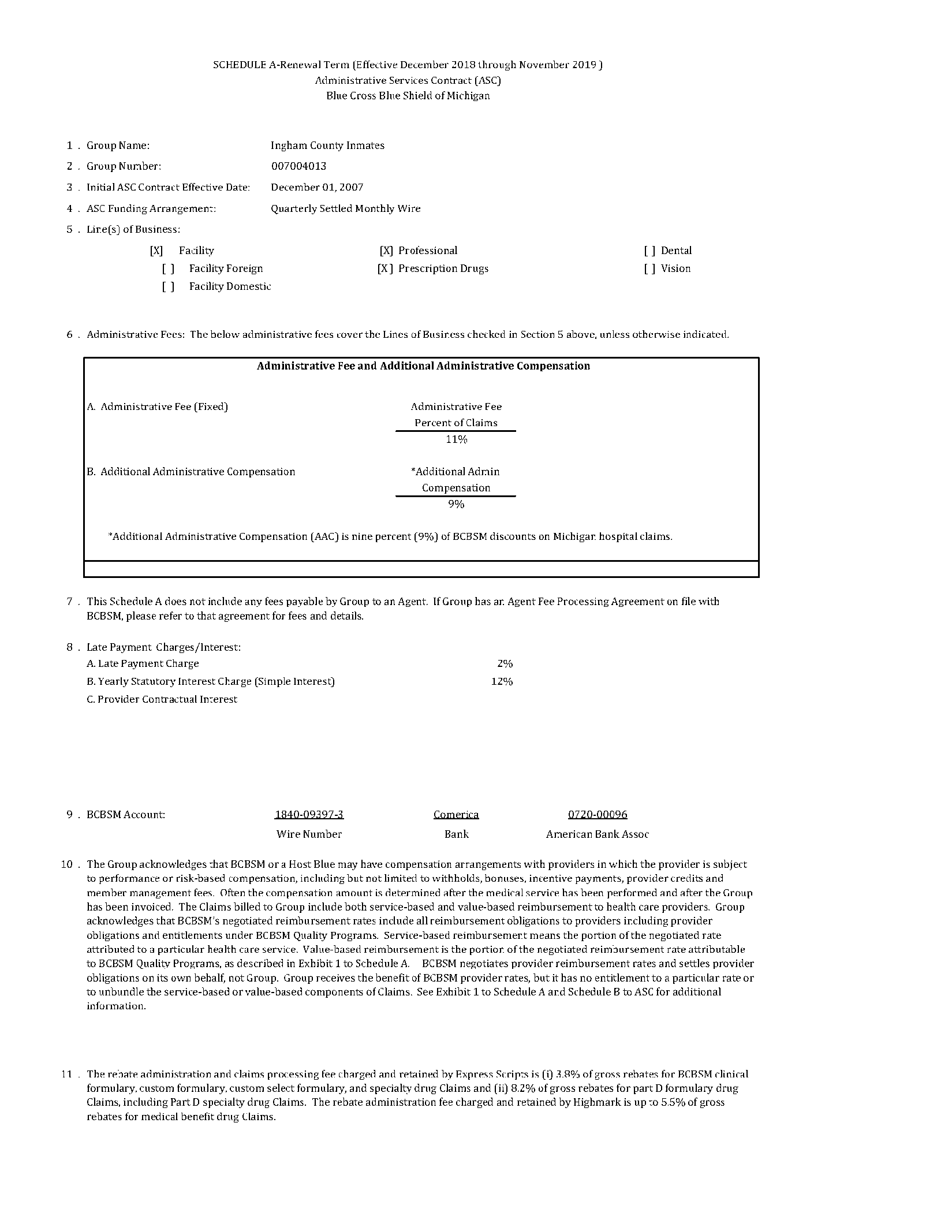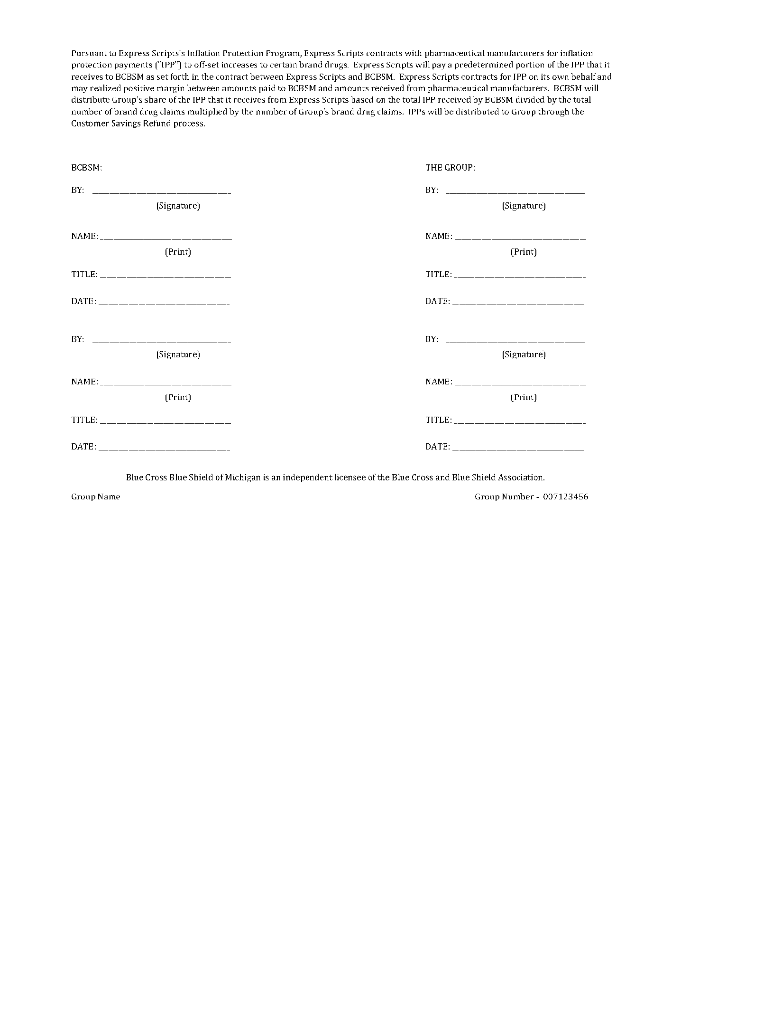

Schedule A - Exhibit 1
BCBSM Value-Based Provider Reimbursement
As in prior years, the Claims billed to Group include amounts that BCBSM reimburses health care providers
including reimbursement tied to value. BCBSM has adopted a provider payment model that includes both
fee-based and value-based reimbursement. BCBSM does not unbundle Claims and does not retain any portion
of Claims as compensation. Provider reimbursement is governed by separate agreements with providers,
BCBSM standard operating procedures, and BCBSM Quality Programs.
BCBSM negotiates provider reimbursement rates on its own behalf and makes those rates available to customers
through its products and networks. The reimbursement rates can, and often do, vary from provider to provider.
Providers may qualify for higher reimbursement rates for satisfying requirements of certain BCBSM Quality
Programs, including, for example, Pay-for-Performance (PFP) rates and Value Based Contracting (VBK) rates
earned by hospitals and Patient Centered Medical Home (PCMH) rates earned by physicians.
Provider reimbursement rates also capture provider commitments to BCBSM Quality Programs. For example,
hospitals participating in Hospital Collaborative Quality Initiatives (CQIs) agree to allocate a portion of their
reimbursement to fund inter-hospital quality initiatives. Intellectual property may be developed through BCBSM
Quality Programs for subsequent license and use by BCBSM or a third party. Group specifically understands,
acknowledges, and agrees that it has no rights to any intellectual property, or derivatives thereof, including, but
not limited to, copyrights, patents, or licenses, developed through BCBSM Quality Programs.
Providers may also receive reward and incentive payments from BCBSM Quality Programs funded through an
allocation from provider reimbursement or collected from Group’s Customer Savings Refund. Such allocations
may be to a pooled fund from which value-based payments to providers are made. For example, pursuant to the
Physician Group Incentive Program (PGIP), physicians agree to allocate 5% of each Claim to a PGIP fund,
which in turn makes reward payments to eligible physician organizations demonstrating particular quality and
pays physician organizations for participation in collaborative initiatives.
As explained in the Blue Card Program disclosure (Schedule B to ASC), an out-of-state Blue Cross Blue Shield
Plan (“Host Blue”) may also negotiate fee-based and/or value-based reimbursement for their providers. A Host
Blue may include all provider reimbursement obligations in Claims or may, at its election, collect some or all of its
value-based provider (VBP) reimbursement obligations through a per attributed member per month (PaMPM)
benefit expense, as in, for example, the Blue Distinction Total Care (BDTC) Program. All Host Blue PaMPM
benefit expenses for VBP reimbursement will be consolidated on your monthly invoice and appear as
“Out-of-State VBP Provider Reimbursement.” The supporting detail for the consolidated amount will
be available on e-Bookshelf as reported by each Host Blue Plan. Host Blues determine which members are
attributed to eligible providers and calculate the PaMPM VBP reimbursement obligation based only on these
attributed members. Host Blue have exclusive control over the calculation of PaMPM VBP reimbursement.
Value-based reimbursement includes other obligations and entitlements pursuant to other BCBSM Quality
Programs funded in a similar manner to those described in this Exhibit. Additional information is available at
www.valuepartnerships.com and www.bcbs.com/totalcare. Questions regarding provider reimbursement and
BCBSM Quality Programs or Host Blue VBP reimbursement should be directed to your BCBSM account
representative.

Schedule B
BlueCard Disclosures
Inter-Plan Arrangements

I. Out–of-Area Services

Overview

BCBSM has a variety of relationships with other Blue Cross and/or Blue Shield Licensees referred to generally as “Inter- Plan Arrangements.” These Inter-Plan Arrangements operate under rules and procedures issued by the Blue Cross Blue Shield Association (“Association”). Whenever Enrollees access healthcare services outside the geographic area BCBSM serves, the Claim for those services may be processed through one of these Inter-Plan Programs and presented to BCBSM for payment in accordance with the rules of the Inter-Plan Arrangements. The Inter-Plan Arrangements are described generally below.

Typically, when accessing care outside the geographic area BCBSM serves, Enrollees obtain care from Providers that have a contractual agreement (“Participating Providers”) with the local Blue Cross and/or Blue Shield Licensee in that other geographic area (“Host Blue”). In some instances, Enrollees may obtain care from Providers in the Host Blue geographical area that do not have a contractual agreement (“Non-participating Providers”) with the Host Blue. BCBSM remains responsible for fulfilling its contractual obligations to you. BCBSM’s payment practices in both instances are described below.

This disclosure describes how Claims are administered for Inter-Plan Arrangements and the fees that are charged in connection with Inter-Plan Arrangements. Note that Dental Care Benefits, except when paid as medical claims/benefits, and those Prescription Drug Benefits or Vision Care Benefits that may be administered by a third party contracted by BCBSM to provide the specific service or services, are not processed through Inter-Plan Arrangements.

- BlueCard® Program

The BlueCard® Program is an Inter-Plan Arrangement. Under this Arrangement, when Enrollees access covered healthcare services within the geographic area served by a Host Blue, the Host Blue will be responsible for contracting and handling all interactions with its Participating Providers. The financial terms of the BlueCard Program are described generally below.

  - Liability Calculation Method Per Claim – In General

    - Enrollee Liability Calculation

The calculation of the Enrollee liability on Claims for covered healthcare services processed through the BlueCard Program will be based on the lower of the Participating Provider's billed covered charges or the negotiated price made available to BCBSM by the Host Blue.

Under certain circumstances, if BCBSM pays the Healthcare Provider amounts that are the responsibility of the Enrollee, BCBSM may collect such amounts from the Enrollee.

In situations where participating agreements allow for bulk settlement reconciliations for Episode-Based Payment/Bundled Payments, BCBSM may include a factor for such settlement or reconciliations as part of the fees BCBSM charges to Group.

Where Group agrees to use reference-based benefits, which are service-specific benefit dollar limits for specific procedures, based on a Host Blue’s local market rates, Enrollees will be responsible for the amount that the healthcare Provider bills for a specified procedure above the reference benefit limit for that procedure. For a Participating Provider, that amount will be the difference between the negotiated price and the reference benefit limit. For a Non-participating Provider, that amount will be the difference between the Non-Participating Provider’s billed charge and the reference benefit limit. Where a reference benefit limit exceeds either a negotiated price or a Provider’s billed charge, the Enrollee will incur no liability, other than any applicable Enrollee cost sharing.

    - Group Liability Calculation

The calculation of Group liability on Claims for covered healthcare services processed through the BlueCard Program will be based on the negotiated price made available to BCBSM by the Host Blue under contract between the Host Blue and the Provider. Sometimes, this negotiated price may be greater for a given service or services than the billed charge in accordance with how the Host Blue has negotiated with its Participating Provider(s) for specific healthcare services. In cases where the negotiated price exceeds the billed charge, Group may be liable for the excess amount even when the Enrollee’s deductible has not been satisfied. This excess amount reflects an amount that may be necessary to secure
(a) the Provider’s participation in the network and/or (b) the overall discount negotiated by the Host Blue. In such a case, the entire contracted price is paid to the Provider, even when the contracted price is greater than the billed charge.

  - Claims Pricing

The Host Blue determines a negotiated price, which is reflected in the terms of each Host Blue’s healthcare Provider contracts. The negotiated price made available to BCBSM by the Host Blue may be represented by one of the following:

- an actual price. An actual price is a negotiated payment in effect at the time a Claim is processed without any other increases or decreases, or

- an estimated price. An estimated price is a negotiated payment in effect at the time a Claim is processed, reduced or increased by a percentage to take into account certain payments negotiated with the Provider and other Claim- and non-Claim-related transactions. Such transactions may include, but are not limited to, anti-fraud and abuse recoveries, Provider refunds not applied on a Claim-specific basis, retrospective settlements, and performance-related bonuses or incentives, or

- an average price. An average price is a percentage of billed charges for covered services in effect at the time a Claim is processed representing the aggregate payments negotiated by the Host Blue with all of its healthcare Providers or a similar classification of its Providers and other Claim- and non-Claim-related transactions. Such transactions may include the same ones as noted above for an estimated price.

The Host Blue determines whether it will use an actual, estimated or an average price in its respective Provider agreements. The use of estimated or average pricing may result in a difference (positive or negative) between the price Group pays on a specific Claim and the actual amount the Host Blue pays to the Provider. However, the BlueCard Program requires that the amount paid by the Enrollee and Group is a final price; no future price adjustment will result in increases or decreases to the pricing of past Claims.

Any positive or negative differences in estimated or average pricing are accounted for through variance accounts maintained by the Host Blue and are incorporated into future Claim prices. As a result, the amounts charged to Group will be adjusted in a following year, as necessary, to account for over- or underestimation of the past years’ prices. The Host Blue will not receive compensation from how the estimated price or average price methods, described above, are calculated. Because all amounts paid are final, neither positive variance account amounts (funds available to be paid in the following year), nor negative variance amounts (the funds needed to be received in the following year), are due to or from Group. If Group terminates, Group will not receive a refund or charge from the variance account.

Variance account balances are small amounts relative to the overall paid Claims amounts and will be liquidated/drawn down over time. The timeframe for their liquidation depends on variables, including, but not limited to, overall volume/number of Claims processed and variance account balance. Variance account balances may earn interest at the federal funds or similar rate. T h e Host Blue may retain interest earned on funds held in variance accounts.

  - BlueCard Program Fees and Compensation

Group understands and agrees to reimburse BCBSM for certain fees and compensation which BCBSM is obligated under the BlueCard Program to pay to the Host Blue, to the Blue Cross and Blue Shield Association (BCBSA), and/or to vendors of BlueCard Program related services. The specific Blue Card Program fees and compensation that are charged to Group and which Group is responsible related to the foregoing are set forth in Exhibit 1 to this Schedule B. BlueCard Program Fees and compensation may be revised annually from time to time as described in H below.

- Negotiated Arrangements

With respect to one or more Host Blue, instead of using the BlueCard Program, BCBSM may process your Enrollee claims for covered healthcare services through Negotiated Arrangements.

In addition, if BCBSM and Group have agreed that (a) Host Blue(s) shall make available (a) custom healthcare Provider network(s) in connection with this Agreement, then the terms and conditions set forth in BCBSM’s Negotiated Arrangement(s) for National Accounts with such Host Blue(s) shall apply. These include the provisions governing the processing and payment of Claims when Enrollees access such network(s). In negotiating such arrangement(s), BCBSM is not acting on behalf of or as an agent for Group, the Group’s health care plan or Group Enrollees.

  - Enrollee Liability Calculation

Enrollee liability calculation for covered healthcare services will be based on the lower of either billed covered charges for covered services or negotiated price that the Host Blue makes available to BCBSM that allows Group’s Enrollees access to negotiated participation agreement networks of specified Participating Providers outside of BCBSM’s service area.

Under certain circumstances, if BCBSM pays the Healthcare Provider amounts that are the responsibility of the Enrollee, BCBSM may collect such amounts from the Enrollee.

In situations where participating agreements allow for bulk settlement reconciliations for Episode-Based Payment/Bundled Payments, BCBSM may include a factor for such settlement or reconciliations as part of the fees BCBSM charges to Group.

W here Group agrees to use reference-based benefits, which are service-specific benefit dollar limits for specific procedures, based on a Host Blue’s local market rates, Enrollees will be responsible for the amount that the healthcare Provider bills for a specified procedure above the reference benefit limit for that procedure. For a Participating Provider, that amount will be the difference between the negotiated price and the reference benefit limit. For a Non-participating Provider, that amount will be the difference between the Non-Participating Provider’s billed charge and the reference benefit limit. W here a reference benefit limit exceeds either a negotiated price or a Provider’s billed charge, the Enrollee will incur no liability, other than any applicable Enrollee cost sharing.

  - Group Liability Calculation

The calculation of Group liability on Claims for covered healthcare services processed through the BlueCard Program will be based on the negotiated price made available to BCBSM by the Host Blue under the contract between the Host Blue and the Provider. Sometimes, this negotiated price may be greater for a given service or services than the billed charge in accordance with how the Host Blue has negotiated with its Participating Provider(s) for specific healthcare services. In cases where the negotiated price exceeds the billed charge, Group may be liable for the excess amount even when the Enrollee’s deductible has not been satisfied. This excess amount reflects an amount that may be necessary to secure (a) the Provider’s participation in the network and/or (b) the overall discount negotiated by the Host Blue. In such a case, the entire contracted price is paid to the Provider, even when the contracted price is greater than the billed charge.

  - Claims Pricing

Same as in the BlueCard Program above.

  - Fees and Compensation

Group understands and agrees to reimburse BCBSM for certain fees and compensation which we are obligated under applicable Inter-Plan Arrangement requirements to pay to the Host Blue, to the Blue Cross and Blue Shield Association, and/or to vendors of Inter-Plan Arrangement-related services. Fees and compensation under applicable Inter-Plan Arrangement may be revised annually as described in section H below. In addition, the participation agreement with the Host Blue may provide that BCBSM must pay an administrative and/or a network access fee to the Host Blue, and Group further agrees to reimburse BCBSM for any such applicable administrative and/or network access fees. The specific fees and compensation that are charged to Group under the Negotiated Arrangements are set forth in Exhibit 1 to this Schedule B.

- Special Cases: Value-Based Programs

Value-Based Programs Overview

Group Enrollees may access covered healthcare services from Providers that participate in a Host Blue’s Value- Based Program. Value-Based Programs may be delivered either through the BlueCard Program or a Negotiated Arrangement. These Value-Based Programs may include, but are not limited to, Accountable Care Organizations, Global Payment/Total Cost of Care arrangements, Patient Centered Medical Homes and Shared Savings arrangements.

Value-Based Programs under the BlueCard Program Value-Based Programs Administration
Under Value-Based Programs, a Host Blue may pay Providers for reaching agreed-upon cost/quality goals in the following ways, including but not limited to retrospective settlements, Provider Incentives, share of target savings, Care Coordinator Fees and/or other allowed amounts.

The Host Blue may pass these Provider payments to BCBSM, which BCBSM will pass directly on to Group as either an amount included in the price of the Claim or an amount charged separately in addition to the Claim.

When such amounts are included in the price of the Claim, the Claim may be billed using one of the following pricing methods, as determined by the Host Blue:

- Actual Pricing: The charge to accounts for Value-Based Programs incentives/Shared Savings settlements is part of the Claim. These charges are passed to Group via an enhanced Provider fee schedule.

- Supplemental Factor: The charge to accounts for Value-Based Programs incentives/Shared Savings settlements is a supplemental amount that is included in the Claim as an amount based on a specified supplemental factor (e.g., a small percentage increase in the Claim amount). The supplemental factor may be adjusted from time to time.

When such amounts are billed separately from the price of the Claim, they may be billed as a Per Attributed Member Per Month (PaMPM) amount for Value-Based Programs incentives/Shared Savings settlements to Group outside of the Claim system. BCBSM will pass these Host Blue charges directly through to Group as a separately identified amount on the Group’s invoices.
The amounts used to calculate either the supplemental factors for estimated pricing or PaMPM billings are fixed amounts that are estimated to be necessary to finance the cost of a particular Value-Based Program. Because amounts are estimates, there may be positive or negative differences based on actual experience, and such differences will be accounted for in a variance account maintained by the Host Blue (in the same manner as described in the BlueCard Claim pricing section above) until the end of the applicable Value-Based Program payment and/or reconciliation measurement period. The amounts needed to fund a Value-Based Program may be changed before the end of the measurement period if it is determined that amounts being collected are projected to exceed the amount necessary to fund the program or if they are projected to be insufficient to fund the program.

At the end of the Value-Based Program payment and/or reconciliation measurement period for these arrangements, the Host Blue will take one of the following actions:

- Use any surplus in funds in the variance account to fund Value-Based Program payments or reconciliation amounts in the next measurement period.

- Address any deficit in funds in the variance account through an adjustment to the PaMPM billing amount or the reconciliation billing amount for the next measurement period.

The Host Blue will not receive compensation resulting from how estimated, average or PaMPM price methods, described above, are calculated. If Group terminates, you will not receive a refund or charge from the variance account. This is because any resulting surpluses or deficits would be eventually exhausted through prospective adjustment to the settlement billings in the case of Value-Based Programs. The measurement period for determining these surpluses or deficits may differ from the term of the administrative services contract.

Variance account balances are small amounts relative to the overall paid Claims amounts and will be liquidated/drawn down over time. The timeframe for their liquidation depends on variables, including, but not limited to, overall volume/number of Claims processed and variance account balance. Variance account balances may earn interest, and interest is earned at the federal funds or similar rate. T h e Host Blue may retain interest earned on funds held in variance accounts.

Note: Enrollees will not bear any portion of the cost of Value-Based Programs except when the Host Blue uses either average pricing or actual pricing to pay Providers under Value-Based Programs.

Care Coordinator Fees

The Host Blue may also bill BCBSM for Care Coordinator Fees for Covered Services which BCBSM will pass on to Group as follows:

  - PaMPM billings; or

  - Individual Claim billings through applicable care coordination codes from the most current editions of either Current Procedural Terminology (CPT) published by the American Medical Association (AMA) or Healthcare Common Procedure Coding System (HCPCS) published by the U.S. Centers for Medicare and Medicaid Services (CMS).

As part of this agreement/contract, BCBSM and Group will not impose Enrollee cost sharing for Care Coordinator Fees.

Value-Based Programs under Negotiated Arrangements

If BCBSM has entered into a Negotiated National Account Arrangement with a Host Blue to provide Value-Based Programs to Enrollees, BCBSM will follow the same procedures for Value-Based Programs administration and Care Coordination Fees as noted in the BlueCard Program section.

- Return of Overpayments

Recoveries of overpayments/from a Host Blue or its Participating Providers and Non-participating Providers can arise in several ways, including, but not limited to, anti-fraud and abuse recoveries, audits/healthcare Provider/hospital bill audits, credit balance audits, utilization review refunds, and unsolicited refunds. Recoveries will be applied/Recovery amounts determined in the ways noted above will be applied so that so that corrections will be made, in general, on either a Claim-by-Claim or prospective basis. If recovery amounts are passed on a Claim-by-Claim basis from the Host Blue to BCBSM they will be credited to Group account. In some cases, the Host Blue will engage a third party to assist in identification or collection of overpayments/recovery amounts. The fees of such a third party may charge to Group as a percentage of the recovery.

Unless the Host Blue agrees to a longer period of time for retroactive cancellations of membership, the Host Blue will provide BCBSM the full refunds from Participating Providers for a period of only one year after the date of the Inter-Plan financial settlement process for the original Claim. For Care Coordinator Fees associated with Value-Based Programs, BCBSM will request such refunds for a period of up to ninety (90) days from the termination notice transaction on the payment innovations delivery platform. In some cases, recovery of Claim payments associated with a retroactive cancellation may not be possible if, as an example, the recovery (a) conflicts with the Host Blue’s state law or healthcare Provider contracts (b) would result from Shared Savings and/or Provider Incentive arrangements or (c) would jeopardize the Host Blue’s relationship with its Participating Providers, notwithstanding to the contrary any other provision of this agreement/contract.
- Inter-Plan Programs: Federal/State Taxes/Surcharges/Fees

In some instances, federal or state laws or regulations may impose a surcharge, tax or other fee that applies to self- funded accounts. If applicable, BCBSM will provide prior written notice of any such surcharge, tax or other fee to Group, which will be Group liability.

- Non-Participating Healthcare Providers Outside BCBSM’s Service Area

  - Enrollee Liability Calculation

    - In General

When covered healthcare services are provided outside of BCBSM’s service area by Non-participating Providers, the amount an Enrollee pays for such services will generally be based on either the Host Blue’s Non-participating Provider local payment or the pricing arrangements required by applicable state law. In these situations, the Enrollee may be responsible for the difference between the amount that the Non-participating Provider bills and the payment BCBSM will make for the covered services as set forth in this paragraph. Payments for out-of-network emergency services will be governed by applicable federal and state law.

    - Exceptions

In some exception cases, BCBSM may pay Claims from Non-participating Providers outside of BCBSM’s service area based on the Provider’s billed charge, such as in situations where an Enrollee did not have reasonable access to a Participating Provider, as determined by BCBSM in BCBSM’s sole and absolute discretion or by applicable state law. In other exception cases, BCBSM may pay such Claims based on the payment BCBSM would make if BCBSM were paying a Non-participating Provider inside of its service area where the Host Blue’s corresponding payment would be more than BCBSM’s in-service area Non-participating Provider payment. BCBSM may choose to negotiate a payment with such a Provider on an exception basis.

Unless otherwise stated, in any of these exception situations, the Enrollee may be responsible for the difference between the amount that the Non-participating Provider bills and the payment BCBSM will make for the covered services as set forth in this paragraph.

  - Fees and Compensation

Group understands and agrees to reimburse BCBSM for certain fees and compensation which we are obligated under applicable Inter-Plan Arrangement requirements to pay to the Host Blue, to the Blue Cross and Blue Shield Association, and/or to vendors of Inter-Plan Arrangement-related services. The specific fees and compensation that are charged to Group and that Group will be responsible for in connection with the foregoing are set forth in Exhibit 1 to this Schedule B. Fees and compensation under applicable Inter-Plan Arrangements may be revised from time to time as provided for in H below.

- Blue Cross Blue Shield Global Core (Formerly known as BlueCard Worldwide® Program)
  - General Information

If Enrollees are outside the United States, the Commonwealth of Puerto Rico and the U.S. Virgin Islands (hereinafter: “BlueCard service area”), they may be able to take advantage of the Blue Cross Blue Shield Global Core Program when accessing covered healthcare services. The Blue Cross Blue Shield Global Core Program is unlike the BlueCard Program available in the BlueCard service area in certain ways. For instance, although the Blue Cross Blue Shield Global Core Program assists Enrollees with accessing a network of inpatient, outpatient and professional providers, the network is not served by a Host Blue. As such, when Enrollees receive care from Providers outside the BlueCard service area, the Enrollees will typically have to pay the Providers and submit the Claims themselves to obtain reimbursement for these services.
- Inpatient Services

In most cases, if Enrollees contact the Blue Cross Blue Shield Global Core Service Center for assistance, hospitals will not require Enrollees to pay for covered inpatient services, except for their cost-share amounts/deductibles, coinsurance, etc. In such cases, the hospital will submit Enrollee Claims to the Blue Cross Blue Shield Global Core Service Center to initiate Claims processing. However, if the Enrollee paid in full at the time of service, the Enrollee must submit a Claim to obtain reimbursement for covered healthcare services. Enrollees must contact BCBSM to obtain precertification for non-emergency inpatient services.

- Outpatient Services

Physicians, urgent care centers and other outpatient Providers located outside the BlueCard service area will typically require Enrollees to pay in full at the time of service. Enrollees must submit a Claim to obtain reimbursement for covered healthcare services.

- Submitting a Blue Cross Blue Shield Global Core Claim

When Enrollees pay for covered healthcare services outside the BlueCard service area, they must submit a Claim to obtain reimbursement. For institutional and professional claims, Enrollees should complete a Blue Cross Blue Shield Global Core International claim form and send the claim form with the Provider’s itemized bill(s) to the Blue Cross Blue Shield Global Core Service Center address on the form to initiate claims processing. The claim form is available from BCBSM, the Blue Cross Blue Shield Global Core Service Center, or online at www.bcbsglobal.com. If Enrollees need assistance with their claim submissions, they should call the Blue Cross Blue Shield Global Core Service Center at 1.800.810.BLUE (2583) or call collect at 1.804.673.1177, 24 hours a day, seven days a week.

  - Blue Cross Blue Shield Global Core Program-Related Fees

Group understands and agrees to reimburse BCBSM for certain fees and compensation which we are obligated under applicable Inter-Plan Arrangement requirements to pay to the Host Blue, to the Association and/or to vendors of Inter- Plan Arrangement-related services. The specific fees and compensation that are charged to Group under the Blue Cross Blue Shield Global Core Program and that Group is responsible for relating to the foregoing are set forth in Exhibit 1 to this Schedule B. Fees and compensation under applicable Inter-Plan Arrangements may be revised from time to time as provided for in section H below.

- Modifications or Changes to Inter-Plan Arrangement Fees or Compensation

Modifications or changes to Inter-Plan Arrangement fees are generally made effective Jan. 1 of the calendar year, but they may occur at any time during the year. In the case of any such modifications or changes, BCBSM shall provide Group with at least thirty (30) days’ advance written notice of any modification or change to such Inter-Plan Arrangement fees or compensation describing the change and the effective date thereof and Group right to terminate the ASC without penalty by giving written notice of termination before the effective date of the change. If Group fails to respond to the notice and does not terminate this Agreement during the notice period, Group will be deemed to have approved the proposed changes, and BCBSM will then allow such modifications to become part of this Agreement.

Exhibit 1

BlueCard Program Access Fees may be charged separately each time a claim is processed through the BlueCard Program. All other BlueCard Program-related fees are included in BCBSM’s administrative fee. The BlueCard Access Fee is charged by the Host Blue to BCBSM for making its applicable Provider network available to Group’s Enrollees. The BlueCard Access Fee will not apply to Non-participating Provider Claims. The BlueCard Access Fee is charged on a per-Claim basis and is charged as a percentage of the discount/differential BCBSM receives from the applicable Host Blue. The percentage for 2018 is 4.30% for fewer than 1,000 PPO or traditional enrolled Blue contracts; 2.40% for 1,000–9,999 Blue PPO enrolled contracts; and 2.22% for 10,000–49,999 Blue PPO enrolled contracts, all capped at
$2,000.00 per Claim. For Groups with more than 50,000 Blue PPO enrolled contracts, Blue Card Access Fees are waived and not charged to the Group. If Group’s enrollment falls below 50,000 PPO enrolled contracts, BCBSM passes the BlueCard Access Fee, when charged, directly on to the Group.

Instances may occur in which the Claim payment is zero or BCBSM pays only a small amount because the amounts eligible for payment were applied to patient cost sharing (such as a deductible or coinsurance). In these instances, BCBSM will pay the Host Blue’s Access Fee and pass it along directly to the Group as stated above even though the Group paid little or had no Claim liability.

