ADOPTED - OCTOBER 22, 2019
AGENDA ITEM NO. 24

Introduced by the Law & Courts, Human Services, County Services and Finance Committees of the:

INGHAM COUNTY BOARD OF COMMISSIONERS

RESOLUTION TO AUTHORIZE POSITIONS, CONTRACTS AND OTHER EXPENSES
TO INCREASE TREATMENT PROGRAMMING FOR 2020 AS AUTHORIZED
BY THE JUSTICE MILLAGE

RESOLUTION # 19 – 441

WHEREAS, on August 7, 2018 the electorate of Ingham County approved the Justice Millage; and

WHEREAS, in addition to providing funding for a new Justice Complex, the millage language authorized funding for “programming for the treatment of substance addictions, treatment of mental illness, and reduction of re-incarceration among arrested persons”; and

WHEREAS, the Law and Courts Committee held several discussions at meetings in 2017 and 2018 concerning the types of treatment programming to be authorized; and

WHEREAS, a workgroup consisting of representatives from 30th Circuit Court, 55th District Court, Community Corrections, Community Mental Health, Ingham County Health Department, Ingham County Sheriff’s Office, the Board of Commissioners Office and the Controller’s Office developed a proposed budget for the expenditure of up to $911,242 in millage funds for the time period January 1 through December 31, 2019, which was approved by Resolution 18-497; and

WHEREAS, the 2020 budget allocates $1,024,000 in programming funding from the Justice Millage; and

WHEREAS, the Law and Courts Committee directed that current programs be continued and proposals be sought for the use of any additional available funding from the 2020 budgeted allocation.

THEREFORE BE IT RESOLVED, that the Ingham County Board of Commissioners hereby authorizes a 2020 budget of up to $891,853 from the Justice Millage to continue the following treatment programs:

- Community Mental Health Correctional Assessment and Treatment Services (CATS): $451,963 to fund three full time mental health therapists to provide mental health therapy and case management services and to coordinate care and increase collaboration at the Ingham County Jail, one full time nurse case manager to work directly in partnership with the Ingham County Health Department/Jail Medical, to integrate behavioral health and physical health care, and one full time mental health secretary to provide clerical support for these services.
- Community Based Programs: $100,600 to fund electronic monitoring, substance abuse assessment and psychological evaluation, day reporting, and MRT – Cognitive Behavioral Change.
- Ingham County Health Department Pathways to Care Program: $91,810 to continue previously grant funded services in a client-centered approach to inmates who have a current or past history of opioid use.
- Ingham County Sheriff’s Office/Jail: $99,000 to fund Break Out/MRT, trauma centered yoga, restorative justice, inmate garden initiative, educational DVDs, and seeking safety.
- Circuit Court/Pretrial Services: $148,480 to fund a Pretrial Services Clerk and a Pretrial Services Investigator.

BE IT FURTHER RESOLVED, that the Ingham County Board of Commissioners hereby authorizes a 2020 budget of up $12,977 for enhancements to the Circuit Court/Pretrial Services program as detailed in Attachment #3.

BE IT FURTHER RESOLVED, that the Ingham County Board of Commissioners hereby authorizes a 2020 budget of up to $104,651 from the Justice Millage for additional funding for Community Mental Health Correctional Assessment and Treatment Services (CATS) to be used to fund a full time Program Manager to assist in the direct management of Jail Re-entry; inclusion in the Ingham County Health Department Medication Assisted Treatment initiative; and to manage Jail Diversion activities, both of which include community liaison and development of the services necessary for re-entry purposes (Attachment #1).

BE IT FURTHER RESOLVED, that the Ingham County Board of Commissioners authorizes a contract not to exceed $556,614 with the Community Mental Health Authority of Clinton, Eaton, and Ingham Counties (CMH) for services as described in Attachment #B2 for the period of January 1, 2020 through December 31, 2020.

BE IT FURTHER RESOLVED, that funds for this contract with CMH will come from the Justice Millage.

BE IT FURTHER RESOLVED, that staff will provide reports in July 2020 providing information about achievements and effectiveness.

BE IT FURTHER RESOLVED, that the Controller/Administrator is authorized to make the necessary adjustments to the 2020 budget consistent with this resolution.

BE IT FURTHER RESOLVED, that the Board Chairperson is hereby authorized to sign any necessary documents consistent with this resolution and upon approval as to form by the County Attorney.

LAW & COURTS: Yeas: Koenig, Slaughter, Celentino, Crenshaw, Trubac, Schafer
Nays: None Absent: Polsdofer Approved 10/10/2019

HUMAN SERVICES: Yeas: Tennis, Trubac, Sebolt, Morgan, Slaughter, Stivers, Naeyaert
Nays: None Absent: None Approved 10/14/2019

COUNTY SERVICES: Yeas: Celentino, Stivers, Grebner, Sebolt, Maiville, Naeyaert
Nays: None Absent: Koenig Approved 10/15/2019

FINANCE: Yeas: Grebner, Morgan, Tennis, Crenshaw, Polsdofer, Schafer, Maiville
Nays: None Absent: None Approved 10/16/2019

ATTACHMENT #1

Justice Behavioral Health Millage
CMHA-CEI/CATS Proposed Expansion of Staffing
January 1, 2020

Background and current program
- JBH added three full time mental health therapist (MHT) to provide mental health therapy and case management service (hire dates: 3/11/19, 5/6/19, 5/13/19).
  - JBH MHT is providing weekly therapy to current clients who are exhibiting mental health symptoms, co-occurring disorders or adjustment issues to approximately 45 individuals.
  - JBH MHT have added three weekly Anger Management Groups (male/female), one Positive Thinking Group (male), two Coping Skills group (male) and two Dialectical Behavioral Groups (male/female). The majority of these groups are on Sundays and evenings – allowing clients to attend more programming. Currently JBH has eight groups with 18-20 individuals in each group. There will be one more Coping Skills groups (male) added by the end of the year
  - JBH MHT offers weekly therapy to all juveniles and youthfuls (14-17 year olds). JBH currently provides weekly therapy to three juveniles and three youthfuls. Traditionally, these populations has not had access ongoing therapy. JBH does consider juveniles and youthfuls a priority population.
  - JBH MHT and our Nurse Care Manager develop transitional plans by linking clients with CMH and/or community resources upon release.
  - JBH MHT are providing behavioral health services to all of those whom may not qualify for other programming due to short jail stays, outside funding area, etc.

- JBH added one full time nurse case manager (hire date 4/15/19).
  - JBH RN works directly in partnership with the ICHD/Jail Medical which includes weekly meeting to reduce duplication of effort and to create a more successful transition process for all interested clients exiting the jail.
  - JBH RN also integrates behavioral health and physical health care between providers, takes orders from the psychiatrist, helps manage medications for those connected with CMH and/or another mental health provider, coordinate withdrawal protocol/risk and develops transitional plan into the community.
  - JHB RN runs daily booking and release reports. RN then identifies known CMH clients upon entry to jail for coordination of medications and/or behavioral health services as well as direct follow-ups with the clients once they are released from jail.
  - JBH RN is responsible for weekly coordination of care with the MSU psychiatrist at the jail and ICHD.

- JBH added one full time mental health secretary (hire date 3/19/19).
  - JBH secretary is providing clerical support, processing all needed paperwork and takes referral information relating to mental health programming.
  - JBH secretary is supporting the collaborative efforts with the ICHD in regards to the nurse case manager.

Ongoing Program Development/Needs:
The current Supervisor, KC Brown, is responsible for; CATS Substance Use Disorder program; CATS Mental Health Crisis Services; the Justice BH Millage program (see above); Jail Re-entry Program (with staff who cover three counties); Jail Diversion activities, coordination of MSU psychiatric services; and the current Ingham County Health Department Initiative to have Medication Assisted Treatment in the Ingham County Jail. Both the JBH program and Jail Reentry programs are expected to grow substantially over the next year. The ICHD grant with the Bureau of Justice to bring MAT into the jail, is also expected to lead to increased staff and community outreach. These increased responsibilities and multiple programs resulted in KC Brown being reclassified to a Supervisor level at CMHA-CEI.

Requested staff and Responsibilities:
CMHA-CEI is requesting to utilize millage funds to hire a full time Program Manager (supervised by KC Brown) to assist in the direct management of Jail Re-entry; inclusion in the ICHD BJA MAT initiative; and manage Jail Diversion activities both which include community liaison and development of the services necessary for re-entry
purposes. This position will also include management of a to be developed outpatient program in the Holt/Lansing area, which would serve Re-entry consumers and individuals initiated on MAT who require ongoing SUD therapy.
Attached Budget:
1 FTE Program Coordinator (with fringes) = $104,651

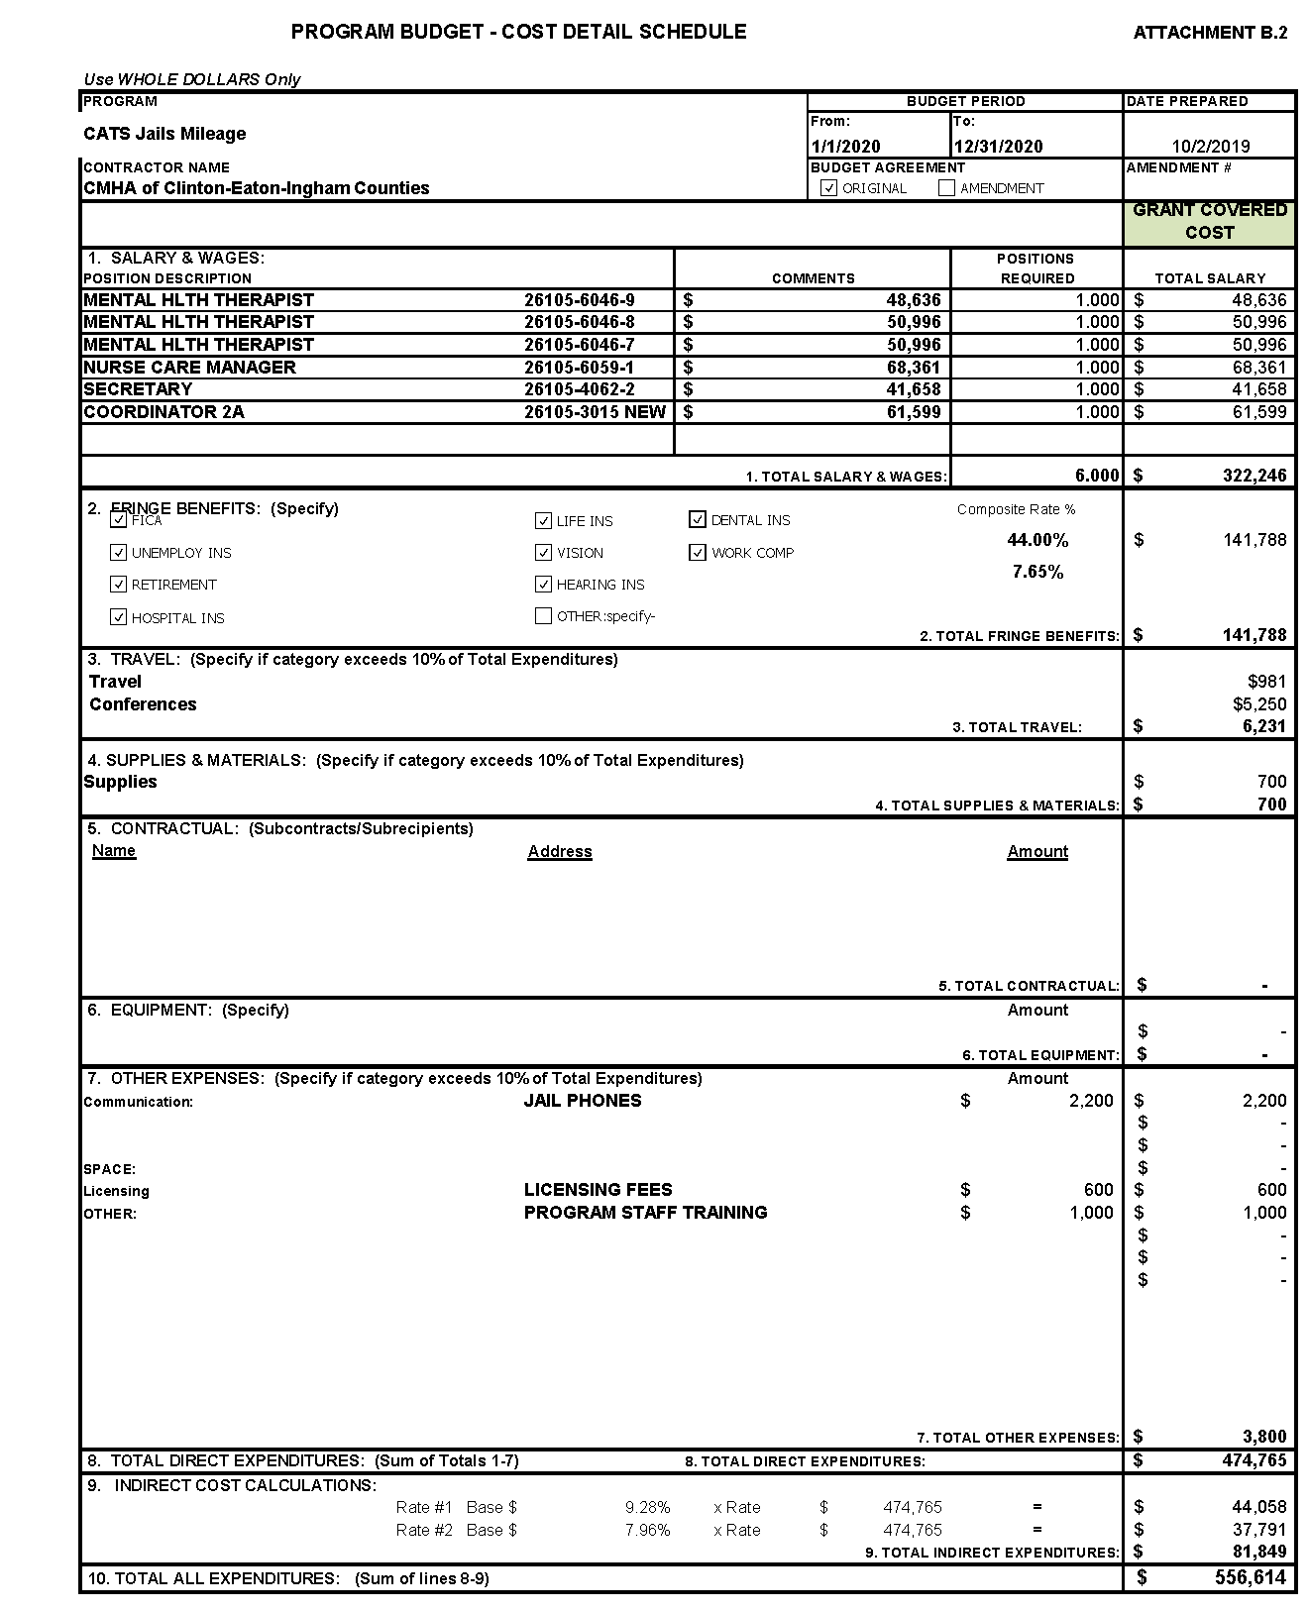

ATTACHMENT #3

PRETRIAL SERVICES PROGRAM REQUESTS: ANNUAL COST
Professional Development & Training: $2,000
- Annual NAPSA Conference:
  - $1,500 [Travel / Lodging / Meals] per Employee
- Miscellaneous Pretrial Training – regional :
  - $500
CATA – Bus Tokens / Indigent Client Assistance: $1,250
- $1,250
  - Tokens – One Way Fare = $1.25 per Token
  - 1,000 Tokens x $1.25 = $1,250

ADAM – Alcohol & Drug Testing / Indigent Client Assistance: $4,000 ($4,032)
- Average Referrals per Year = 140
  - 20% Indigent Clients / Financial Need = 14 Clients
- 1X per Week Testing = $12
- (3) Month Testing Period = 12 Weeks

- 140 x .20 = 28 (Indigent Clients) 28 x 12 (12 Weeks Testing) x $12 (Cost per Test) = $4,032

Automated Text Notification System:
MATTERHORN PLATFORM - Text message for court dates/reporting $4000
- Initial program setup =$1000
- Monthly subscription = $250.00/mo
CLEAR SUBSCRIPTION $1694.52
- CLEAR is an online investigation solution designed to assist in locating and identifying individuals, phone numbers, licenses, assets, addresses, etc. Circuit Court has a contract with CLEAR. We are requesting an additional subscription for Pretrial Services to assist in connecting with our clients.

