ADOPTED – OCTOBER 27, 2020
AGENDA ITEM NO. 36

Introduced by the Law & Courts, Human Services and Finance Committees of the:

INGHAM COUNTY BOARD OF COMMISSIONERS

RESOLUTION TO AUTHORIZE POSITIONS, CONTRACTS AND OTHER EXPENSES
TO INCREASE TREATMENT PROGRAMMING FOR 2021 AS AUTHORIZED
BY THE JUSTICE MILLAGE

RESOLUTION #20 – 473

WHEREAS, on August 7, 2018 the electorate of Ingham County approved the Justice Millage; and

WHEREAS, in addition to providing funding for a new Justice Complex, the millage language authorized funding for “programming for the treatment of substance addictions, treatment of mental illness, and reduction of re-incarceration among arrested persons”; and

WHEREAS, the 2021 budget allocates $1,043,456 in programming funding from the Justice Millage; and

WHEREAS, a surplus of $302,538 remains in unspent funds from the 2019 programming allocation; and

WHEREAS, the Law and Courts Committee directed that current programs be continued for 2021.

THEREFORE BE IT RESOLVED, that the Ingham County Board of Commissioners hereby authorizes a 2021 budget of up to $1,080,411 from the Justice Millage to continue the following treatment programs:

- Community Mental Health Correctional Assessment and Treatment Services (CATS): $582,505 to fund three full time mental health therapists to provide mental health therapy and case management services and to coordinate care and increase collaboration at the Ingham County Jail, one full time nurse case manager to work directly in partnership with the Ingham County Health Department/Jail Medical to integrate behavioral health and physical health care, and one full time mental health secretary to provide clerical support for these services. Also funded is a full time Program Manager to assist in the direct management of Jail Re-entry; inclusion in the Ingham County Health Department Medication Assisted Treatment initiative; and to manage Jail Diversion activities, both of which include community liaison and development of the services necessary for re-entry purposes.
- Community Based Programs: $145,600 to fund electronic monitoring, substance abuse assessment and psychological evaluation, day reporting, and MRT – Cognitive Behavioral Change.
- Ingham County Health Department Pathways to Care Program: $77,449 to continue previously grant funded services in a client-centered approach to inmates who have a current or past history of opioid use.
- Ingham County Sheriff’s Office/Jail Programming: $113,400 to fund inmate initiatives, seeking safety, break out, trauma centered yoga, restorative justice, and parenting.
- Circuit Court/Pretrial Services: $161,457 to fund a Pretrial Services Clerk and a Pretrial Services Investigator.

BE IT FURTHER RESOLVED, that the Ingham County Board of Commissioners authorizes a contract not to exceed $582,505 with the Community Mental Health Authority of Clinton, Eaton, and Ingham Counties (CMH) for services as described in Attachment #1b for the period of January 1, 2021 through December 31, 2021.

BE IT FURTHER RESOLVED, that funds for this contract with CMH will come from the Justice Millage.

BE IT FURTHER RESOLVED, that the $36,955 excess over the 2021 allocation of $1,043,456 will be funded from the 2019 programming remaining balance in the Justice Millage Fund.

BE IT FURTHER RESOLVED, that staff will provide reports in July 2021 providing information about achievements and effectiveness.

BE IT FURTHER RESOLVED, that the Controller/Administrator is authorized to make the necessary adjustments to the 2021 budget consistent with this resolution.

BE IT FURTHER RESOLVED, that the Board Chairperson is hereby authorized to sign any necessary documents consistent with this resolution and upon approval as to form by the County Attorney.

LAW & COURTS: Yeas: Slaughter, Polsdofer, Celentino, Crenshaw, Sebolt, Trubac, Schafer
Nays: None Absent: None Approved 10/15/2020

HUMAN SERVICES: Yeas: Trubac, Stivers, Tennis, Morgan, Slaughter, Naeyaert
Nays: None Absent: Koenig Approved 10/19/2020

FINANCE: Yeas: Morgan, Tennis, Grebner, Crenshaw, Polsdofer, Schafer, Maiville
Nays: None Absent: None Approved 10/21/2020

ATTACHMENT #1a

Community Mental Health Millage Report June 2019 – June 2020
Correctional Assessment & Treatment Services (CATS)
Justice Behavioral Health (JBH)

Currently approximately 45% of the jail’s population is being served by general CATS programming, of that 21% are receiving direct behavioral health services with JBH staff. From June 2019 to June 2020, JBH has independently served 345 unique clients.

- Upon the hiring process, JBH was fully staff with three mental health therapists (MHT), one nurse care manager (NCM) and one secretary from May 2019 through December 2019. JBH did have a three month staffing gap for one of the therapist positions which has been filled however, new hire training has been limited due to the COVID-19 pandemic.
  - JBH MHT provides weekly therapy both in individual and group modalities. Overall, JBH has provided 1,347 individual therapy sessions. JBH considers individuals under the 18 years of age as a high priority population so they are served as soon as possible. JBH has provided 138 services to this specific population over the last year.
  - JBH MHT has been facilitating routine weekly Anger Management Groups, Coping Skills group and Dialectical Behavioral Groups until Mid-March 2020 (COVID -19 pandemic has prevented all current group work). The majority of these groups are on weekends and during evening hours which allows clients to attend more daytime programming. In the future there are plans to add a Co-Occurring Group to address substance use issues as well. JBH has provided 2,623 group encounters.
  - JBH NCM continues to play a vital role in integrated healthcare between the ICHD/Jail Medical and behavioral health needs. The NCM also serves as a liaison for the MSU Psychiatric Residency Program at the jail. The NCM creates transitional healthcare plans by linking clients with community providers upon release. JBH has had over 200 direct care contacts.
  - JBH secretary continues to provide clerical support and processes all of the needed paperwork for the program.
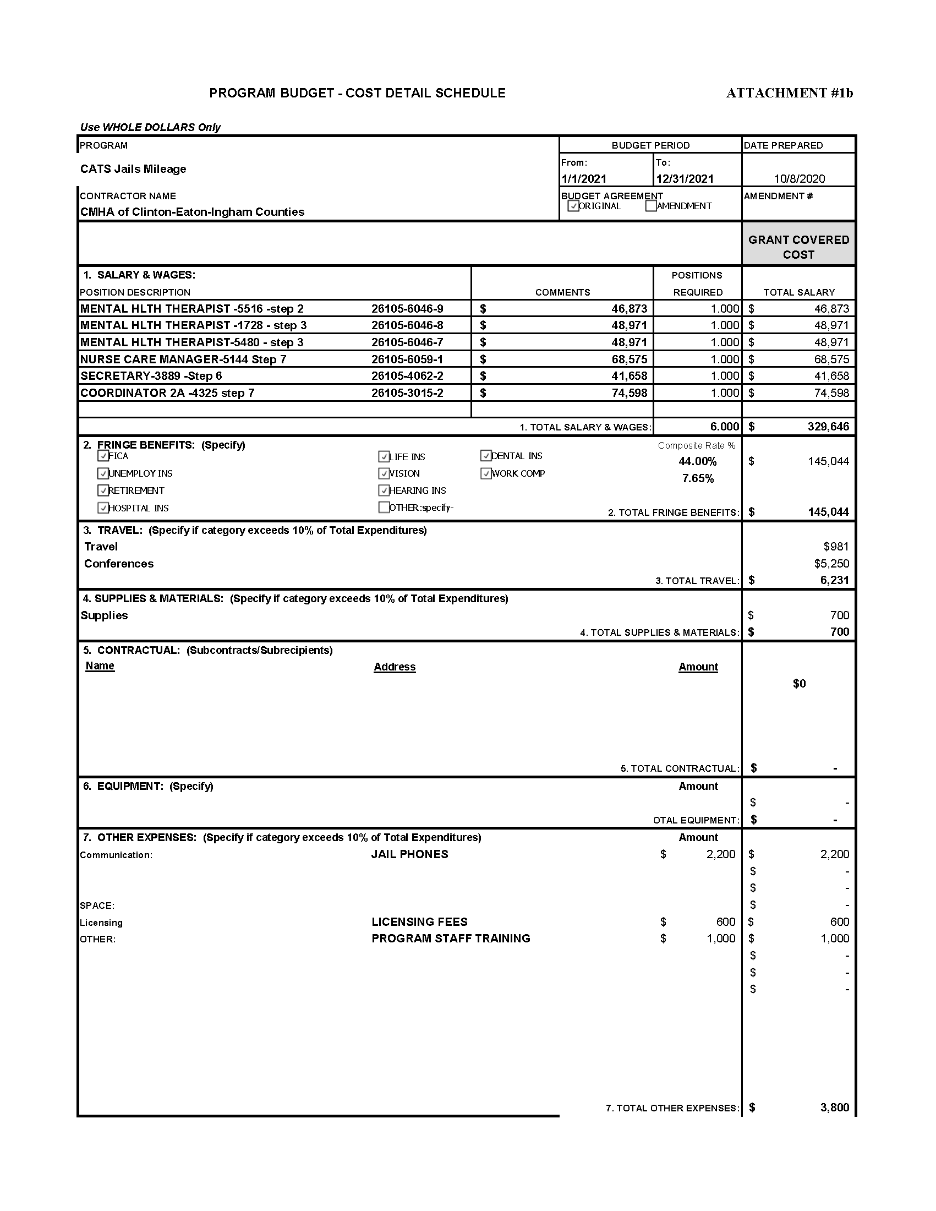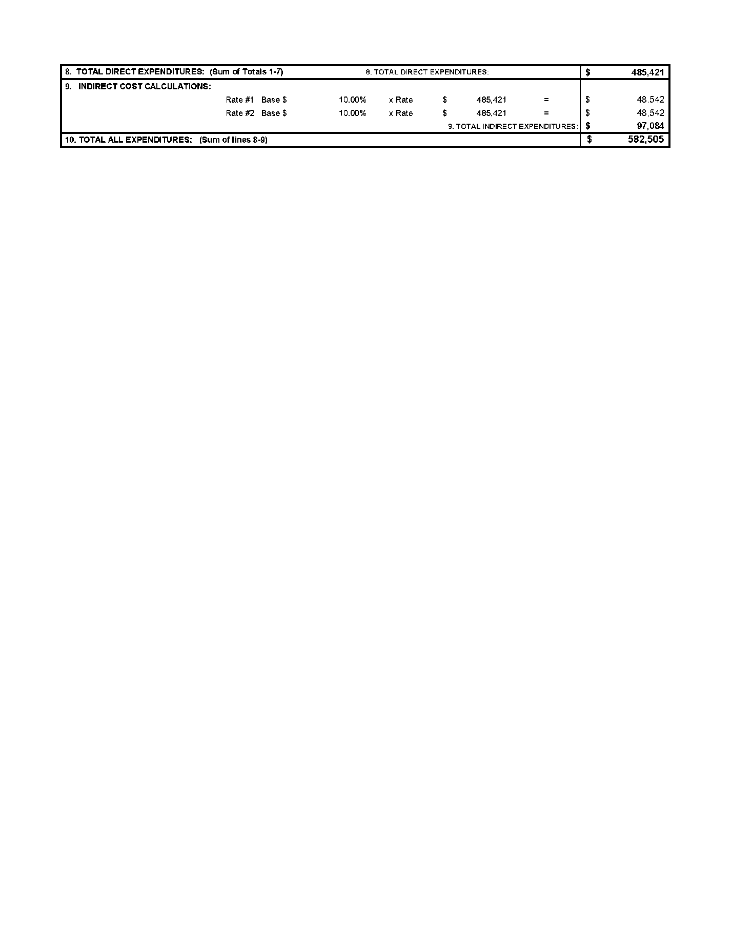

ATTACHMENT #2
COMMUNITY CORRECTIONS - COMMUNITY BASED PROGRAMS
2021 JUSTICE COMPLEX MILLAGE PROPOSAL
According to the Department of Justice, Bureau of Justice Assistance, over the last two decades, a critical mass of evidence has accumulated challenging the prior prevailing belief that nothing works to rehabilitate offenders. (BJA, 2014) To the contrary, research findings show that evidence-based interventions can significantly reduce recidivism. It is clear that sanctions alone do not result in positive behavior change or reduce recidivism (R. Warren, CJI/NIC, 2007). The leading researcher in what works and what does not in reducing recidivism, Edward J. Latessa, Ph.D., states that, “Not a single review of studies of the effects of official punishment alone has found consistent evidence of reduced recidivism.” While up to 60% of treatment services studies reported reduce recidivism rates (E. Latessa, 2002).

Electronic Monitoring: __________ _$70,000
Electronic monitoring (EM) is an effective and cost efficient resource, capable of directly reducing the jail population while maintaining public safety.

In addition to monitoring and tracking, a large National Institute of Justice study showed significant decreases (31%) in the probation failure rate for all groups of offenders and age groups who are supervised on electronic monitoring (NIJ, 2011). Use of alcohol monitoring devices deters recidivism during use; and, when combined with treatment, provides the user an opportunity to change negative behavior (Court Review, V. Flango & F. Cheesman).

Judicial Services Group, Ltd. (JSG) utilizes a variety of monitoring devices that can provide a broad range of supervision parameters based on the individual user. Locally, EM is used in pretrial and probation supervision, as an alternative to incarceration under the Sheriff’s jurisdiction, and saves jail staff that would otherwise be used for hospitalized inmates. In 2020, EM utilization increased significantly, due to the COVID-19 pandemic. EM has proven to be an important resource to assist with reducing the jail population by providing county funded services to users diverted from the jail and to self-pay clients who lost employment or had their hours reduced due to COVID-19.

Substance Abuse Assessments and Psychological Evaluations $5,000
Conducting a clinical assessment is essential to understanding the nature and severity of the patient’s health and social problems that may have led to or resulted from the substance use. This assessment is critical in determining the intensity of care that will be recommended and the composition of the treatment plan. Tailoring the treatment to specific needs increases the likelihood of successful treatment engagement and retention. Research shows that those who are matched with the appropriate level of treatment using ASAM (American Society of Addiction Medicine) criteria participate more fully in treatment and typically have better outcomes. (3X improvement in addiction severity outcomes at 3 months/30% reduction in dropout from treatment/25% - 300% reduction in no shows to next stage of treatment) (ASAM, D. Gastfriend, MD).

Psychological Evaluations determine the severity of a specific mental health concern or to determine an individual’s capacity for adequate functioning. Assessments and evaluations may be required to develop a sentence that includes appropriate treatment placements and programming.

Day Reporting: __ ______ $52,000
This program provides an additional layer of monitoring and supervision, structure, accountability and programming in the community. Based on individual need, it addresses a wide array of fundamental needs such as food, clothing, housing and housing. All critical to successful integration into the community and being able to focus on treatment. Also based on assessed need, on-site evidence based groups are include Cognitive Behavioral Therapy, Dialectical Behavior Therapy, Seeking Safety, Anger Management, and Conflict Resolution. AA and NA groups meet onsite.

Community Corrections funded Day Reporting has a highly successful completion rate that ranges from 65% - 70%. This demonstrates its effectiveness at assisting participants achieve their Individual Plan goals with no rearrests while engaged in the 120 day program. While, Day Reporting programs across the country are not standardized, there are a number of studies of similar programs that demonstrate significant recidivism reduction (30% - 60%) (PA 2013, Utah & Oregon 2010).

Expanding this State funded Community Corrections program will increase the number of offenders served, including those not be eligible under State MDOC approved criteria (e.g. District Court misdemeanants).

MRT – Cognitive Behavioral Change ___ $18,600
Moral Reconation Therapy (MRT) is a systematic treatment strategy to decrease recidivism among adult criminal offenders by using 16 objectively defined steps focusing on seven basic treatment issues to promote positive change. MRT is a cognitive-behavioral treatment approach that is probably the most widely researched offender treatment modality (Meta-Analysis, G. Little, 2005). 200 outcome studies have been conducted up to 20 years after treatment and release of over 100,000 individuals. Overall, finding lower recidivism rates, improved personality variables, and enhanced treatment compliance. (S. Swan, 2013)

Expanding this State funded Community Corrections program will increase the number of offenders served, including those who are not eligible under State MDOC approved criteria.

TOTAL __ $145,600 Submitted by Community Corrections: September 21, 2020

ATTACHMENT #3

Jail Programming - Justice Millage Budget – 2021
Program Provider/Expense Title | Budget | Program Description
Program Coordinator - Supplies and Discretionary Expenses | $5,000 | Inmate Initiatives - Garden, Employment assistance, Training/Educational DVDs, and other program facilitation discretionary funds
Cognitive Consultants, LLC | $17,600 | Seeking Safety (26 week program)- helps people attain safety from trauma and/or substance abuse through  teaching reflective thinking and coping skills. Sessions are conducted in group settings as well as one-on-one. This program is complimented by Trauma Centered Yoga.
Body Connection Yoga | $15,600 | Trauma Centered Yoga - is provided to male and female felony offenders, on a voluntary basis, by a certified trauma informed yoga instructor.
Cognitive Consultants, LLC | $35,200 | Break Out (10 week program) - is based on Moral Reconation Therapy (MRT) which is a form of cognitive-behavioral programing designed for male and female criminal justice offenders. Jail Re-Entry Planning and Life Skills offers clients the opportunity to establish short term achievable goals, identify personal strengths and overcome projected barriers to success.
TBD, currently: "It Takes A Village Educational Consulting, LLC" | $20,000 | Restorative Justice (15-30 week program) - Offers participants a chance to take accountability and repair the harm done by their crimes, while teaching mediation, conflict resolution, and problem solving. Participants can earn certificates for being trained in mediation.
TBD, currently: Wellness INX | $20,000 | Parenting -This program includes instructions to:  • Promote children’s development,  • Improve child/parent attachment,  • Improve child/parent communication skills,  • Enhance self-esteem of participants,  • Improve child/parent social control, and  • Reduce aggressive behaviors by children and their caregivers.
TOTAL: | $113,400
ATTACHMENT #4a

JUSTICE MILLAGE
30TH CIRCUIT COURT PRETRIAL SERVICES PROGRAM

0

PRETRIAL SERVICES PROGRAM REQUESTS: ANNUAL COST

Funding for Pretrial Services Clerk and Investigator $148,840

Funding for the Professional Development & Training: $2,000
- Annual NAPSA Conference:
  - $1,500 [Travel / Lodging / Meals] per Employee
- Miscellaneous Pretrial Training – regional :
  - $500
CATA – Bus Tokens / Indigent Client Assistance: $1,250
- $1,250
  - Tokens – One Way Fare = $1.25 per Token
  - 1,000 Tokens x $1.25 = $1,250

ADAM – Alcohol & Drug Testing / Indigent Client Assistance: $4,000 ($4,032)
- Average Referrals per Year = 140
  - 20% Indigent Clients / Financial Need = 14 Clients
- 1X per Week Testing = $12
- (3) Month Testing Period = 12 Weeks

- 140 x .20 = 28 (Indigent Clients) 28 x 12 (12 Weeks Testing) x $12 (Cost per Test) = $4,032

Automated Text Notification System:
MATTERHORN PLATFORM - Text message for court dates/reporting $4000
- Initial program setup =$1000
- Monthly subscription = $250.00/mo

CLEAR SUBSCRIPTION $1694.52
- CLEAR is an online investigation solution designed to assist in locating and identifying individuals, phone numbers, licenses, assets, addresses, etc. Circuit Court has a contract with CLEAR. We are requesting an additional subscription for Pretrial Services to assist in connecting with our clients.

ATTACHMENT #4b
PRETRIAL SERVICES CLERK

The creation of the Pretrial Services Clerk position, made possible by funding from the Justice Millage, has improved the ability of the Circuit Court to provide services to our clients, and to collect and assess data that indicates and supports the effectiveness of our agency in achieving our mission and purpose.

Our Pretrial Clerk explains: In general, I have aided the court, the public and defendants in ways which are both routine and complex. I help people find court rooms/court dates. Many times people confuse 3R with floor 3 in our building. People often stop into our office (before Covid-19) trying to find courtrooms or are just generally confused where to go in the building. I’ve directed many people who were unsure of where to go in the VMC/GPB. It may seem like a minuscule task, but it happens often.

In addition, I serve as the face of Pretrial. Defendants are not always sure of what Pretrial Services entails. Typically, I am the first person they talk to in the office and I am able to provide any initial information such as upcoming court dates or attorney information. Being arrested and/or arraigned can be a daunting, overwhelming process. Many defendants do not absorb the bond or court information they are given during that time. Thus, it’s imperative they contact Pretrial Services so our office can fill in any pieces of information they are missing as well as gather any information the courts may not have about defendants such as accurate addresses or telephone numbers.

One of the largest aspects of my job is collecting data for our Pretrial Services office. I track the start and close of all felony cases in Ingham County--even if a defendant is not required to report to Pretrial Services. We keep track of a defendant’s successful appearances, bond conditions, failures to appear in court, re-arrests, and revocations of bond. Before my employment at Pretrial Services in April of 2019 this type of data was not collected or recorded. From this data we are better able to grasp our total impact on defendants as well as improve our processes and practice.

PRETRIAL SERVICES INVESTIGATORS

The addition of a Pretrial Services Investigator position, made possible by the Justice Millage, has allowed the team to effectively and timely meet with and manage a growing client list which is largely due to the Covid-19 pandemic. At the same time, we are able to remain responsive to the Court. In February 2020, Pretrial Services managed 436 cases, while in September 2020 it manages 590 cases, an increase of 26%.

In regard to the efficacy of the Pretrial Services Program, our investigators share the following experiences.
- This summer, 2020, one of my defendants had not reported and it was unlike him to do so. I had a contact number for his sister and she advised she had not heard from him in a few weeks. This was unusual behavior for the defendant, to not have checked in with his sister. I had suggested to the sister that she might contact the police department and have them take a missing person report. In doing so, if the defendant was located, his welfare would be checked. The defendant would have been advised to contact his family or the family would have been notified of his location.

The sister contacted me a day later, advising she had filed the report and felt better knowing that someone was looking for her brother. The sister called again, the following week, and notified me the defendant had been located and taken to the hospital. The defendant was being treated for potential life threatening medical issues that had altered his mental health and ability to understand the need for medical treatment. The sister was very thankful for the help.

- In February 2020, during enrollment, it was evident that one of my defendants had some cognition issues and hygiene concerns. The defendant’s guardian/mother, via telephone a few weeks later, confirmed these concerns. The defendant was a candidate for Mental Health Court. Our Mental Health Court Case Manager and I had spoken with the defendant’s mother on several occasions in regard to her, and her son’s, living situation.

I have the experience to recognize when there is a need for mental health care. I presented options to the defendant’s mother, as she did not know what her options were. After a few weeks, defendant’s mother decided to petition the court for an order to have the defendant evaluated by CMH. According to her, the defendant is considerably better. I can discern a difference when speaking with the defendant. The defendant’s guardian/mother was very thankful for the help.

- Since July 2019, I have been supervising a defendant who is charged with a violent felony offense. She had been incarcerated from March 2019 – July 2020 due to not being able to post bond. Due to the pandemic, her bond was amended by the judge of record and she was placed on pretrial release with a condition that she was to be supervised by Pretrial Services.

As the defendant’s case manager, I have been her “go to” person. Because she has been incarcerated for over a year, she lost her housing and employment. Additionally, this defendant has minimal family support and no current transportation. Upon her release, she had to make a fresh start, which was made even more difficult due the pandemic. To date, she has been compliant with her reporting requirements and other conditions of release. As a Pretrial Services Investigator, I am able to help her navigate through the court process. She has recently been able to obtain employment. Although she currently resides at a local shelter, she is in the process of finding housing that is more permanent. Even when things don’t always go her way, she always appreciates my help and ends our telephone conversations with a, “thank you.”

- Not all my clients are as happy to report to me and the experience can start off on a negative note. I recently had one client who called for enrollment and immediately he responded with a negative attitude. He was angry. He was upfront with me and indicated to me that he was innocent and that he didn’t know why he had to report to me, because he wasn’t guilty. As I do with all my clients, I start by telling them that this is a court order and as an officer of the court, my job is to help them get through the process and help them comply with the conditions set forth by the court, so they don’t end up incarcerated. I told my client that I did not know the circumstances surrounding his arrest, but at this point in the process, he was considered innocent.

By giving him respect and understanding, his attitude with me changed. He apologized and said the he has been under much stress. About two weeks ago, his case was dismissed. He called me immediately and told me that he appreciated that I didn’t judge him, but he doesn’t plan on being on my caseload ever again.

- This defendant has been under the supervision of the Pretrial Services Division since her completion of inpatient recovery for substance use issues and initial enrollment in June 2019. She had initially been charged with two counts of Assault with Intent to Do Great Bodily Harm Less Than Murder. Upon her second reporting contact with Pretrial Services, the defendant provided completion paperwork for substance use and anger management classes. She also indicated that she had been taking alcohol /drug screenings while previously at inpatient treatment, which were negative, as the client had stated that she had been sober.

She was arraigned in 2020 for a new felony case involving two charges and reported to Pretrial Services soon after to be enrolled for this new case. The defendant was readmitted to inpatient treatment in Lansing to begin another substance use program. Eventually, she was accepted into a recovery program and moved to a residential facility to begin a recovery and empowerment program. This specific program is nine to twelve months in length and is designed to help women overcome their addictions, while identifying self-defeating behaviors and maximizing their potential to live and work in the community. This program is a comprehensive therapeutic process that encompasses emotional, physical, intellectual, and spiritual factors, and assists women in becoming responsible and independent. The participant resident’s days are structured by a staff of licensed professionals, specialists, and volunteers who supervise planned activities. The participant resident is provided with individual therapy, group therapy, spiritual counseling, case management, referrals to community resources, physical fitness opportunities, and access to the local library.

The defendant has been very consistent in reporting every Tuesday, to Pretrial Services since March 2020 and has been continuing her “journey of sobriety” and gaining “life skills” throughout the pretrial period of the pending cases. She recently indicated that she is also working on her G.E.D. She has been very gracious in recognizing the opportunity she has been given to participate in such an empowering recovery program and credits Judge Aquilina for guiding her into this program.

Pretrial Services has attempted to provide assistance and support to this client by establishing a professional relationship in the weekly contacts to assure that the defendant is fully aware of any upcoming court proceedings, as well as assuring that the defendant has been compliant with all court ordered terms and conditions of bond release. This particular person has been compliant with all orders of the Court, has maintained communication with defense counsel, and has reported to Pretrial Services as directed.

It has been rewarding to this Pretrial Services Investigator to see an individual gain and maintain sobriety, deal with her pending cases in a very responsible manner, and grow as a person throughout the pretrial supervision period.

- During a work day, I enrolled a defendant and provided the defendant with my contact information and my business card. When I returned to work the next morning, I received multiple voicemails from the defendant stating that he was “getting help” and that he was going to be admitted into an inpatient mental hospital. The defendant stated that he could not find his Defense Attorney’s contact information and since I just gave him my contact information earlier that day, it was the only contact number he had on him at the time.
When I received the voicemail messages, I contacted the hospital that the client stated that he was staying at to verify the information. I asked the medical staff to have the defendant contact me when he was available to make phone calls.

After the information was confirmed, I submitted an Informational Report to the Judge, the Assistant Prosecuting Attorney, and the defendant’s Defense Attorney because the defendant was scheduled for a Probable Cause Conference hearing the following week.
At the time, I was the only person that the defendant had contacted regarding his inpatient treatment and his outdate at the clinic was undetermined. I was able to forward the information to the court so that the Probable Cause Conference Hearing could be adjourned and so that the court was informed of the incident that occurred.

Once the defendant was cleared from the inpatient treatment, I was contacted by the defendant and I submitted a Supplemental Report to the Judge advising that the defendant was out of the hospital. This assisted all parties within the court system because of the communication that the defendant had with Pretrial Services. I was able to provide accurate information to the court prior to the scheduled court proceeding. This reduced the chance of the defendant failing to appear for his court proceeding and it reduced the chance of the defendant receiving a Bench Warrant for his arrest.

- We provide defendants with local resources to assist them while they’re in the Community (shelter, food, mental health, AA meetings, indigent, etc.) as well as provide them with their court proceeding information. On the other spectrum, we are able to provide updated contact and supervision information to all the Judicial Courts within Ingham County regarding each Defendant. An example of this scenario is that I had a defendant who was required to report to Pretrial Services and he was required to conduct random testing for drugs and alcohol per his bond conditions. Since the defendant was failing to do both and multiple attempts were made to contact the defendant, I submitted the information to the Judge as a Bond Violation Report. I received a response from the Judge on the Bond Violation Report with a request to schedule a Summons Regarding Bond Violation court proceeding.

I received a date for the Summons Regarding Bond Violation from the Judge’s Judicial Assistant and I completed and mailed the document reflecting the purpose of the court proceeding to the defendant, Assistant Prosecutor, and the Defense Attorney.

As requested by the Judge, I appeared at the Bond Violation Hearing and I provided the information of the alleged Bond Violation on record to the court. During this court proceeding, the defendant stated that the reason he was not reporting to Pretrial Services and conducting his random drug screenings was because he had been at the hospital receiving medical treatment. The Judge responded to the defendant’s statement requiring that the defendant submit medical documentation to Pretrial Services for proof of the treatment.

Once I received the medical documentation from the defendant, I thoroughly investigated the information, which includes but is not limited to: contacting the hospital where the defendant allegedly received treatment and compared the defendant’s story to the medical documentation that the defendant provided.

I contacted the hospital to authenticate the documentation received from the defendant. I was advised that the documentation that the defendant provided to Pretrial Services was not authentic. The manager at the hospital stated that there were multiple issues with the documentation provided and that she strongly suggested that the documentation was not authentic and that it did not come from one of their staff. From the information gathered regarding the documentation, it appeared that the defendant had falsified the medical documentation to the court. All of the information gathered was then submitted to the Judge, the Judge’s staff, the Assistant Prosecutor, and the defendant’s Defense Attorney.

