ADOPTED - SEPTEMBER 27, 2022
AGENDA ITEM NO. 22

Introduced by the Human Services Committee of the:

INGHAM COUNTY BOARD OF COMMISSIONERS

RESOLUTION TO AUTHORIZE A MEMORANDUM OF UNDERSTANDING WITH MICHIGAN STATE UNIVERSITY EXTENSION FOR THE HESSE-EARL YOUTH FISHING PROGRAM

RESOLUTION #22 – 425

WHEREAS, the Hesse-Earl Youth Fishing Program is an annual event in Ingham County Parks that empowers young people with skills to lead for a lifetime and become the foundation for future success; and

WHEREAS, a Memorandum of Understanding is necessary to define the relationship with, and gain the assistance of Michigan State University Extension to provide the best educational experience for young individuals learning to fish; and

WHEREAS, Michigan State University Extension and Ingham County Parks are agreeable to the arrangement reflected in the attached Memorandum of Understanding between the parties.

THEREFORE BE IT RESOLVED, that the Ingham County Board of Commissioners hereby authorizes the attached Memorandum of Understanding with Michigan State University Extension.

BE IT FURTHER RESOLVED, that the term of the Memorandum of Understanding shall be for one (1) year from execution of the agreement.

BE IT FURTHER RESOLVED, that this contract will continue on a year-to-year basis unless either party provides written notice to the other that it intends to terminate the contract.

BE IT FURTHER RESOLVED, that Michigan State University Extension or Ingham County Parks Department may terminate this agreement, with or without cause, with 120 days written notice.

BE IT FURTHER RESOLVED, that the Chairperson of the Board of Commissioners is hereby authorized to sign any necessary contract documents on behalf of the County after approval as to form by the County Attorney.

HUMAN SERVICES: Yeas: Trubac, Cahill, Crenshaw, Slaughter
Nays: None Absent: Tennis, Sebolt, Naeyaert Approved 09/19/2022

Memorandum of Understanding between
Michigan State University Extension and Ingham County Parks Department

Michigan State University (MSU), through its Extension programs and in collaboration with Ingham County Parks Department, is committed to providing fun, educational opportunities that empower young people with skills to lead for a lifetime and become the foundation for future success.

To maximize the impact of both organizations’ efforts to support youth development, Ingham County Parks Department and MSU have committed to sharing resources in the following ways:

Michigan State University Extension will:

- Serve the Chairperson role for the Hesse-Earl Youth Fishing Program
  - Set up necessary meetings and prepare minutes
  - Coordination among partners
- Be responsible for Fundraising and Budgeting
- Recruit and manage volunteers including assignment of duties
- Prepare and sign letters and certificates to youth participants
- Prepare and send Thank You Communications to Donors and Volunteers
- Purchase equipment and materials for tackle boxes
- Oversee the loading of Tackle Boxes and assembly of Rods and Reels
- Be leader for Set-up of Learning Stations for workshops
- Coordinate with other Partners for Sea Lamprey education at workshops and schools
- Provide macroinvertebrates for educational display
- Coordinate with other partners for arrangement of venues outside Ingham County Parks jurisdiction
- Pay postage for mailings to kids
- Organize photography at workshops and sorting of posed and candid pictures of participants
- Coordinate liability insurance with partners at venues not in Ingham County Parks jurisdiction
- Comply with Ingham County Parks Department Special Events Policy, except provision

Ingham County Parks Department will:

- Provide and prepare venues that are within their jurisdiction
- Handle registration and correspondence with participants
- Provide clerical support including nametags, check-in sheets, printing of materials for follow-up mailings to participants/families
- Provide facilities to store equipment. Ingham County is not responsible for damage/loss of equipment.
- Assist with set-up for workshops
- Coordinate with local high school volunteers to help
- Provide Special Event application to MSU
- Term and Termination
The term of this contract will be for the one (1) year from execution of the agreement. This contract will continue on a year-to-year basis unless either party provides written notice to the other that it intends to terminate the contract. Either MSU Extension or Ingham County Parks Department may terminate this agreement, with or without cause, with 120 days written notice.

- General Terms
  - Independent Contractor. The University is an independent contractor providing services to Ingham County Parks Department. Ingham County Parks Department and the University do not have the relationship of legal partners, joint ventures, principals, or agents. MSU Extension
Personnel have no right to any of Ingham County Parks Department’s employee benefits.
  - Force Majeure. Each party will be excused from the obligations of this agreement to the extent that its performance is delayed or prevented by circumstances (except financial) reasonably beyond its control, including but not limited to, acts of government, embargoes, fire, flood, explosions, acts of God, or a public enemy, strikes, labor disputes, vandalism, or civil riots.
  - Assignment. This agreement is non-assignable and non-transferable.
  - Entire Agreement. The agreement expands upon and is incorporated into the Special Events Permit Application to be submitted annually by MSU Extension to Ingham County Parks Department. This agreement can only be modified in writing signed by both MSU Extension and Ingham County Parks Department.
  - No Third Party Beneficiaries. The agreement is solely for the benefit of MSU Extension and Ingham County Parks Department. It does not create any benefit or right for any other person.
  - Liability. Each party shall be responsible for its own liability insurance coverage. In the event that liability to third parties, loss, or damage arises as a result of activities conducted jointly by the parties in fulfillment of their responsibilities under this Agreement, such liability, loss, or damage shall be borne by the parties in relation to each party’s responsibilities under these joint activities, provided that nothing herein shall be construed as a waiver of any governmental immunity as provided by statute or court decisions.
  - Nondiscrimination. The parties will adhere to all applicable federal, state and local laws, ordinances, rules and regulations prohibiting discrimination. The University, as required by law, will not discriminate against a person to be served or any employee or applicant for employment because of race, color, religion, national origin, age, sex, sexual orientation, gender identity, disability, height, weight, marital status, or any other factor prohibited by applicable law.

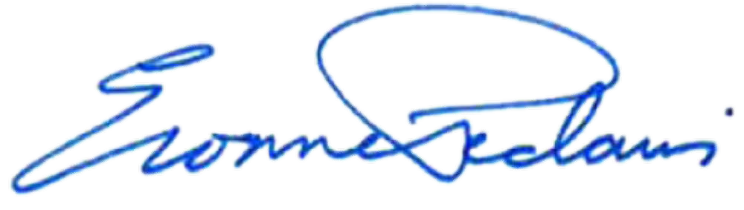  MICHIGAN STATE UNIVERSITY | COUNTY OF INGHAM
By: | By:
Evonne Pedawi, Director  Contract & Grant Administration | Bryan Crenshaw, Chairperson County Board of Commissioners
Date: 9 August 2022 | Date:

